Portpatrick Primary
Needs You!

Christmas Fundraiser

Our very creative pupils have made a range of Christmas Crafts to sell at our
Village Craft Fayre that was held on Saturday 27th of November.

We have some items left that we are keen to sell to boost our fundraising.

If possible, please send in money with your child to purchase on a
first cone-first served basis.
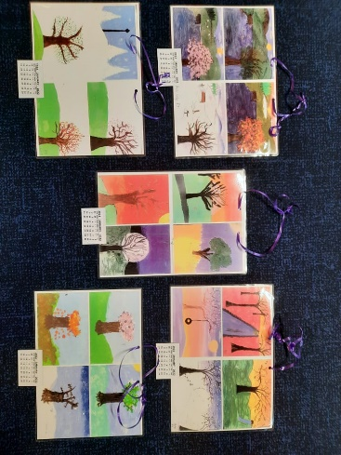
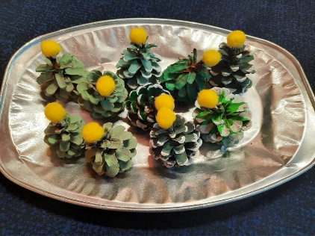
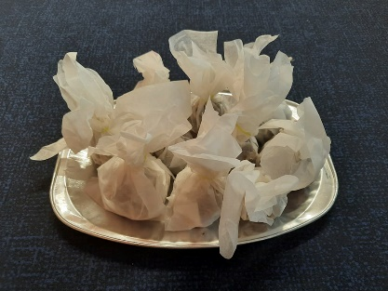
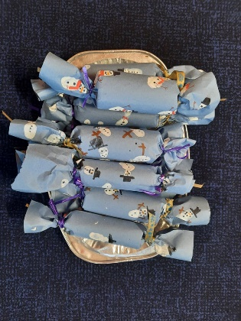
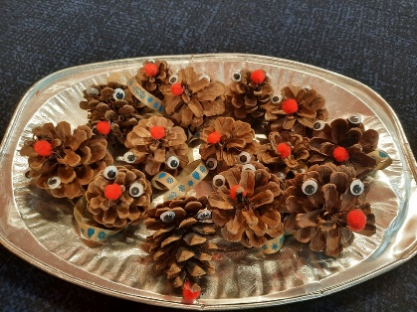
Bird Seed Balls | 10p each - 50p for 6
Bird Seed Pine Cones | 20p
Pine Cone Reindeer Tree Ornament | 20p
Pom-Pom Pine Cone Decoration | 20p
Eco Friendly Christmas Cracker | 50p
Four Seasons Artwork Calendars | 50p

As part of our Eco Schools and Rights Respecting Schools work, we are also collecting for our local foodbank. Please send in any donations of non-perishable items that you may be able to donate by the 17th of December.

The boys and girls appreciate your support so very much.
Thank You!

