How to access your child’s Glow account at home

1 | Using your normal internet (ideally Chrome), Go to  the this website link: https://glow.rmunify.com/  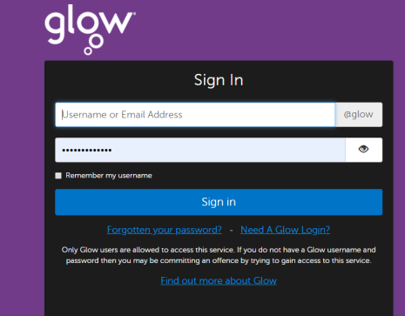
2 | Have your child use their login and password to access the Glow website. This should be written in their homework diary. This will be checked as working before they leave school.
3 | 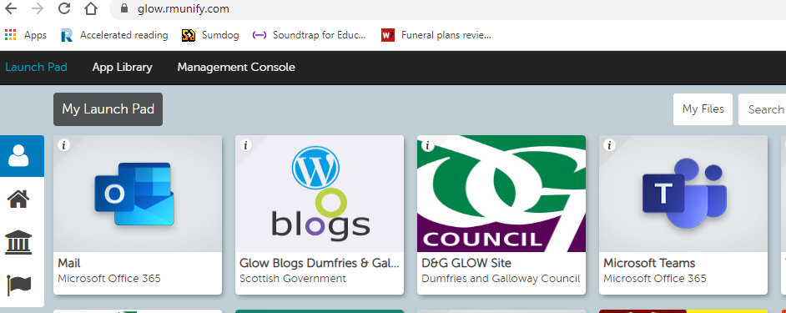  Click on either the Mail or Teams tile as required.
4 | 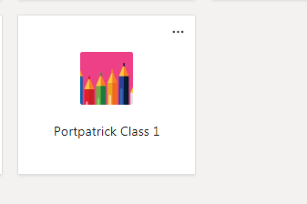  Select the desired team, in this case Portpatrick Class 1 is shown.
5 | To access stored files, click on the files tab on the top toolbar  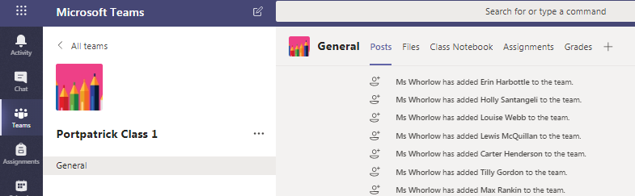
6 | Click on the folder of your choice, in this case Sleeping Beauty Play. Materials can be accessed, downloaded and printed etc. directly from here.  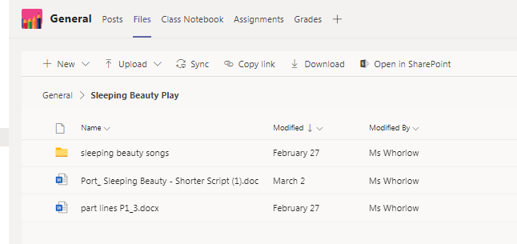
 | Your child can access their Glow email account at any time by completing steps 1 -3. Instead of selecting the Teams tile, simply select the blue mail tile (1st envelope image shown in box 3).

