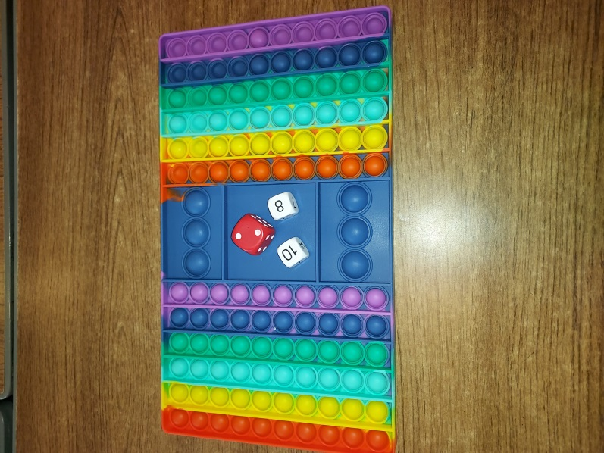
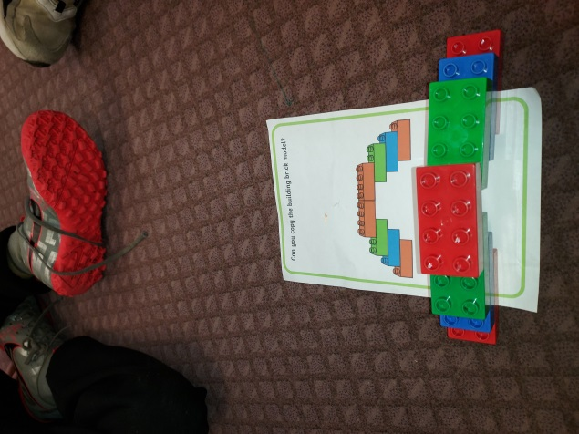
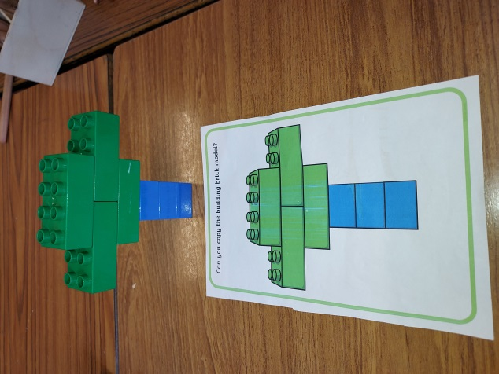
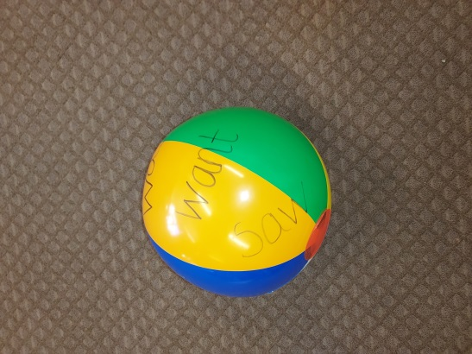
We have been busy in P1 this week continuing to learn our sounds and numbers. P2/3 have also been focusing on sounds and common words and looking at numbers and place value. Below are some of the activities which we use in class to develop these skills, they engage the children and the children enjoy them, which always promotes learning.

