P4 Class Newsletter

Welcome back. We hope that you all enjoyed a relaxing summer holiday. Please find below further information on the learning that will take place in P4 from August till December.

**Language**

**Reading**

The pupils will access a range of fiction and non-fiction texts during class, group and individual reading times. They will participate in reciprocal reading tasks to develop their higher order thinking skills and understanding of text.

**Writing**

Correct letter formation is encouraged at all times.

Pupils will focus on how to make their writing more interesting. They will explore the use of adjectives, connectives and a variety of openers to support them in up-levelling their writing, making it more engaging.

**Listening and Talking**

These skills are developed as pupils engage in daily class discussions. Pupils will be learning how to ask deep and interesting questions and to respond with detailed answers.

**Spelling**

Spelling words will be set each week in class. The words, and accompanying activities, will be sent home each week for revision.

Regular exposure to common words/ high frequency words is beneficial. Please look out for additional lists sent home.

Mr McKenna will be teaching French on Wednesdays.

The pupils are revising greetings/ personal information/ colours and numbers to 20.

They will also focus on the weather and Christmas in France.

**Maths/ Numeracy**

New group names as chosen by the pupils.

**Spheres**

Pupils will be learning how to estimate and round numbers to the nearest 100, demonstrating understanding of the rule for rounding up or down.

They will revise forwards and backwards number sequences up to 1000 and beyond, with a particular focus on bridging hundreds.

Pupils will identify the value of digits within numbers and will count on and back in steps of 1s, 10s and 100s.

**Cylinders and Cubes**

Pupils will be learning how to estimate and round numbers to the nearest 1000, demonstrating understanding of the rule for rounding up or down.

They will revise forwards and backwards number sequences for numbers which include 4 digits, with a particular focus on bridging hundreds/ thousands and numbers which are multiples of 10/ 100/ 1000.

Pupils will identify the value of digits within numbers and will count on and back in steps of 1s, 10s, 100s and 1000s.

All pupils will extend their knowledge of addition strategies and mental strategies.

They will be applying learnt skills when working on worded tasks and challenges.

Mr McKenna will focus on shape.

Pupils will name, identify and classify a range of 2D and 3D shapes. They will use mathematical language to describe the properties of shape.

.

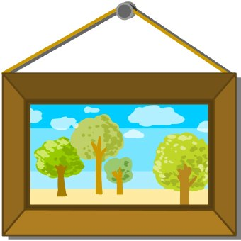

.

**Health and Wellbeing**

Health - We will be focusing on feelings and emotions.

P.E. – The class will have P.E. on Mondays with Miss Collins and on Wednesdays with Mr McKenna. We intend on making the most of the outdoor space for physical activities when possible and appropriate.

Please provide clothing which is suitable for indoor and outdoor lessons.

The main focus for the term is team games. The pupils will use a range of equipment, learning safe handling rules and developing a variety of skills.

**Social Studies**

This term’s topic is Scottish Islands. The pupils will learn more about the geography of Scotland, using atlases to support their learning. They will make links with a school from a different geographical area of Scotland.

They will consider Scotland’s transport links and accessibility.

During term 2 the focus will be houses, homes and climate.

**Expressive arts**

**Art** – We will be experimenting with line, tone and shade and exploring and extending patterns. They will learn more about different media and recognise the value of showing respect and care for artwork.

**Drama** – Activities will link to terms 1 and 2 topics, for example, extreme weather scenarios.

**Music** – The pupils will be listening to a variety of music. They will share their opinions and give justification. They will listen for different instruments within songs and participate in activities where they find and copy the beat.

**ICT and Technology**

Pupils have access to computers and use them to support their learning in many ways. They will revise internet safety and will gain independence when accessing a variety of software and websites.

We will be developing sewing skills.

**Religious and Moral Education**

The class will be learning about key beliefs of Islam.

They will also focus on the Festival of Light.

**Science**

The class will be learning about water during term 1.

Light, sound and waves will be our focus during term 2.

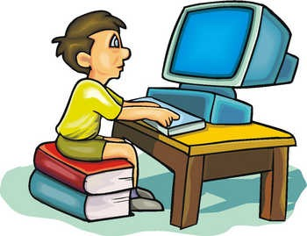

j0351860

**How to contact the school**

Telephone number: 01671 402 477

E-mail Address: gw08officeminnigaff@ea.dumgal.sch.uk

**Points of interest**

Please ensure all items of clothing are clearly marked with your child’s name.

Throughout the year we will be learning in the outdoors, please ensure your child has appropriate clothing everyday – warm coat, waterproof coat and footwear.

**Homework**

**Reading** – Reading books will usually be sent home to support and consolidate learning. **Please-** only read set pages as indicated in diaries. Discussing what has been read, making predictions and links to own experiences will support classroom learning and discussions.

**Spelling** – Handed out on Tuesdays, due back on Thursdays.

**Maths**- Tasks and activities will be issued when appropriate for consolidation at home.