P1/2 Newsletter August- December 2019

Miss Brown

**Useful Information**

Homework folders should be brought to school every day to enable class teacher to track progress and for the safe keeping of letters/notes etc.

Tasks will be detailed within the homework diaries. When complete, this should be signed by an adult. Occasionally, changes to timetable may result in homework not being updated. If this occurs, please continue to revise existing letter sounds/ word lists etc. Homework will be set at the start of the week and should be completed on the specified days to ensure relevant skills and knowledge have been taught/ introduced in school. **Please do not go on ahead as knowledge will not have been taught in class.**

Reading homework will be allocated through the week. Please only read what has been detailed in homework diary and focus on predicting and questioning with your child.

The pupils have the opportunity to earn ‘Golden Time.’ They are encouraged to be ‘Learners for Life’ who follow the ‘Golden Rules.’

Pupils can also earn points for their house team.

‘Pupil of the Week’ will have the special privilege of sitting on a special chair in class for the whole week!

**Things to remember**:

-Gym shoes should be worn within the school (some stock available from school office).

-Water bottles are to be used in class. These will be sent home daily for cleaning purposes. Please- water only.

-Tuck is available every day. Pupils are responsible for the safekeeping of their money.

Another option to consider- Mrs McClelland has offered to set up a bank system whereby parents/ carers could come in on Monday morning and deposit tuck money in a named pot. Change would be sent home with children on Friday. We hope this will reduce loss of money.

**Maths and Numeracy**

P1 pupils are learning about:

-Pattern and Relationships

The pupils will consider colour, size and shapes when identifying, continuing and creating patterns.

-Number and number processes.

The pupils will be learning number formation, counting strategies, sequencing and describing order.

-Addition and subtraction

They will be learning some language of addition and subtraction, +,- and = signs and learn to carry out basic calculations.

-Money

They will be using money in role play situations, recognising coins and identifying their value.

P2 pupils will revise the above and they will gain increased knowledge of the number system, considering tens and units and learning strategies to support them when counting on and back.

They will focus on addition and subtraction beyond 10 and will transfer this knowledge when working with money during practical tasks.

We will also be exploring 2D and 3D shape.

Pupils will use a range of resources and materials as part of an active learning approach.

Maths homework will be issued to support progress during some learning blocks.

**Language and Literacy**

Primary 1

The pupils are taught using a synthetic phonics programme*.* The children will participate in a wide range of multi-sensory activities to support their learning of letter sounds and formation. They will be working towards blending sounds together to enable them to read words confidently.

They will also learn common words which may include ‘tricky’ parts where letters are making different sounds.

Correct pencil grip should be encouraged at all times. The children have been practising their ‘froggy finger’ grip in class.

They are working hard on writing their own names to the very best of their ability.

MC900440428[1]

Primary 2

Pupils continue to progress through our spelling programme.

There will be a major focus on learning letter digraph sounds (when two letters go together to make one sound).

Correct letter formation should be encouraged at all times.

Pupils are developing knowledge of sentence structure.

Talking and listening skills are developed during regular story sessions and class discussions.

French

Mrs Gordon teaches French on a Monday. The pupils will be learning basic greetings and numbers to 10.

This session we are learning about

‘Fairy tales.’ where we will be focusing on reading different fairy tales. Following the pattern of the words and taking part in relevant activities.

If your child has a particularly favourite fairy tale please let me know and I will try and incorporate it into our block of stories.

**Health and Wellbeing**

Mrs Gordon teaches health on a Monday.

We are focusing on emotions and feelings.

Pupils are also learning how to develop and maintain positive relationships with their peers.

They will continue to develop personal hygiene routines such as hand washing and tooth brushing.

After the October holidays the class will focus on substance misuse and how to keep themselves safe is certain situations.

The class has P.E. on Wednesdays and Fridays. It would be beneficial to bring P.E. kit every day so a change of clothes is available if necessary.

On P.E days it would be beneficial if pupils would not wear any earrings or jewellery to prevent any damage or loss.

**Expressive Arts**

The pupils enjoy regular art and craft activities linking to their learning across the curriculum.

Pupil will be learning about different colours and experimenting with making and mixing their own colours.

During music pupils will focus on learning a rhythm and beat and how it can be played on percussion instruments.

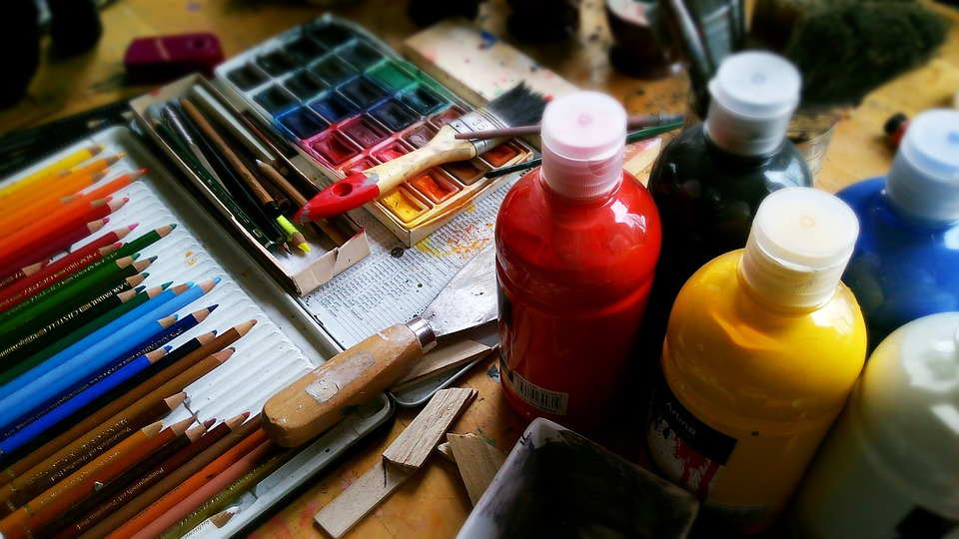



**Other Curricular Areas**

**Religious and Moral Education**

During term 1 the class will be learning the basics of Islam. During term 2 they will be learning about the Christmas story.

**I.C.T. and Technology**

Pupils have access to computers and an interactive Promethean board to support their learning.

They will be learning to access specific online games and software with greater independence.

Pupils will use our listening centre to enhance their learning in other curricular areas. They will also have opportunity to digitally record images and their voice during tasks.

j0195384

**Science**

The class will be learning about water. We will be learning about the different states of water (solid, liquid and gas) and taking part in some experiments to show these. We will also be learning about the water cycle and how important water is in our daily lives.