

Name:

*

*“Pupil support staff make close and meaningful relationships with children and young people. They are often best placed to hear children and young people’s views and experiences on the individual challenges they face and the support they need. Their contribution to discussions with teachers and school leaders about needs, strategies and planning for all children and young people is therefore essential. Educational establishments must ensure there is a forum and good opportunities for pupil support staff to contribute to professional discussion and access appropriate professional learning opportunities.” (Education Scotland, 2021).*



*“Pupil support staff make close and meaningful relationships with children and young people. They are often best placed to hear children and young people’s views and experiences on the individual challenges they face and the support they need. Their contribution to discussions with teachers and school leaders about needs, strategies and planning for all children and young people is therefore essential. Educational establishments must ensure there is a forum and good opportunities for pupil support staff to contribute to professional discussion and access appropriate professional learning opportunities.” (Education Scotland, 2021).*

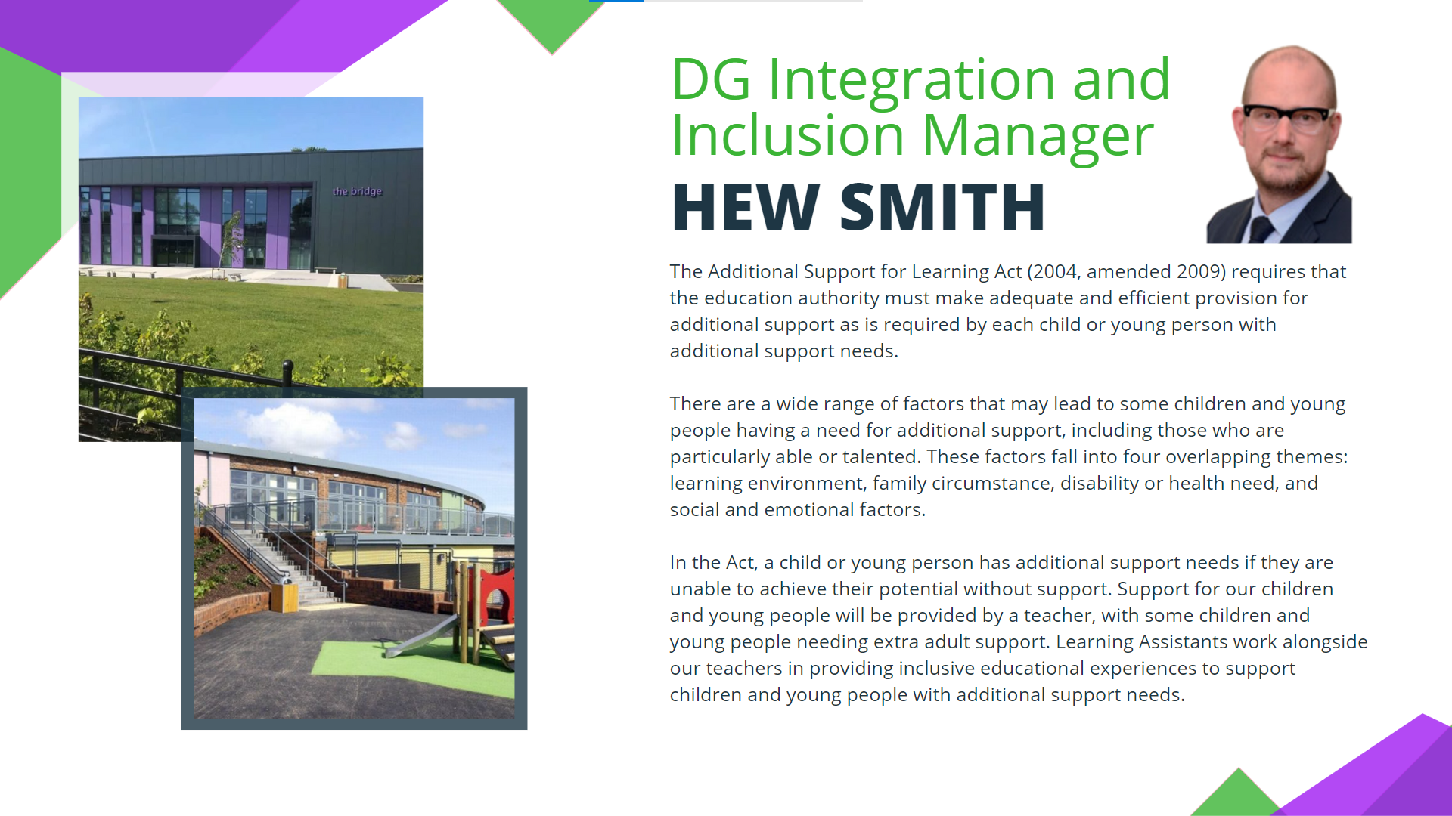

3

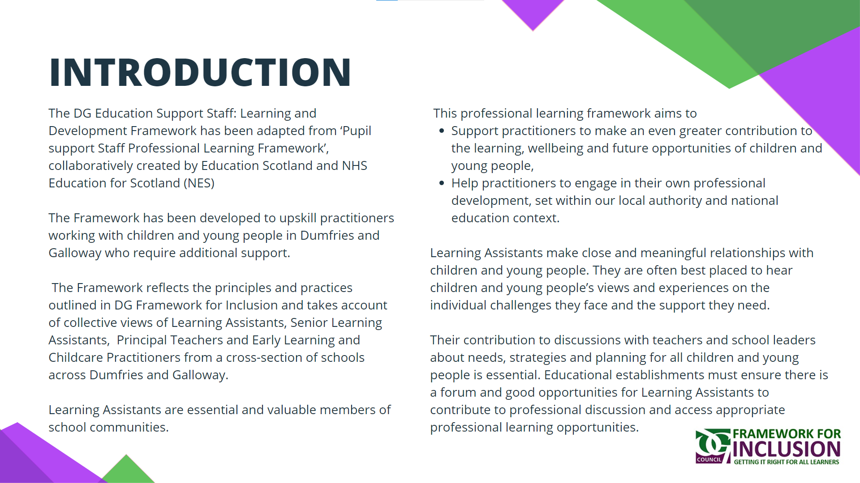

4

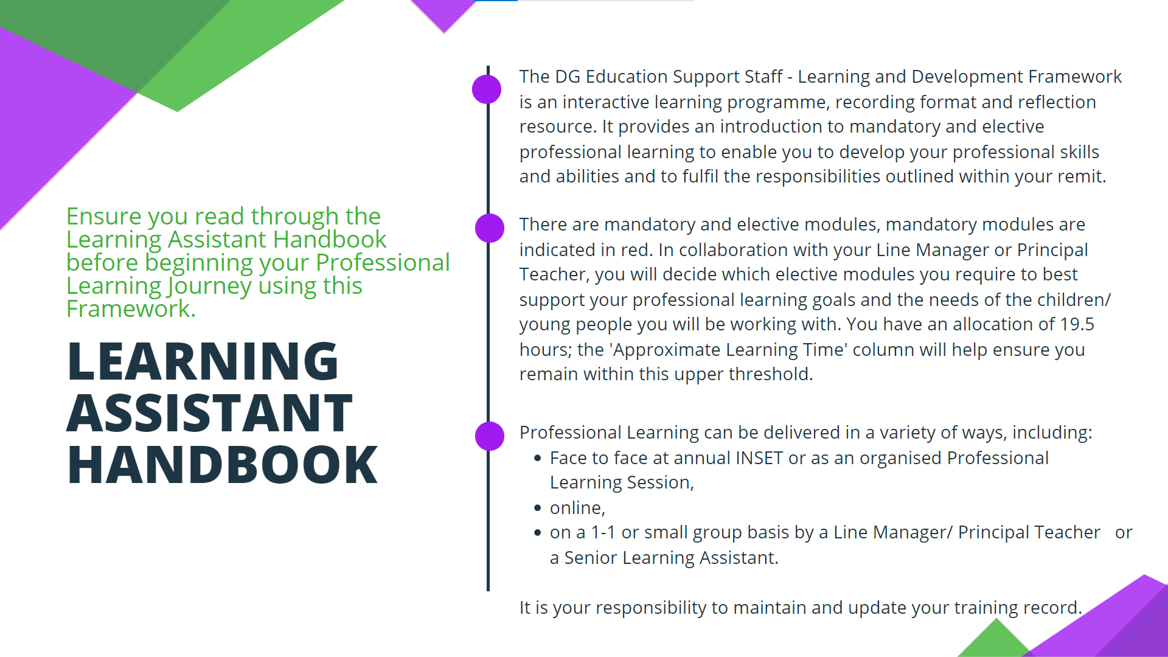

5

[Click here to watch 'Introduction to DG Learning and Development Framework'](https://sway.office.com/NiSt8xVbSzlAGICZ?ref=Link)

|  |  |  |  |  |
| --- | --- | --- | --- | --- |
| **Section 1** | | | | |
| **Scottish Educational context and knowledge** | | | | |
| **Subsets** | **Approximate Learning Time** | **Professional Learning** | **Reflections and Next Steps** | **Have you completed this subset? Please click below to select an option** |
| Scottish education context | 5 minutes  5 minutes | [Curriculum for Excellence](https://sway.office.com/sYWiFixSEdkiCj5S?ref=Link)  [GIRFEC](https://sway.office.com/sYWiFixSEdkiCj5S?ref=Link) | A[**broad general education**](https://education.gov.scot/education-scotland/scottish-education-system/broad-general-education/)**,** (often abbreviated to BGE )including well planned  experiences and outcomes across all the curriculum areas from the period from age  3 to the end of S3, covering all of the experiences and outcomes across all curriculum  areas up to and including the third level, and further experiences and outcomes at  the fourth level, chosen to provide greater specialisation and depth. This includes | No |
| UNCRC and Rights and Participation | 5 minutes | [An Introduction to United Nations Convention on the Rights of the Child (UNCRC)](https://sway.office.com/OD7DNros6TapmmA0?ref=Link) |  | No |
| GDPR | 5 minutes | [An Introduction to General Data Protection Regulation (GDPR)](https://sway.office.com/OrsDCjkkq9B0XnGO?ref=Link) |  | No |
| Responsibility of All | 4 hours  15 Minutes  10 Minutes | [respectme: Scotlands Anti-Bullying Service](https://sway.office.com/AxdicwiI6CCTdW3W?ref=Link)  [Health and Safety at Work, Accident/Incident reporting & Firesafety](https://sway.office.com/AxdicwiI6CCTdW3W?ref=Link)  [Conduct and use of mobile phones/ social media in a school setting](https://sway.office.com/AxdicwiI6CCTdW3W?ref=Link) |  | No |
| **Section 2** | | | | |
| **Communication and Collaboration: Developing Positive Relationships** | | | | |
| **Subsets** | **Approximate Learning Time** | **Professional Learning** | **Reflections and Next Steps** | **Have you completed this subset? Please click below to select an option** |
| The skills to build positive, trusting relationships with **children and young people** (mentoring and interpersonal skills) | 2 minutes  15 minutes  10 minutes  8 minutes  15 minutes | [How to support a child who makes a disclosure.](https://sway.office.com/UdnD3U9LlGfSPHfQ?ref=Link)  [Building positive relationships.](https://sway.office.com/UdnD3U9LlGfSPHfQ?ref=Link)  [Introduction to Trauma Informed Practice.](https://sway.office.com/UdnD3U9LlGfSPHfQ?ref=Link)  [Trauma awareness when supporting people who have a learning disability](https://sway.office.com/UdnD3U9LlGfSPHfQ?ref=Link)  [Why does ‘shaming’ not positively impact behaviour?](https://sway.office.com/UdnD3U9LlGfSPHfQ?ref=Link) |  | No |
| The ability to build positive relationships with **parents and carers** (language skills) | 10 minutes | [Effective Communication: Having difficult conversations.](https://sway.office.com/Ga7AHBgx8uDo2NIp?ref=Link) |  | No |
| The ability to build positive collaborative relationships with **other establishments, education and support staff** | Variable | [Building your professional network- Introduction to DG Learning Assistants Teams space.](https://sway.office.com/neMwe7YiwFsDdnle?ref=Link) |  | No |
|  | | | | |
| **Section 3** | | | | |
| **Child Wellbeing and Development** | | | | |
| **Subsets** | **Approximate Learning Time** | **Professional Learning** | **Reflections and Next Steps** | **Have you completed this subset? Please click below to select an option** |
| The ability to identify and respond to the **emotional, wellbeing** and **development needs** of children and young people | 5 minutes  5 minutes per section (5)  5 minutes  15 minutes (x2) | [What is Neurodiversity?](https://sway.office.com/i4lL77CnAyTV0Y3b?ref=Link)  [Introduction to Autism](https://sway.office.com/i4lL77CnAyTV0Y3b?ref=Link)  [Introduction to Dyslexia](https://sway.office.com/i4lL77CnAyTV0Y3b?ref=Link)  [Practitioner Inputs and practical advice.](https://sway.office.com/i4lL77CnAyTV0Y3b?ref=Link) |  | No |
| The ability to support **positive relationships and behaviour,** including **reducing distressed behaviour** | 1 hour | [Introduction to Nurture: The 6 Nurturing Principles.](https://sway.office.com/zFHWHLk34b52sSFP?ref=Link)  [Introduction to distressed behaviour and how to help.](https://sway.office.com/zFHWHLk34b52sSFP?ref=Link) |  | No |
| The **skills, knowledge** and ability to support children and young people | 5 minutes  20 minutes  5 minutes  15minutes per section  5 minutes  15 minutes  2 hours  10 Minutes  25 Minutes | **Curricular Support**  [Numeracy](https://sway.office.com/BsjdjVhUHAVgVQqL?ref=Link)  Strategies to support learners with **Numeracy and Maths**  **difficulties.**  Introduction to **Numeracy Launch Pads**  [Literacy](https://sway.office.com/BsjdjVhUHAVgVQqL?ref=Link)  Strategies to support learners with **Reading difficulties**.  Introduction to **Developing Balanced Literacy**- The Reading House  Strategies to support learners with **Spelling difficulties**.  [Health and Wellbeing](https://sway.office.com/BsjdjVhUHAVgVQqL?ref=Link)  [Mental Health and wellbeing- We all have mental health.](https://sway.cloud.microsoft/zFHWHLk34b52sSFP?ref=Link)  [DG HWB Site](https://sway.cloud.microsoft/zFHWHLk34b52sSFP?ref=Link)  [Tobacco and Vaping Support](https://sway.cloud.microsoft/zFHWHLk34b52sSFP?ref=Link) |  | No |
| The ability to **support language** and **communication development** in children and young people | 10 minutes per course. | [How to support effective communication (Certificated Modules)](https://sway.office.com/J1NnDI014cmEPUe1?ref=Link)  [Understanding Deaf and Hearing Loss (Login must be created)](https://sway.office.com/J1NnDI014cmEPUe1?ref=Link)  [Understanding Cerebral Visual Impairment (CVI)](https://sway.office.com/J1NnDI014cmEPUe1?ref=Link)  **SECONDARY ONLY**  [SQA Assessment Arrangements- Support](https://sway.office.com/J1NnDI014cmEPUe1?ref=Link)   * Practical Assistants * Prompters * Readers * Scribes |  | No |
| Safeguarding and Child protection | 10 minutes | [Child Protection and Safeguarding](https://sway.office.com/SHL6WVeVEv6ghFXv?ref=Link)  [Child sexual exploitation in Dumfries and Galloway](https://sway.office.com/SHL6WVeVEv6ghFXv?ref=Link) |  | No |
| **Section 4** | | | | |
| **Personal and Professional Development** | | | | |
| **Subsets** | **Approximate Learning Time** | **Professional Learning** | **Reflections and Next Steps** | **Have you completed this subset? Please click below to select an option** |
| The ability to drive **your professional development,** with the support of your school, employer and national agencies | 4 Hours  Year-long SCQF (level 6)  Qualification | Teaching Assistants: Support in Action.  [- Open Learn Course.](https://sway.office.com/SCZkWivK7AfD2jOT?ref=Link)  [PDA- Education Support Assistance (Run in conjunction with Dumfries and Galloway College)](https://sway.cloud.microsoft/SCZkWivK7AfD2jOT?ref=Link) |  | No |
| Being a Pupil Support practitioner in Scotland. | 1. minutes | [Learning Assistant: Handbook and FAQs](https://sway.office.com/HX0xcNtSpOYotgBl?ref=Link) |  | No |
| The ability to **effectively use IT** to support children and young people and for self-guided learning | 16 minutes  2 minutes | [Introduction to using GLOW](https://sway.office.com/ceMEFhIFTCiYrANq?ref=Link)  [Cyber resilience and Internet Safety](https://sway.office.com/ceMEFhIFTCiYrANq?ref=Link) |  | No |
| **Section 5** | | | | |
| **Wellbeing, Organisation and Creativity** | | | | |
| **Subsets** | **Approximate Learning Time** | **Professional Learning** | **Reflections and Next Steps** | **Have you completed this subset? Please click below to select an option** |
| The ability to adapt and **develop creative solutions** in the **classroom** or **other learning / support setting** | 2 minutes per video | The Creativity Toolbox- Education Scotland   * Creative approaches to problem solving and teamwork   <https://sway.office.com/X8MaVGrV5KHnzquz?ref=Link> |  | No |
| The ability to positively **manage your personal wellbeing** with the support of your employer and establishment team | 5 minutes | [Dumfries and Galloway Council.](https://sway.office.com/8n2Mf9ZM1SlWyoZJ?ref=Link)  [Your Wellbeing Action Plan](https://sway.office.com/8n2Mf9ZM1SlWyoZJ?ref=Link) |  | No |
| The ability to **plan**, with your line manager, for maximum**, positive impact** of pupil contact time | Variable | [Performance and Development Reviews (PDR) form](https://sway.office.com/fbucrzPVga6BZih4?ref=Link) |  | No |
| **A picture containing graphics, logo, font, graphic design  Description automatically generated‘Live’ Professional Learning Record**  Click here to access: [Live Professional Learning Directory 23-24.pdf](https://glowscotland.sharepoint.com/:b:/r/sites/dumfriesandgallowaycouncil/D%26GCouncil/DGCPD/Courses/Live%20Professional%20Learning%20Directory%2023-24.pdf?csf=1&web=1&e=Nzohlg) | | | | |
| **Course/ Session Title** | **Date** | **Hours to claim back?**  **(See** LA HUB- FAQs for more information**)** | **Reflections and Next Steps** | **Time sheet completed?**  **Please click below to select an option** |
| *e.g.*  *Meeting Learners Needs* | *Wednesday 15th November* | *3.30pm-4.25pm*  *(55mins)* | ***Autism- Top Tips:*** *We often have the closest relationship with the young people, so have confidence to share your insight/ knowledge/ recommendations with the class teacher. Small changes can make a big difference- too much perfume? Subtle noises?*  ***Ed Psyc:*** *PACE- Dan Huges. Think about using a Playful, Accepting, Curious and Empathetic approach. Use ‘I wonder’ instead of ‘You are being….’*  ***Relationship Rich Schools:*** *Nurture principles, children’s brains can be in ‘Saber Tooth Tiger Land’ be empathetic to this, Unconditional positive regard, teaching children how to behave is part of their learning- manage our expectations.* | No  Date: |
|  |  |  |  | No  Date: |
|  |  |  |  | No  Date: |
|  |  |  |  | No  Date: |
|  |  |  |  | No  Date: |
|  |  |  |  | No  Date: |
|  |  |  |  | No  Date: |

