**Bullying Behaviours**

We follow the national ‘Respect Me’ guidance on approaches to anti-bullying. It can be found here: [Respect for All - The National Approach to Anti-Bullying for Scotland's Children and Young People (Nov 2024)](https://www.gov.scot/binaries/content/documents/govscot/publications/advice-and-guidance/2024/11/respect-national-approach-anti-bullying/documents/respect-national-approach-anti-bullying-scotlands-children-young-people/respect-national-approach-anti-bullying-scotlands-children-young-people/govscot%3Adocument/respect-national-approach-anti-bullying-scotlands-children-young-people.pdf) . We also follow local guidance and have created our own anti-bullying policy for our school.

The national definition of bullying is:

***“Bullying is face-to-face and/or online behaviour which impacts on a person’s sense of physical and emotional safety, their capacity to feel in control of their life and their ability to respond effectively to the situation they are in.***

***The behaviour does not need to be repeated, or intended to cause harm, for it to have an impact. Bullying behaviour can be physical, emotional or verbal and can cause people to feel hurt, threatened, frightened and left out.”***

***(Respect Me, 2024)***

Bullying is both **behaviour** and **impact**; what someone does and the impact it has on the person’s capacity to feel in control of themselves. We call this their sense of ‘agency’.

All reports of bullying behaviour will be taken seriously and investigated by the Child Protection Co-ordinator (Headteacher, Depute Headteacher or Nursery Manager). Bullying is a violation of the UNCRC, now enacted in Scots law.

**Kirkcudbright Primary School**

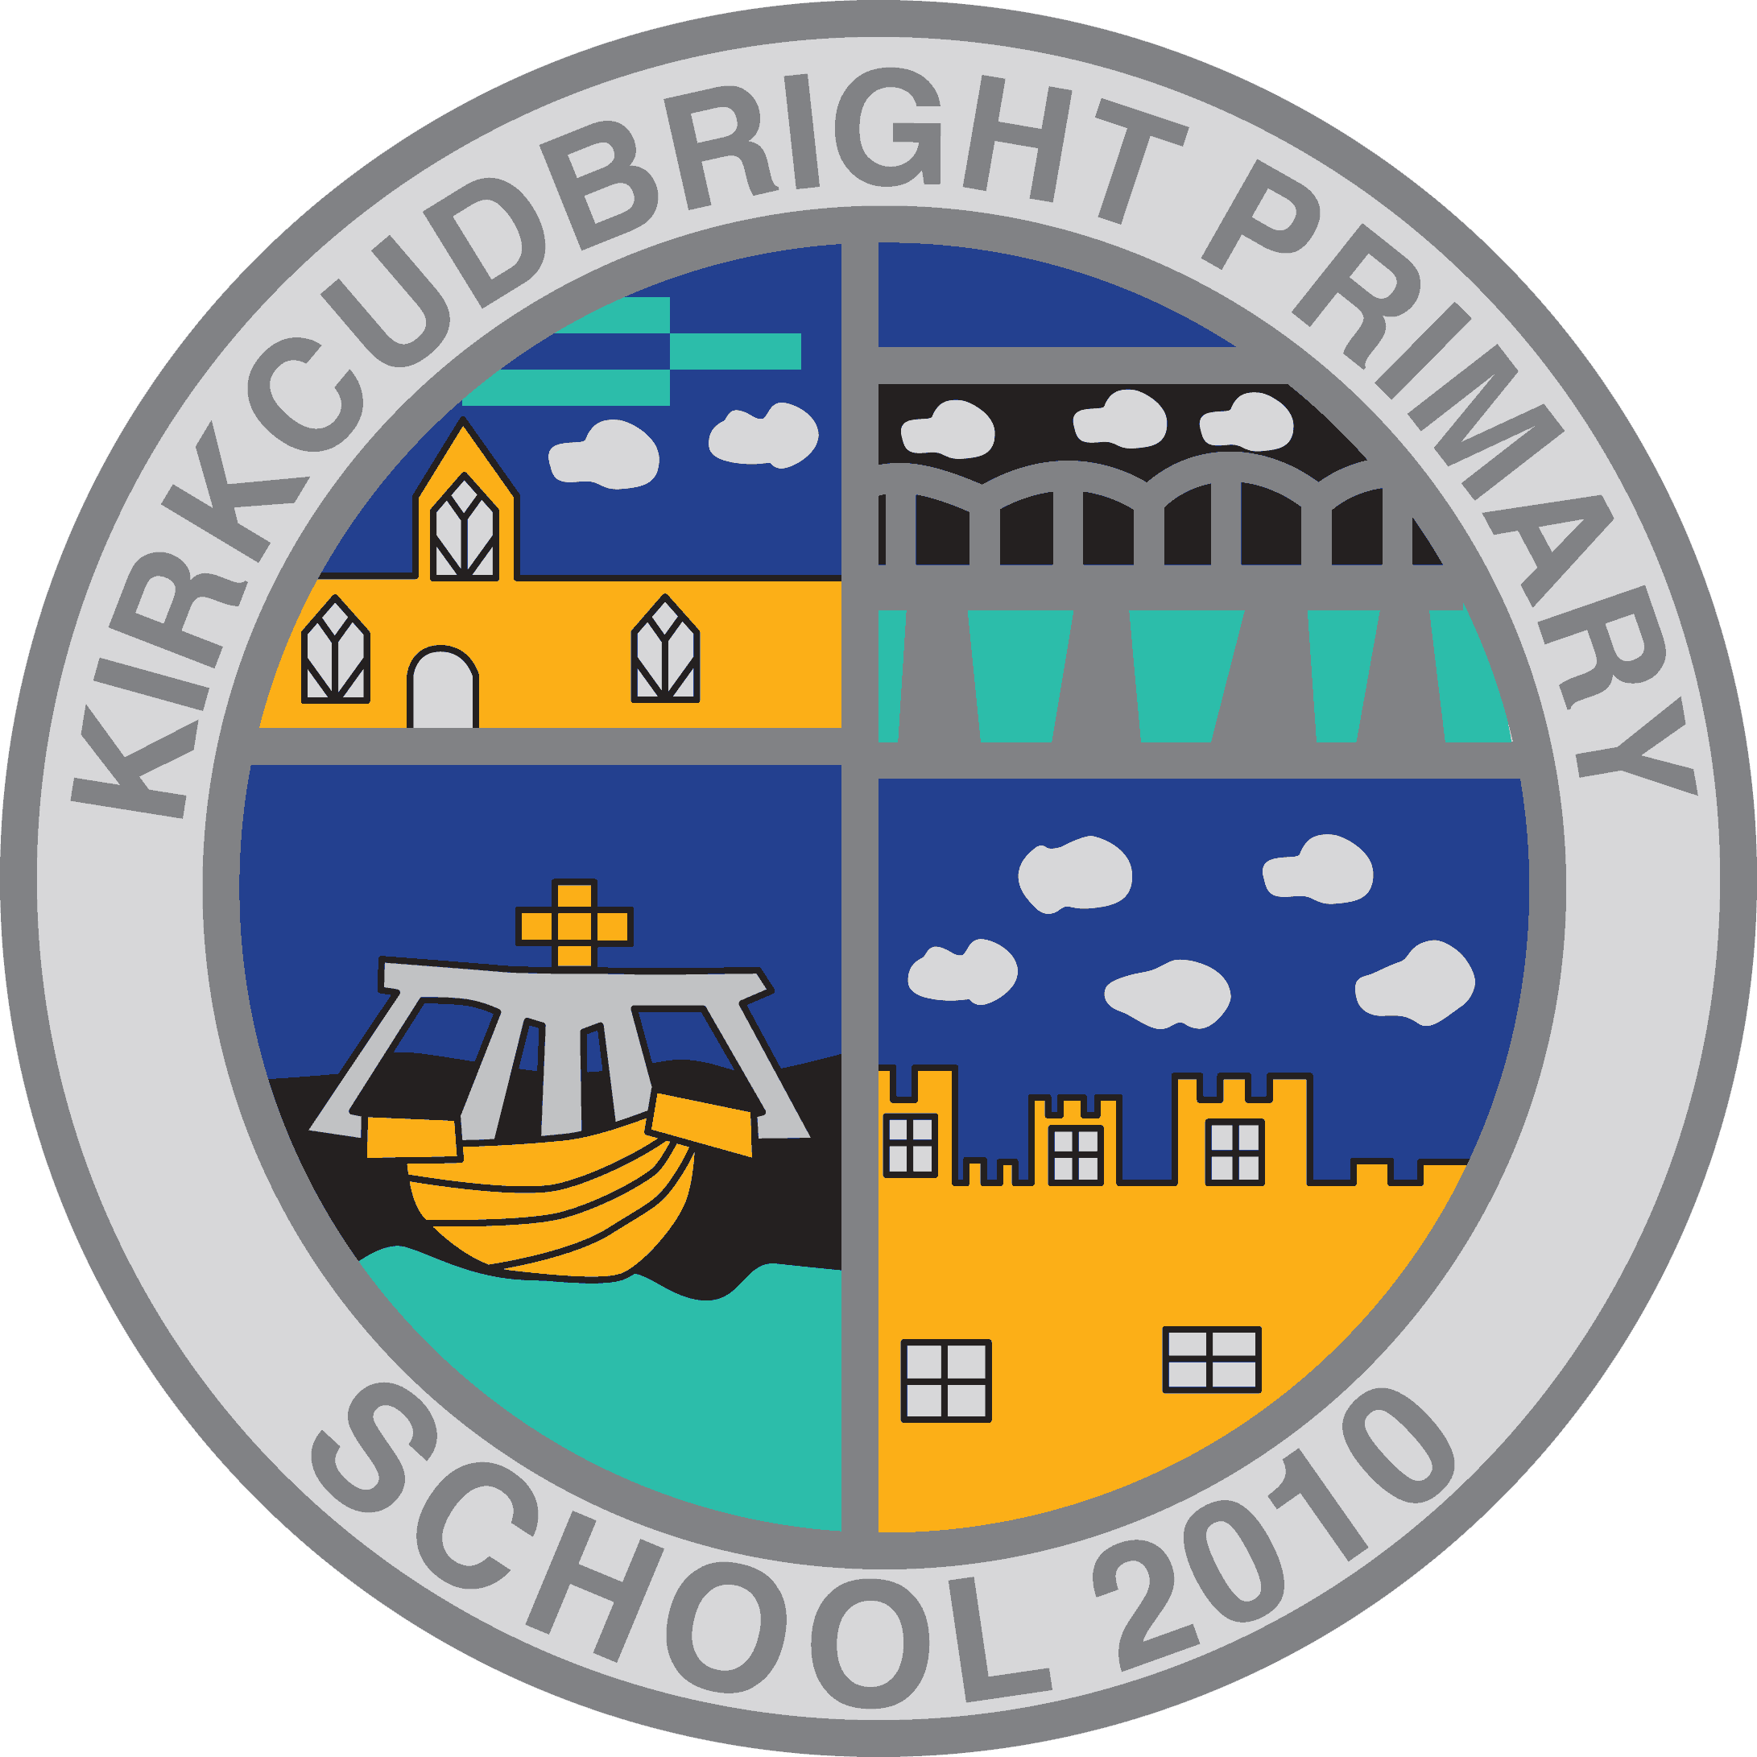

**Promoting Positive Relationships**

**Why are ‘positive’ relationships important?**

The values we have are reflected in our behaviour. In our school, we model positive and respectful relationships which creates a safe and nurturing learning environment for all. Our shared vision and values clarify our expectations around maintaining positive relationships:

This is because we want to:

* feel healthy, happy and ready to learn
* feel cared for, safe and respected
* demonstrate high standards of behaviour and learning
* support each other to reach our full potential, and
* learn in a variety of ways to develop our knowledge and skills

**Rewarding Positive Behaviour**

We have five Houses – King, Hornel, Oppenheimer, Sassoon and Taylor. Using appropriate classroom points systems, learners are awarded House points for demonstrating our values in their words and actions. We have weekly assemblies where house points are shared and celebrated. Each term, an extra playtime is given to the successful House. At the end of the session, overall House winners receive a trophy and a small reward.

Learners share their successes and achievements in a variety of ways including during class news time, assemblies, via our school Facebook page, via email and in our local newspaper. They also receive verbal praise, stickers and certificates in class to celebrate achievements.

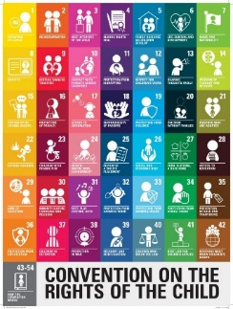**Class and Playground Charters**

Every child has Rights. It is important that our actions respect the Rights of others. We expect adults and children to conduct themselves in a way that ensures these Rights are upheld. We create class and playground charters detailing the individual class expectations based upon our school values and the UNCRC. Class charters are linked to our school values and are displayed.

**Supporting Learners to Correct Behaviours**

We use our Mood-o-meter and coloured ‘zones’ to support learners in recognising their feelings and behaviours so that they can take appropriate action, independently or with support, to stay in the green ‘I’m me’ zone.

* Adults explain which value the child is not following and encourage them to use a ‘Green Tool’ to move back to the ‘Green Zone’. (This is done orally and never displayed.)
* If a child continues to display unacceptable behaviour from the class charter then they will receive a verbal warning from an adult and a reminder to use their ‘Green Tools’.
* A second warning results in 1:1 support to use their ‘Green Tools’ from an adult – Leadership team, a teacher or a Learning Assistant.
* Repetitive behaviours will result in the child ‘paying back’ missed learning time at another time such as break, lunch time or at home.
* At a suitable time and when the child is calm, a restorative conversation will take place with the child and the adult who was impacted by their behaviour to set goals for the next day.
* EACH DAY is a new start to enable children to review, reflect and achieve success again.

**Restorative Conversations**

Restorative conversations encourage us to reflect on the impact of our behaviours, repair relationships and realise that we can make choices leading to better outcomes.

The five restorative questions we use are:

1. What happened?
2. What were you thinking at the time?
3. What have you been thinking since?
4. What impact has this had on the other person?
5. How can we prevent it from happening again?

Consequences will always be logical, related to the situation, have a focus on learning and should take individual needs and capacity into account. This may mean that responses vary for individuals because their needs are different. The approach will remain consistent with a focus on repairing the harm caused, preventing it from happening again and returning to and refocussing on the learning as quickly as possible.

**Consequences of Persistent Disruptive Behaviours**

* Time out in another class or with the leadership team.
* A phone call home to inform parents/ carers of ongoing issues.
* Individual behaviour supports and strategies will be put in place to help the child integrate positively into the classroom.
* The Headteacher/ Depute headteacher will monitor progress and support discussions with the child, parents/ carers and staff.
* If we believe that there may be an underlying barrier to learning then we will follow the ‘D&G Stages of Intervention’ model to ensure that a bespoke plan is in place to support individuals.

**Exclusion**

Exclusion is a last resort and will only be used when all efforts at prevention and early intervention have been exhausted. The period of exclusion can be up to 10 days or for an extended period to provide time for a bespoke, targeted support plan to be created to facilitate a return to education, whether in the same establishment or elsewhere.