

A b c d e f g h I j k l m n o o p q r s t u v w x y z



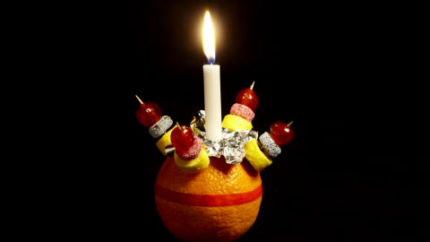

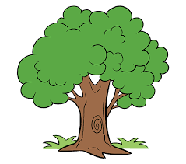

**Modern Languages French**

Reinforce Greetings, Classroom language, Days of the week, Months and Colour. Numbers to 30. Weather expressions.



Kirkcudbright Primary School

2023-2024 P3

**Expressive Arts**

Art & Design Topic/Seasonal linked art. – Mrs Philip



Music – Topic and seasonal with Mrs Philip and Mr McClure – hymns, Christmas songs.

**Literacy/English**

* Reading
* Weekly homework.
* Topic related reading/weekly library time.
* Topic related and general comprehension.
* Phonic sounds revision/progression through programme 3.
* Reading in the curriculum.

Writing

* Narrative and recount writing based on writing targets.
* Setting and description in writing.
* Weekly Spelling.
* Grammar – alphabetical order, sentences and plurals of nouns.
* Handwriting practice – letter formation and linking letters in handwriting.

Listening & Talking

* Group discussions/Circle Time.
* Listening for information activities.
* Listening skills activities.

**Outdoor Learning –**

Visits to the wooded area next to the school to complete a variety of activities linked to topic work and other curricular areas. Dress warmly!

**Technologies**

Continue to develop Digital Literacy Skills including word processing and saving work.

Use Paint, Google, Word and other computer resources to reinforce learning in maths, language and topic.

Coding using code.org – Write instructions for the computer. Continue with course A, moving to B.

**Health & Wellbeing**

Participation - with Mrs Philip.

Take part in class activities and help plan for Christmas Fayre activities. Recognise and discuss achievements in and out of school.

PE – Mrs Philip– Throwing, catching and ball skills in games including football.

Dance – Social dance related to Christmas.

Daily Mile

**RME**

**Mrs McLeman**

**Christmas**

Recap the Christmas Story.

The Christian symbolism of the visits of the shepherds and the Magi at Christmas.

The plight of homeless people at Christmas.

**Maths/Numeracy**



**Number, Money, Measure**

Number Processes/Place Value

Counting and place value to 1000 working with hundreds, tens and ones to improve understanding and application of place value.

Addition and Subtraction.

Continue adding and subtracting vertically and horizontally within 20 then within 100.

Continue to speed up add/subtract number bonds within 20.

Mental Maths/ Maths Talk

Continue to extend strategies for solving questions mentally within 20 to be applied beyond 20.

Multiplication and division – 2x 5x 10x tables.

Shape – 2D and 3d shapes including square based pyramid, triangular prism, pentagon and hexagon.

**Social Studies**.

Needs and Wants.

Housing.

Looking at housing in the local area.

Thinking about things we need and things we want, personally and in the community and the differences between these.

Find out about organisations which meet the needs of people and groups in the community.