**Kirkcudbright Primary School**

**Nursery P1: READY! STEADY! GO!**

People Who Will Help Me

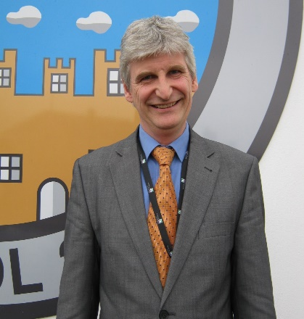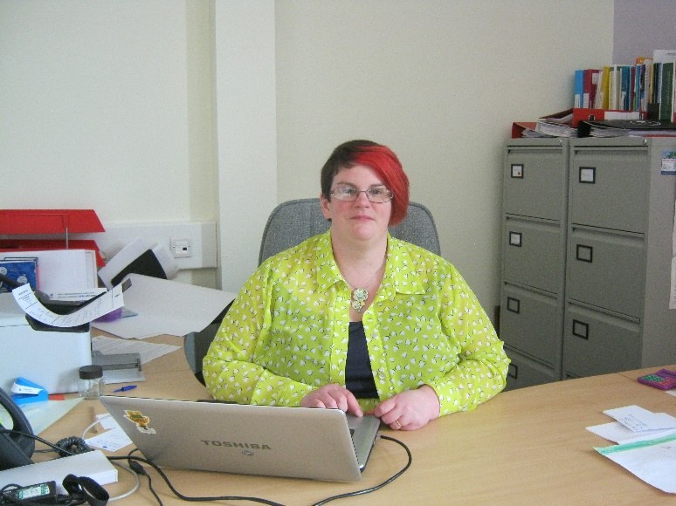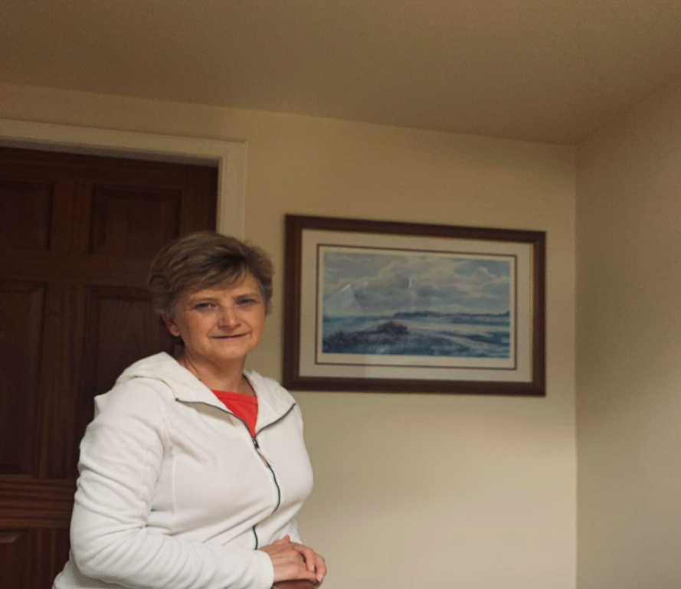

Mr Stevens

**Head Teacher**



Mrs McClelland

**Depute Head Teacher**

Mr Flannighan

**P1F Class Teacher**

Mrs McMillian

**P1M Class Teacher**



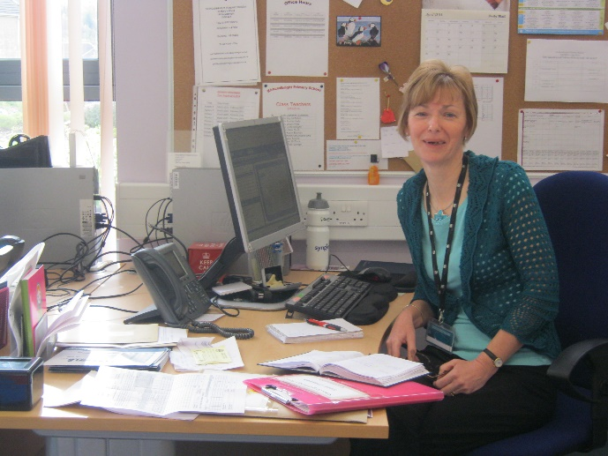

Darren Toole

**Facilities Manager**

Tricia McCombe

**Playground Supervisor**

Mrs Eccles

**Office Staff**