**PlF**

**Ready**

**Set**

**Go**

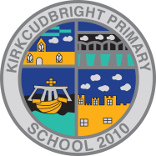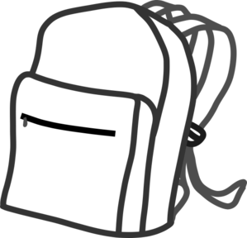

**‘My First Day’ - Essentials Items**

* Uniform.
* School bag.
* Pants/socks (store in school bag).
* P.E. Bag.
* P.E. Kit, including gym shoes (store in P.E. bag).
* Art shirt (adult size **old** t-shirt).
* Water bottle.
* Snack (one **small** ‘snack’).

Please add a **name label** to as many items as possible.



**‘My First Day’ - Essentials Items**

* Uniform.
* School bag.
* Pants/socks (store in school bag).
* P.E. Bag.
* P.E. Kit, including gym shoes (store in P.E. bag).
* Art shirt (adult size **old** t-shirt).
* Water bottle.
* Snack (one **small** ‘snack’).

Please add a **name label** to as many items as possible.

**PlF**

**Ready**

**Set**

**Go**

