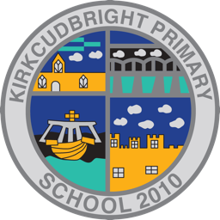
Kirkcudbright Primary School
Nursery P1: READY! STEADY! GO!

Preparing for P1 - Learning Activities
Encourage your child to dress/undress themselves folding the clothes when they are finished with them | Encourage your child to hold pencil, crayon, paintbrush properly and practice applying pressure to make marks. | Mark make with chalks, pens, pencils, paints etc. Talk about the colours and as you do so ask them to point to the colours and then ask them which colour is red, blue etc.
Encourage your child to put their shoes on properly, take them off and put them away. | Show your child how to write their name with a capital at the beginning and then lower case letters. | Mark making using shaving foam, sand, flour, mud - make shapes and help your child to name them. Draw zig zags, wavy lines, straight lines etc.
Can your child put on and fasten their coat? Do they need to practise doing and undoing zips and buttons? | Can your child recognise their name or part of it? Make name cards and place around the house e.g. bedroom door, coat peg, fridge door etc. | Encourage your child to draw a picture of themselves- can they add detail- eyes, nose mouth, hands, and fingers?
Can your child go to the toilet independently and wash their hands correctly? | Can your child use cutlery correctly? Show them how to cut up their food and encourage them to do it independently. Get them to open packets of crisps and biscuits and share them out. | Can your child recognise numbers? Hide numbers around the house/garden and see if your child can recognise them. Look for numbers in the environment when you are out walking.
Encourage your child to hold scissors correctly. Snipping paper to make grass, cutting out pictures etc | Story time- explore your favourite story, draw your favourite character, see if your child can relay the story back to you. Can they answer who/what/when/where questions? | Loose parts play-build a tower, castle, make a vehicle, a bridge- use your imagination! Can they draw a plan of their creation and discuss it? Perhaps they need to draw a map to reach their castle, etc.

