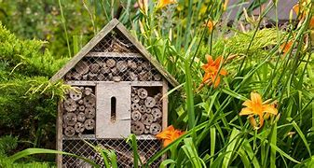

Hedgehog Homes & Bug Hotels
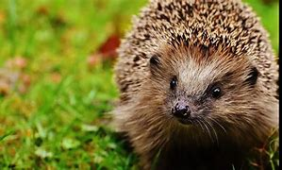
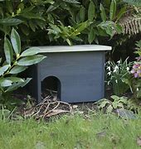

Kirkcolm and Leswalt Eco Groups are looking for some old wooden planks, or just old wood so we can try and build hedgehog homes and bug hotels. We pupils want to try and include animals into our everyday lives. This will help possibly get our green flag renewed for the THIRD time! And, most of the pupils have said it would be great to see hedgehogs and bees wondering and flying around the playground. Also, it means that we, as a community, can try and improve the amount of animals in our village.
Thank you!

