If you need to contact us about anything regarding your child then please email us and we will get back to you asap. If it is an urgent matter, please phone the school.
Mrs Clanachan (Mon, Tues, Wed) gw10clanachancarolyn@glow.sch.uk
Mrs Sim (Wed, Thur, Fri) gw08simrachel1@glow.sch.uk
LITERACY  In Writing, we will be continuing our focus on tools for writing by using connectives.  In French, we will be learning to describe ourselves.   | NUMERACY  In Numeracy we will be focusing on ‘Adding and Subtracting’.  In Topic Maths we will be focusing on ‘Time’, in particular converting between analogue and digital time.
EXPRESSIVE ARTS  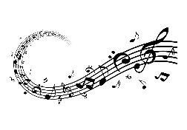  Our focus this term will be Music and Dance. We will be continuing our weekly sessions with Grant Dinwoodie from ‘Ram Tam’. We will learn about key aspects of music such as beat, rhythm, pitch and tempo.  We will be sharing this learning with parents in a class concert towards the end of the term. More information to follow! We will be learning traditional Scottish dance during P.E. | A BIG Plea  Please make sure your child’s name is clearly labelled on ALL items of clothing.  If your child likes to play on the grass pitch during break/lunch then please send them with a spare pair of old trousers/joggers. The pitch can get very muddy and this helps to protect their uniforms and the classroom carpets.  We still have some pupils without indoor shoes – please support us with this.
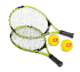  HWB in Term 2  PE is every Wednesday and Thursday –  On a Wednesday please bring your P.E kit to school in a bag.    On a Thursday, please come to school wearing your P.E kit but bring your school uniform in your bag. P.E kit should include joggers/leggings/shorts, a t-shirt and suitable shoes for outdoor PE. Your school cardigan/jumper will also be worn. We will be using the changing rooms beside the school hall to change this year.  Our Wellbeing focus this term is ‘Included’. | Library Visit  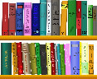  Our Library Visit this term will be on Thursday 7th November. Please send your child to school with their library card (if possible) and any books they have to return.  No P.E. kit needed on this day.
Homework
Spelling and Reading homework will continue as last term.
Sumdog challenges will be set monthly. Pupils can complete these during a time that suits them, if they wish to do so.
IDL    Our IDL topic this term will have an RME focus. We will be exploring stories from world religions, to show an understanding of some of their key beliefs and values. We will be looking at a variety of religions from across the world, starting with Judaism as picked by the pupils in the class. | 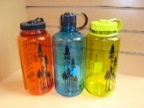  WATER BOTTLES / SNACK  Please remember to send in a bottle filled with water every day for your child - no juice please, and a small snack every day too. Only 10 minutes is given to snack so ideally send something that can be accessed and eaten easily. REMEMBER NO NUTS OR NUT PRODUCTS.  This includes many chocolate spread products – e.g. Nutella, Nutoka.

