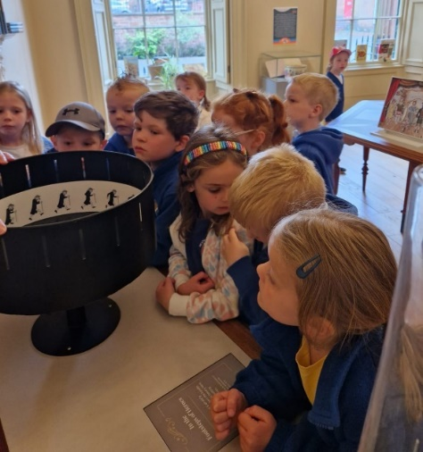

Heathhall School
Supporting Our Pupils
2022 -2023
At Heathhall we welcome and encourage the involvement of all partners in promoting effective learning for children to enable them to develop skills for Learning, Life and Work across all aspects of the curriculum.
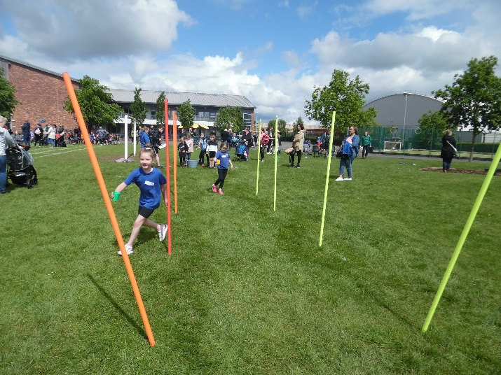
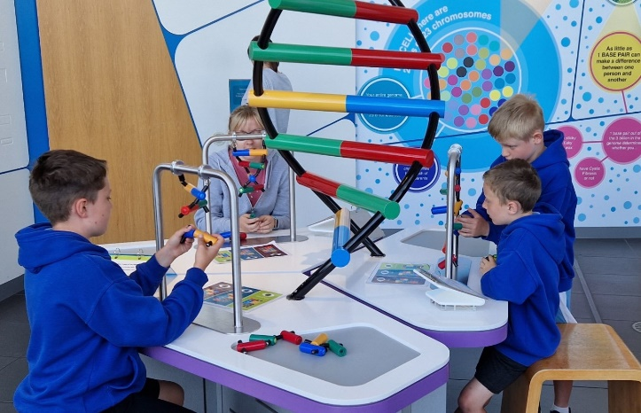

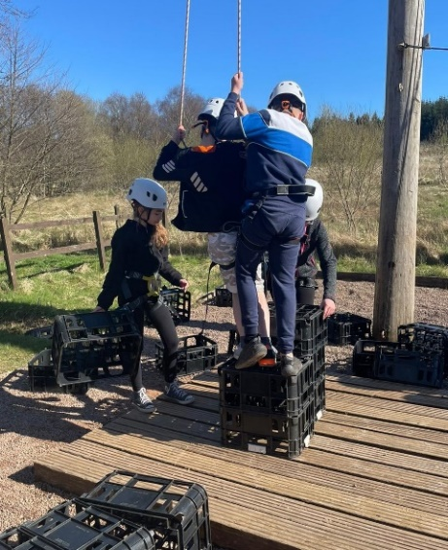
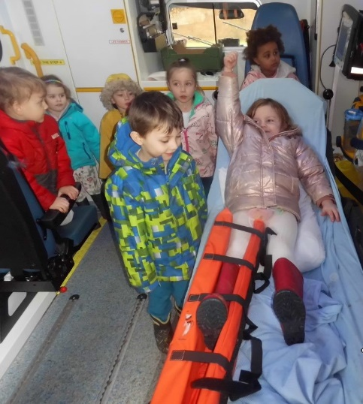

HEATHHALL SCHOOL – SUPPORTING OUR PUPILS
SESSION  2022-2023 | PUPILS INVOLVED | OTHER PARTNERS INVOLVED | DETAILS OF ACTIVITY / EVENT
Over the school year pupils at Heathhall have a number of opportunities where Curriculum for Excellence is delivered through partnership working. All staff at Heathhall work with partners to deliver learning and other experiences. This will vary from year to year but this list provides an idea of the variety of partners we have worked with during 2022-2023.
Activities which take place on a regular basis throughout a term or over the year.
 | Individuals in P5, P5/6, P6 | Mr D Bass (D&G Instrumental Music Service) | Guitar tuition for individual pupils in P5 and P5/6
 | Individuals in P5/6, P6 & P7 | Mr Irving (D&G Instrumental Music Service) | Drumming tuition for individual pupils in P6 & P7
 | Individuals in P5/6 | Mr Renwick (D&G Instrumental Music Service) | Clarinet and Violin tuition for individual pupils in P5/6
 | Various classes | Active Schools | Lunchtime football club which pupils can opt into: Term 1 optional for P4 and P5 pupils. Term 2 – Optional for P3 pupils
 | Individuals from various classes | Mrs Brown | Digital Leaders after school club.
 |  | Mr Allison – Active Schools | After school group (Thursday) – Badminton
 | P 6 & P7 | Ann Robinson | After school group (Tuesday) - Badminton
 | P5-P7 | Mr Ross/Mr Sharp | After school football club
 | P6 to P7 | Miss Renwick | After school Netball
 | P5 to P7 | Miss Russell | After school hockey – Term 3
 | P6 & P7 | Mrs R Topping | P6 and P7 Pupils Book Club (Group of 10 pupils)
 | Nursery | Lochthorn Library staff | Visiting nursery every two weeks to read stories to the children
 | P5 to P7 | Mrs Clanachan/Mrs Scott | Before school – Cross country training
 | P4 | Mrs Brown | After school - Coding club
 | Whole school | Lochthorn Library | Visit Lochthorn Library as part of literacy learning (Each class makes one visit each term)
 | P5 | Mrs Copeland/Mrs Lynn | After school gardening group – developing our sensory garden and Outdoor classroom areas (Term 4)
 | Group from P5 to P7 | Miss L Lundy | After school club – Ukulele (Block of 4 weeks in Term 4)
 | P2 | Mrs H McKirdle | After school club – Construction (Term 4)
September
 | P1/2/3 | Scottish Book Trust | Pupils all receive free Book bags through the Read, Write, Count programme. Aims to build parent’s confidence in including fun reading, writing and counting activities in their everyday lives.
 | Nursery | Maths Weeks Scotland OWL & parents | Outdoor maths sessions during morning with parents supporting outside maths activities and learning opportunities
 | Whole school | Rev. Mhairi Wallace | Visit from Church of Scotland Minister Rev. Mhairi Wallace from Tinwald, Kirkmichael & Torthorwald Parish
 | Nursery | Parent/carers | Nursery Information Event – General nursery information, routines, sharing of learning, parent participation in new Nursery Vision, Value and Aims
 | Nursery | Parent/carers | Questionnaire and collation of views made by parents who could not attend Nursery Information Event
 | Nursery | Parent/carers | Come and Play sessions over two weeks
 | Nursery | Jade – Community support from Tesco, Peel Centre | Supplied and supported the children to make healthy fruit smoothies for snack time
 | P5/6 P6 & 7 Pupils | Active schools | Hockey coaching – Rules of the game, player’s position/role within the team and hockey tactics.
 | P2/3 | Community Safety Team | Skills Academy – Our Community topic - Community Officer and Seagull Officer visited pupils to talk about their role in the community.
 | Whole School | Community Police officer | Information/Discussion session during Assembly about the role of a Police Officer and keeping safe in the community (Particularly area around the old Gates factory)
 | P2 | Amey Cleaning Staff | Staff introduced to P2 class – Linked to respect for our environment and expectation of looking after our classroom and school
 | P6 | Dumfries Ice Bowl | Introduction to the sport of Curling and an opportunity to try it out.
 | P6 | Jade – Community Champion from Tesco | Supplied fruit to support the children to make healthy fruit kebabs as part of the Food and Health topic during Skills Academy.
 | Whole School | Make It Happen | Presentation on App Design to all classes – Pupils app design competition
October
 | P1 and P1/2 | Forest Schools | Classes took part in maths activities outdoors. Parents were invited in to share in the pupils’ learning.
 | Nursery | Child smile | Observing tooth brushing in nursery and a tooth brushing talk with the Child smile puppets
 | P7 | Multi-agency Emergency Services/Health & Safety | Operation Safety–Home fire safety, escape plans and electrical safety as well as information from Police Scotland and Scottish Ambulance Service.
 | Whole school | NHS Nursing team | Flu vaccinations – Links to world of work and developing awareness of reasons for vaccination programmes
 | P7 | Dumfries High School | ‘Play in a Day’ Health and Wellbeing / Drama day for P7 pupils (Part of transition to secondary school activities)
 | P7 | Dumfries High School | Transition visits from Mr Cubbin, Headteacher at Dumfries High School
November
 | P4 to P7 | Maths Roadshow | Workshops for all classes on Maths
 | Whole School | Queen of the South Football | Coaching for all classes in football skills and playing as a team.
 | P4 and P4/5 | Feis Rois | Traditional Youth Music Initiative - Learning about Scottish Music and developing skills in this area.
 | Whole school | Poppy Appeal Scotland | Raising awareness of Poppy Appeal and what it means  Money donated was given to Royal British Legion
 | Primary 7 | Aviation Museum & Community Council | Attend and lay a wreath at Remembrance service at Aviation Museum, Heathhall.
 | Whole School | Parents/Carers | Parent/Pupil/Teacher Talk Time – Opportunity for all to discuss pupil progress.
 | Whole school | Children in Need | Raising awareness of what this charity does – Pupils took opportunity to take part in “Wear what you want” Children in need day and gave a donation.
 | Nursery | Parent/carers | Come and Play sessions over two weeks
 | P1 and P1/2 | Heathhall Community | Linked to Skills Academy the pupils were exploring the local community to find out about local amenities.
 | Whole School | Community Safety Team & Recycling officer | Andrew Hay from the D&G Community Safety Team & Recycling officer visited to speak to pupils at Assembly about safety in our environment.
 | Group of pupils | Mr Sharp | Visit to the Glasgow Emirates Arena to spectate – Girls in Sport - Billy-Jean King Competition
 | P2/3 | Thomas Robertson (Bagpiper) | Thomas visited P2/3 on St Andrew’s Day to play his bagpipes. P2/3 were learning about Scottish culture.
 | Whole school and Nursery | Bethan Cubbin (Bagpiper) | Visited all classes to play Scottish music as part of school’s St Andrew’s day celebrations.
 | P7 | Drax UK | Drax representative – GSC Learning Lab – Meet the expert
December
 | Whole School | First Base Charity | Mark Franklyn from First Base Charity in Dumfries attended a whole school assembly to speak to the pupils about the work they do providing food packs for families and individuals in need. Pupils had taken part in a “Wear What you Want” day and donated food products to the Charity First Base.
 | P4 | Heathhall Friendship group | Pupils from Primary 4 class visited the Heathhall Community Centre to provide Christmas entertainment.
 | P7 | Glasgow Science Centre | Showcase and investigation stations following Learning Lab
 | Nursery | Dunelm | Children & Parents donated gift for 5 Christmas Tags to the ‘Delivering Joy’ appeal for older people and animals in our community.
 | Nursery | Parents/Carers | Christmas Carol celebration in Nursery Garden.
 | P1, P1/2, P2, P2/3 & P3 | Heathhall Community | People are invited from our local community to visit us for our Christmas Performance Dress Rehearsal. Children also visit from Little Acorns nursery and First Steps Nursery.
 | P1, P1/2, P2, P2/3 & P3 | Parent/Carers | Christmas Show performance – ‘Christmas around the World’
 | P4 | Parents/Carers | Christmas entertainment for Parents/Carers – Songs and poems
January | P4 &P4/5 | Feis Rois | Sharing our learning event to Parents/Carers – Clan Gathering – singing scots/gaelic songs, performing dances
 | Whole School | Robert Burns Day | Whole school ‘Wear a touch of tartan’ Classes learning about Scottish Culture and Robert Burns
 | P4 | DG One | Swimming lessons (3 weeks – Tue/Wed/Thur)
 | Whole School | Make It Happen | Presentation of App design Winners
 | Nursery | Lochthorn Library Staff | Visiting nursery every two weeks to read stories to the children
February | P5 – P7 | Royal Navy | Science/Technology/Engineering and Mathematics (STEM) Activities
 | P5 | Robert Burns Centre | “Remembering Rabbie” workshop where pupils were learning about the life of Robert Burns, Scottish poet in Dumfries.
 | Nursery, P1 to P3 | Emily Smith | Youth Music Initiative – Singer/ song writer working with pupils who are learning about music and songs through PLAY.
 | Nursery | Parents/Carers | Come and Play sessions over two weeks
 | Whole School | Parents/Carers | Parent/Pupil/Teacher Talk Time – Opportunity for all to discuss pupil progress
 | P1 | Childsmile | Stephanie visited class as part of their learning in Health and Well Being.
 | P1 | Julie Stevens | Local author and artist speaking to children about creating stories as part of their Literacy learning.
 | Nursery, P1 & P1/2 | Ambulance –Paramedics  Police Officer  Fire Service | Learning about actions to take to help someone in an emergency and how medicines can be used in a safe way to improve health.
March | Whole School | Irish Dance Group DDMIX for Schools (Online link) | During an assembly whole school took part in a live Irish Dance session to celebrate St Patrick’s day.
 | Whole School | Sustrans | Big Walk and Wheel event Monday 20th March to Friday 31st march 2023 – Promoting walking, park & stride, scooter or cycling to develop fitness and improve the environment.
 | Whole School | Sustrans | Dress up and Bling your bike competition – celebration at end of Big Walk and Wheel event.
 | P5, P6 & P7 pupils | Mrs Clanachan, Mrs Scott & Mr Sharp | Before school - Cross country club
 | Nursery | Parent | Parent came in to talk about the language Urdu and teach the children some words as the children have been asking to learn words in different languages.
 | Nursery |  | People in the work place – A nursery pupil’s Dad came in to talk about where milk comes from and milk production as he works on a dairy farm.
 | Nursery | Jill - Crossing Patrol | Jill spoke to the children about Road Safety.
 | Nursery | The Frothy Bike Co. Dumfries | Children and staff went to the Frothy Bike Co. in Dumfries to collect 3 balance bikes that they gifted the nursery to support Play on Pedals learning
 | Whole School |  | Past pupils who have excelled in their sport visited the school and spoke to the children and answered pupils’ questions – Faye Henderson - Curling, Stephanie Grant – Football and Netball, Skye Rae – Distance runner.
 | P5, P6 & P7 pupils | Mr Sharp | Cross country club
April
 | P6 | Rock UK | Residential Trip - Experience of outdoor education
May
 | Whole school | Sustrans | Learn to Ride/Skills type sessions are run for a variety of age groups, from P1 to P7 and cover a range of skill levels from ‘Ditch the stabilisers’ varieties to advanced skill sessions.
 | Nursery | Parent/carers | Potted Sports Day  Parents supporting child to take part in various sports activities within the nursery garden.
 | P6 & P7 | Fire Safety Officer | Learning about fire safety and what to do in an emergency
 | P6 | Dumfries High School | Science event – Crime Scene Investigation activity day. An opportunity for pupils to work in a science context and meet and work with pupils from DHS cluster primary schools looking towards transition to secondary school.
 | P6 | Active Schools | Sports leadership and team building skills.
 | Nursery Pupils | Active Schools | Team building skills
 | P6 | Rock UK | Residential Trip - Experience of outdoor education.
 | Whole school | Parents/Carers | Open afternoon event – Parents/carers visit their children’s classroom to share in their learning
 | Whole School | Sarah Kirkpatrick | Sarah Kirkpatrick, Lead Resuscitation Officer worked with individual classes as well as speaking to pupils at assembly about her career as a nurse.
 | P1 to P7 | Sustrans | All classes had the opportunity to use the pedal powered smoothie bike. This stationary bike is used to power an attached blender to make healthy nutritional smoothies as well as promoting wellbeing and exercise.
 | Whole School | Dumfries Young Carers Centre | Visitor to Assembly –Emily Davies spoke to the pupils about the work of the Young Carers Centre in Dumfries and how this can help young people.
June
 | Group of P6 Buddies | Little Acorns Nursery | Groups of children visit nursery to introduce themselves to children joining Heathhall School in August 2023 as part of our transition process.
 | P4/5, P5, P5/6 and P6 | Glasgow Science Centre | Visit to Science Centre with interactive activities and linked to various Interdisciplinary context e.g. The Water Cycle
 | P5 to P7 | Nithsdale Active Schools Community Sport | Nithdale primary hockey festival
 | Nursery | Parents/Carers | Pre-school children parents Come and play sessions
 | Nursery | Parents/Carers | Moving On Ceremony for children moving on to P1. Parents invited
 | P5 to P7 | Miss Renwick | Netball festival
 | P1 and P1/2 | Moat Brae | Visit to Moat Brae linked to literacy learning.
 | P7 | Alba printers | Working with P7 teachers to compile and produce Primary 7 yearbook.
 | P6 | Dumfries High School | CSI day – Science investigation day at Dumfries High School – opportunity to become more familiar with the secondary school and the science department.
 | P7 | Dumfries Young Carers Centre | Emily Davies visited P7 class to share the work of the Young Carers Centre answering any questions pupils had.
 | P7 | D&G Fire and Rescue Service | Officers from fire and rescue service speaking to pupils about safety around water, safety in the community around empty buildings, fire safety messages
 | Whole School | John Caskie | Visitor to assembly – Speak to the pupils about the history of Guid Nychburris
 | Whole School | Glasgow Children’s Hospital | Visitor to Assembly – Julie Price from Glasgow Children’s Hospital charity
 | Whole school | Guid Nychburris | Visit from Cornet, Cornet’s Lass, Lynors, Queen of the South & her attendants.
 | Individuals from P6 and P7 | Guid Nychburris Football | Guid Nychburris Football Competition P7 and P6 teams
 | P7 | Parents/Carers | Leavers presentations and performance to parents.
 | P2, P2/3, P3, P4 | Royal Highland Education Trust (RHET) | As part of their IDL context – Living Things and learning about food journeys in HWB pupils took part in various activities including: visiting a local farm, lambs visiting Heathhall school, a tractor visiting Heathhall School from Cornthwaits Agricultural Group, making butter from milk and an ice cream tasting.
 | P7 | Dynamic Earth, Scottish Parliament buildings, National Museum of Scotland, Edinburgh. | Edinburgh Residential Trip – Opportunity for pupils to apply their learning in real life contexts and experience the city environment.

