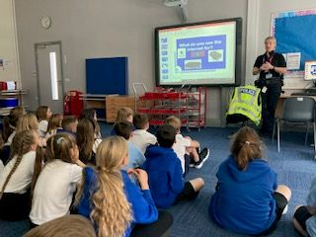


Heathhall School
Supporting Our Pupils
2024 -2025
At Heathhall we welcome and encourage the involvement of all partners in promoting effective learning for children to enable them to develop skills for Learning, Life and Work across all aspects of the curriculum.
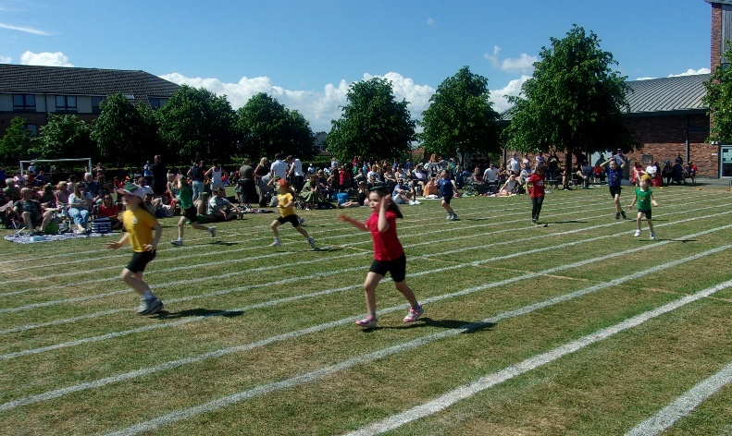
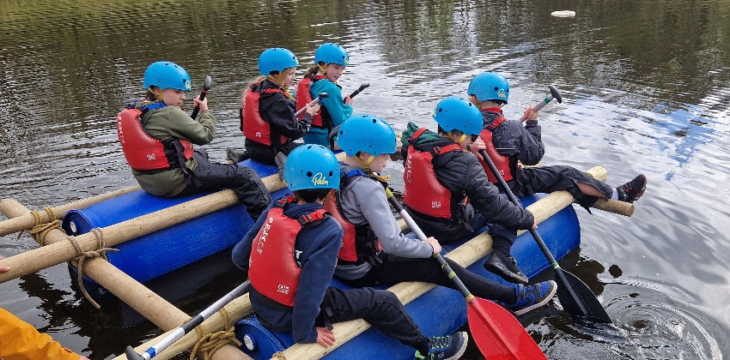


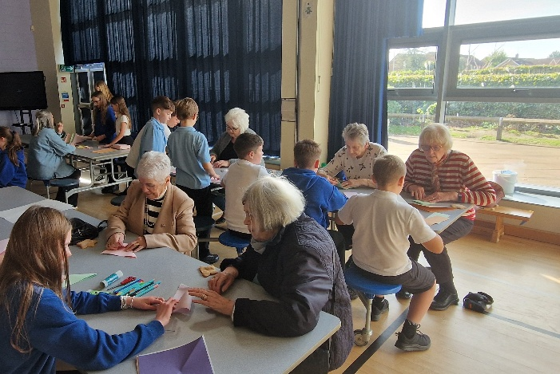



HEATHHALL SCHOOL – SUPPORTING OUR PUPILS
SESSION  2024-2025 | PUPILS INVOLVED | OTHER PARTNERS INVOLVED | DETAILS OF ACTIVITY / EVENT
Over the school year pupils at Heathhall have a number of opportunities where Curriculum for Excellence is delivered through partnership working. All staff at Heathhall work with partners to deliver learning and other experiences. This will vary from year to year, but this list provides an idea of the variety of partners we have worked with during 2024-2025.

Activities which take place on a regular basis throughout a term or over the year.

 | Individuals in P5, P6, P6/7 and P7 | Mr D Bass (D&G Instrumental Music Service) | Guitar tuition for individual pupils in P5/6, P7R & P7B
 | Individuals in P5/6, P6, P6/7 & P7 | Mr Irving (D&G Instrumental Music Service) | Drumming tuition for individual pupils in P5, P5/6, P6 & P7R
 | P4D, P4S, P5 and P5/6 | Active Schools | Lunchtime football club which pupils can opt into across the school year.
 | Individuals from P7 classes | Mrs Brown | Young Digital Leaders lunchtime club (Takes place throughout the year)
 | P2/3 | Active schools | After school club - Games
 |  | Mr Allison – Active Schools | After school group (Thursday) – Badminton
 | P6 & P7 | Ann Robinson | After school group (Tuesday) - Badminton
 | P5-P7 | Mr Sharp | After school Football Club
 | P6 to P7 | Miss Renwick | After school Netball Club
 | Nursery | Tesco | Nursery children work with a member of nursery staff and order food items from Tesco Supermarket through online shopping for Nursey Snack.
 | Nursery | Lochthorn Library staff | Visiting nursery every two weeks to read stories to the children
 | P5 to P7 | Mrs Clanachan/Mr Sharp | Before school – Cross Country training (January to March)
 | P4 | Mrs Brown | After school - Coding Club led by pupil digital leaders (Term 4)
 | Whole school | Lochthorn Library | Visit Lochthorn Library as part of literacy learning (Each class makes one visit each term)
 | P1-P7 | Mrs Copeland | After school gardening group – developing our sensory garden and Outdoor classroom areas
 | P1 and P7 | Child Smile | Leadership opportunity for P7 pupils who encourage and help P1 pupils in tooth brushing. (Throughout the school year)
 | P1 to P7 | Mrs Copeland | After school Gardening Club
 | P4 – P5 | Mr Irving | After school Girls Football Club
 | Nursery | Heathhall Community | Community walks following maps and plotting routes/ taking photos
 | P1 to P7 | P7 Pupils and Mr Sharp | Go Noodle – Fun active dance breaktime club which pupils can opt into
 | P5 to P7 | Mrs Hannay | Lunch time Chess Club – which pupils can opt into across the school year
 | P3 to P7 | Mr Sharp | Summer Golf After School Club. Opportunity for pupils to learn skills for golf.
September
 | All P7 Pupils | Dumfries High School | ‘Play in a Day’ Health and Wellbeing / Drama Day for P7 pupils (Part of transition to secondary school activities)
 | P6 | Sustrans | Bikeability course – Learning cycling skills and road safety while cycling
 | P6 | Sustrans | Learning how to look after and maintain a bicycle, puncture repair etc.
 | P2/3 | Amey Staff | Lenor and team visit to P2/3 class to share and discuss their role in the school – looking after the classrooms, corridors, toilet facilities etc
 | P4S | Mrs Darrant | Sushi making linked to Literacy – writing a procedure.
 | Whole school | Parents/Carers | Open afternoon event – Parents/carers visit their children’s classroom see them in their new learning environment and celebrate the launch of update to Heathhall School Developing Positive Relationships Policy
 | P1 and P7 pupils | Child Smile | Learning about the correct way to brush our teeth.
 | Nursery | Parent/Carers | Come and Play sessions over two weeks
 | Whole school | Rev. Mhairi Wallace | Visit from Church of Scotland Minister Rev. Mhairi Wallace from Tinwald, Kirkmichael & Torthorwald Parish
 | Whole School | Sustrans  Mrs Woods/Mrs Sim | i-Bike Crew encouraged pupils to cycle to school 23rd-27th September. Pupils could come to school wearing bright clothing and they could have a bike breakfast at school.
 | P4S | Mark Gallagher  Personal Trainer | P4 pupils were learning about how to improve their physical health through regular exercise and healthy eating.
 | Nursery | Nithsdale Veterinary Practice | Nursery children visit to local Veterinary practice to follow their learning as they were playing at looking after animals and being vets in the nursery.
 | Nursery | Childsmile | Stephanie visited to introduce the children to Flossy the Childsmile dinosaur and talk to the children about brushing their teeth.
 | Nursery | Lochthorn Library staff | Visiting nursery every two weeks to read stories to the children
 | Nursery | P6 children | Supporting nursery children with digital technology learning experiences
 | P4D | Alex Bryson  Personal Trainer | As part of their learning about a ‘Healthy Body’ pupils learnt about healthy eating and exercise.
October
 | P4S | Dumfries High School Sports Leaders | Pupils from DHS delivered P.E lessons to pupils
 | Nursery | Child smile | Observing tooth brushing in nursery and a tooth brushing talk with the Childsmile puppets
 | P7 | Multi-agency Emergency Services/Health & Safety | Operation Safety – Home fire safety, escape plans and electrical safety as well as information from Police Scotland and Scottish Ambulance Service.
 | P4 to P7 | Police Scotland | Community police officer – Speaking to pupils about the use of social media – what is appropriate and where to go for advice/help
 | P5 to P7 | Heathhall Community | Celebration of Older Person’s Day – Children spent time with older visitors from Heathhall community. Pupils served shortbread they had made, and they led activities e.g. chair aerobics, bingo, singing and craft activities.
 | Whole school | NHS Nursing team | Flu vaccinations – Links to world of work and developing awareness of reasons for vaccination programmes
 | P1/2/3 | Scottish Book Trust | Pupils all receive free Book Bags through the Read, Write, Count programme. Aims to build parent’s confidence by including fun reading, writing and counting activities in their everyday lives.
 | P1 and P1/2 | Heathhall Community | Cross curricular links with Numeracy/Literacy pupils took part in a Heathhall Hallowe’en Walk
 | P5 and P7 | DRAX Power | P5 engaged in a webinar Hydroelectric power in Scotland (Global science/Climate change etc)
 | P5 and P6 | Razmataz | Health and Wellbeing – Classes had a workshop taster session on dance.
 | Nursery | Lochthorn Library staff | Visiting nursery every two weeks to read stories to the children
 | Nursery | Parents | Parents invited to Bookbug sessions every two weeks
 | Nursery | Drumming Group | 20 children visited the Heathhall Community Centre to hear and join in the Drumming Group
 | Nursery | Heathhall Community | Cross curricular links with Numeracy/Literacy pupils took part in a Heathhall Hallowe’en Walk
 | P2/3 | Lochthorn Library | P2/3 shared a book review to be displayed at Lochthorn Library
November
 | Nursery | Local shops e.g. Nisa | Groups of nursery pupils visit the local Nisa store to help buy ingredients for baking and cooking or as part of their snack.
 | Whole school | Poppy Appeal Scotland | Raising awareness of the Poppy Appeal and what it means.  Money donated was given to Royal British Legion
 | Primary 7 | Aviation Museum & Community Council | Attend and lay a wreath at Remembrance service at Aviation Museum, Heathhall.
 | Whole School | Parents/Carers | Parent/Pupil/Teacher Talk Time – Opportunity for all to discuss pupil progress.
 | Whole school | Children in Need | Raising awareness of what this charity does – Pupils took the opportunity to take part in “Wear what you want” Children in need day and gave a donation.
 | Whole school | Sustrans | Scooter week – encouraging us to be more active. Pupils have two slots over the week developing their skills on scooters
 | Nursery | Parent/Carers | Come and Play sessions over two weeks
 | Nursery | Parents | Parents invited to Bookbug sessions every two weeks
 | P7 | Dumfries High School | Transition visits from Mr Cubbon, Headteacher at Dumfries High School
 | Nursery | Lochthorn Library staff | Visiting nursery every two weeks to read stories to the children
 | Nursery | InStep Dance Studio | Dance session in nursery for all the children delivered by dance teacher
 | Nursery | Heathhall Community & school | Work Kindness Day – delivering Kindness cards to Nithsdale Vet, First Steps, Nursery, NISA, Hairdressers, Little Acorns Nursery and various staff and classes in the school
December
 | All P6 Pupils | Dumfries Ice Bowl | Introduction to sport of Curling
 | All P7 pupils | Dumfries High School | ½ day visit to Dumfries High School – learning about school life in secondary school.
 | Whole school | Rev. Mhairi Wallace | Visit from Church of Scotland Minister Rev. Mhairi Wallace from Tinwald, Kirkmichael & Torthorwald Parish during Assembly
 | Whole school | iBike-Sustrans | Leg it to Lapland challenge 2nd-6th Dec 24 – all pupils encouraged to walk/cycle/scooter to school – improving active physical health.
 | P4S and P4D | Ramtam with Grant Dinwiddie | Pupils took part in several workshops learning to play the Ukulele as well as songs with rhyme, rhythm and repetition
 | P4S & P4D | Ramtam with Grant Dinwiddie | Parent/Carers were invited to share their children’s learning. Pupils played the Ukulele and sang songs.
 | Nursery | Parents/Carers | Christmas celebration in Nursery.
 | Nursery | Other local nurseries | The children made and then posted Christmas Cards to nurseries in the Dumfries area.
 |  | Heathhall Community | People are invited from our local community to visit us for our Christmas Performance Dress Rehearsal. Children also visit from Little Acorns Nursery and First Steps Nursery.
 | P1-P3 | Parent/Carers | Christmas show performance
 | P5 – P7 | Heathhall Community | Visitors from Heathhall community – Pupils served shortbread they had made, and they sang Christmas songs to entertain their visitors.
 | P4S | Vicky Purdie NHS | As part of their learning about ‘How to deal with emergencies’ in Health and Wellbeing, pupils had experience of learning how to do chest compressions on the Call Push Rescue (CPR) manikin.
 | P7R | Liz Mansen  D&G Council | As part of an IDL topic Liz spoke to pupils about ‘Diversity’ - people’s differences including culture and religion
January
 | P4D and P4S | DG One | Swimming lessons (3 weeks – Tue/Wed/Thur)
 | Whole School | Sustrans Scotland – Dr Bike | Opportunity to learn about how to look after your bike and have a bike service
 | Whole School | Robert Burns Day | Whole school ‘Wear a touch of tartan’ Classes learning about Scottish Culture and Robert Burns
 | P7 | Community Police Officer | Community Police Officer speaking to pupils about use of social media
 | Nursery | Big Burns Supper family initiative | All parents involved in a lantern making workshop held in the nursery for Big Burns Supper.
 | Whole school | Sustrans | Pedal Powered bike – Pupils experienced using a pedalled static bike to generate an electrical charge to power a ‘smoothie maker’
February
 | Whole school | Rev. Mhairi Wallace | Visit from Church of Scotland Minister Rev. Mhairi Wallace from Tinwald, Kirkmichael & Torthorwald Parish during Assembly
 | P5 | Gent Explorer | 4 x online sessions with a focus on META skills especially ‘Collaboration.’
 | Whole School | Parents/Carers | Parent/Pupil/Teacher Talk Time – Opportunity for all to discuss pupil progress
 | P5 – P7 | Active schools | Regional Badminton Competition
 | All pupils P6 to P7 | Sustrans | Doctor Bike – After school session on bicycle maintenance
 | Whole school | Digital Leaders | Safer Internet day activities
 | P7 | Soundtrap | Pupils took part in a digital music workshop
 | P1 | Sustrans | Ditch the Stabilisers – Children had opportunity to learn to ride a bike with no stabilisers
 | Nursery | Cargenbridge and Dalbeattie nurseries | Our children spoke to the children at Cargenbridge and Dalbeattie nurseries via Teams on the interactive board.
 | P7R & P7R | Sustrans | Transition to Secondary school bike ride – P7R & P7B pupils had the opportunity to cycle to DHS along the cycle path as an example of a way to travel independently to school. This is an eco-friendly way to travel and helps keep us fit and healthy.
 | Whole School | Solway Sharks Ice Hockey Team | Representative players from Solway Sharks visited Heathhall School. They talked about education and skills required to succeed e.g. teamwork, resilience, communication, focusing etc
March
 | P1 | Parents/Carers | Open afternoon event – Parents/carers visit their children’s classroom to share in their learning
 | P7 & P7 | Active Schools | Cross Country - regional championships and national championships
 | Whole School | Sustrans | Big Walk and Wheel challenge – Aim to inspire pupils to make active journeys to school 24th to 28th March 2025
 | Whole School | World Book Day | Scottish Book trust work with partners to support teachers and families in Scotland to celebrate World Book Day with children
 | Nursery | Ambulance Service | Talk about what paramedics do to help us. Children went on the ambulance, sat on the bed, heard the medical machine noises and had their pulse taken with the finger monitor.
 | Whole School | Comic Relief Charity | Children take part in Comic Relief Day learning about organisations that tackle poverty, conflict and climate change. They raise money to donate to the charity.
 | P3 | Police Scotland | Dumfries Community Policing Cyber Resilience / Internet Safety - PC McClung
April
 | P6 | Rock UK | Residential Trip - Experience of outdoor education
 | Nursery  And P1 | Police Service | Police talked about how they help us. Children handled different parts of the police uniform and equipment. Children sat in and looked around the Police Van.
 | P3 | Young Writers | Pupils’ poems published in book ‘Monster Acrostics 2025 – Fun Fiends’
 | Whole School | Sustrans | Big Bike Breakfast club event
May
 | Whole school | Sustrans | Learn to Ride/Skills type sessions are run for a variety of age groups, from P1 to P7 and cover a range of skill levels from ‘Ditch the stabilisers’ varieties to advanced skill sessions.
 | Nursery | Parent/Carers | Potted Sports Day  Parents supporting child to take part in various sports activities within the nursery garden.
 | Nursery | P7 Digital Leaders | P6 Digital Leaders came into nursery and worked on coding with nursery children.
 | P5 to P7 | Fire Safety Officer | Learning about fire safety and what to do in an emergency.
 | P6 | Dumfries High School | Science event – Crime Scene Investigation activity day. An opportunity for pupils to work in a science context and meet and work with pupils from DHS cluster primary schools looking towards transition to secondary school.
 | P6 | Active Schools | Sports leadership and team building skills.
 | Nursery Pupils | Active Schools | Team building skills
 | Whole school | Rev. Mhairi Wallace | Visit from Church of Scotland Minister Rev. Mhairi Wallace from Tinwald, Kirkmichael & Torthorwald Parish
 | Whole school | Parents/Carers | Open afternoon event – Parents/Carers visit their children’s classroom to share in their learning with a numeracy focus.
 | Nursery Pupils | Parent/Carers | Open Afternoon – Celebration of our children’s learning in Heathhall Nursery
 | P7 | Dynamic Earth, Scottish Parliament buildings, National Museum of Scotland, Edinburgh. | Edinburgh Residential Trip – Opportunity for pupils to apply their learning in real life contexts and experience the city environment.
 | Whole school | Parents/carers | School sports day
 | P6 and P7 | Active schools | Sprint relay event
 | P3 | Barony College  Dumfries Ice Bowl  Open Reach  Natural Gas  Natural Gas | STEM Career visits focusing on the application of meta-skills in the World of Work and making links to the use of meta-skills in our learning:  Dairy Scientist/Senior Scientist Vet Lab/Teaching animal care Barony College (N Porter)  Duty Officer at Dumfries Ice Bowl (C Jardine)  Open Reach: Telecommunications Engineer (R Walker)  Natural Gas: Head of Operations and Technical Admin (T Robertson and G Robertson)  NHS Pharmacist Technician and Trainee Pharmacist (D Davidson & R Rose)  Working on a sailboat (G Porter)  Careers Advisor (K Burns)
 | P1 to P7 | Guid Nychburris Association | Many classes took the opportunity to enter the annual Guid Nychburris Schools Handwriting Competition
 | P3 | Active Schools | Visit from Mr J Allison linked to P3 pupil’s choice of learning about Sports as part of their IDL context.
 | P3 | Heathhall Community Centre | Community Engagement Worker H Whittle speaking to pupils about “My Perfect Place” – Community and Citizenship
 | P4D | Drumlanrig Castle | A guided tour of the Castle and Gardens and an afternoon in the adventure playground.
 | P4S | Mary Queen of Scots Society | Visitor to speak to the class during their IDL context of Mary Queen of Scots
 | P4S | Crichton Carbon Centre | P4S took part in a workshop on biodiversity
June
 | Group of P6 Buddies | Little Acorns Nursery | Groups of children visit nursery to introduce themselves to children joining Heathhall School in August 2025 as part of our transition process.
 | Group of P6 Buddies | First Steps Nursery | Groups of children visit nursery to introduce themselves to children joining Heathhall School in August 2025 as part of our transition process.
 | Nursery | Parents/Carers | Pre-school children’s parents Come and Play sessions
 | P5 to P7 | Miss Renwick | Netball festival
 | P5 to P7 | Fire Safety Officer | Learning about fire safety including danger of fires in disused buildings.
 | P7 | Alba Printers | Working with P7 teachers to compile and produce Primary 7 yearbook.
 | Whole School | Heathhall Community Centre | Visitor to assembly Community Engagement Worker - H Whittle
 | P3 | Heathhall Community Centre | Litter picking in local community: joined by Community Engagement Worker H Whittle. Visit to the Community Centre to see ‘My Perfect Place’ entries on display.
 | Whole School | John Caskie  Guid Nychburris Association | Visitor to assembly – Speak to the pupils about the history of Guid Nychburris
 | P4S | Holyrood Palace | Visit to Holyrood Palace linked to IDL context of Mary Queen of Scots
 | P2/3 | Dalscone | P2/3 Visit to Dalscone. As part of their IDL context they took part in a workshop on Insects.
 | P1 & P1/2 | Drumlanrig Castle | Links to IDL context learning about castles and minibeasts.
 | Individuals from P6 and P7 | Guid Nychburris Football | Guid Nychburris Football Competition P7 and P6 teams
 | Whole school | Guid Nychburris Association | Visit from Cornet, Cornet’s Lass, Lynors, Queen of the South & her attendants.
 | Individuals from P3 &P4 | Guid Nychburris Association | Presentation to pupil who won John McQueen trophy for best handwriting in competition (overall winner). Presentation of Highly commended certificates and a gold medal to other pupils
 | P7 | Parents/Carers | Leavers presentations and performance to parents.
 | Nursery | Parents/Carers | Moving On Ceremony for children moving on to P1.

