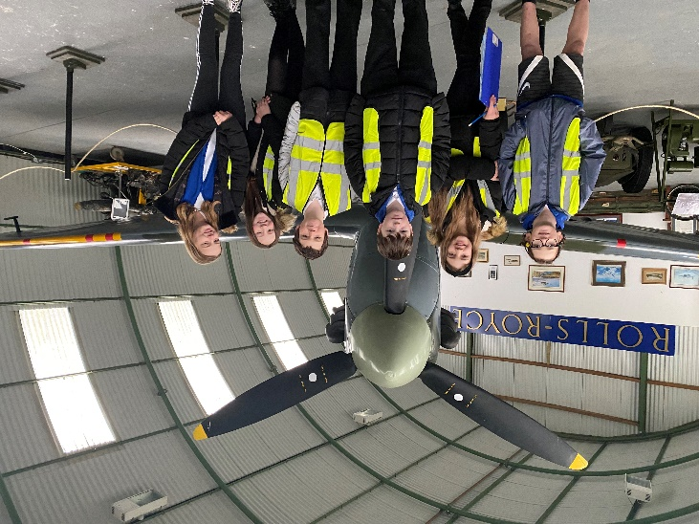

Heathhall School
Supporting Our Pupils
2021 -2022
At Heathhall we welcome and encourage the involvement of all partners in promoting effective learning for children to enable them to develop skills for Learning, Life and Work across all aspects of the curriculum.
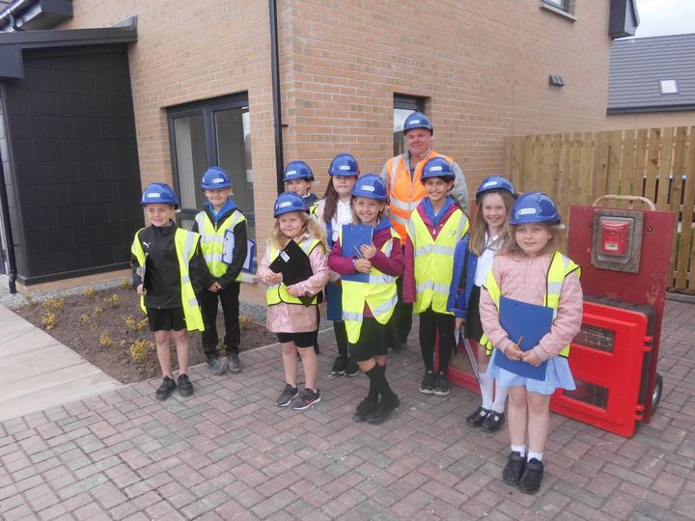
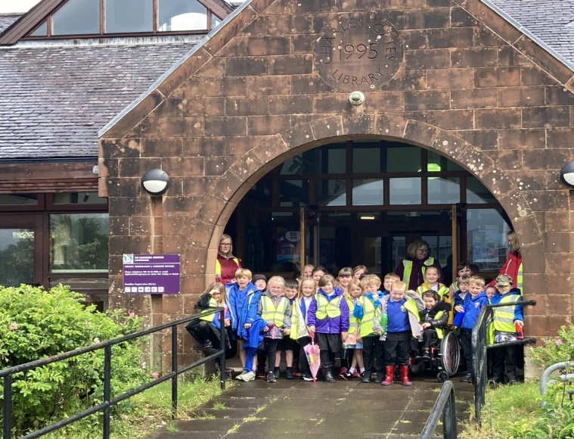
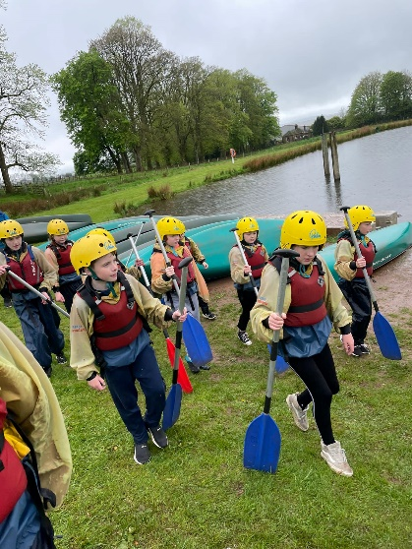
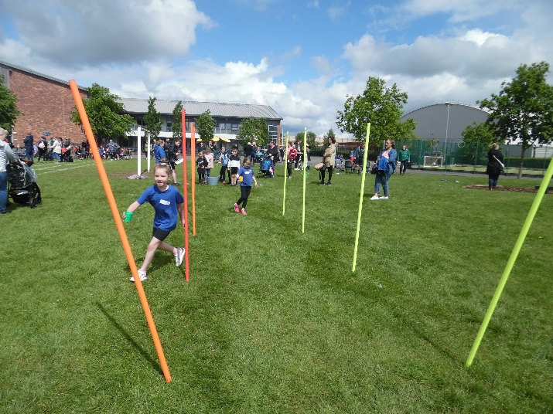

HEATHHALL SCHOOL – SUPPORTING OUR PUPILS
SESSION  2021-2022 | PUPILS INVOLVED | OTHER PARTNERS INVOLVED | DETAILS OF ACTIVITY / EVENT
Over the school year pupils at Heathhall have a number of opportunities where Curriculum for Excellence is delivered through partnership working. All staff at Heathhall work with partners to deliver learning and other experiences. This will vary from year to year but this list provides an idea of the variety of partners we have worked with during 2020-2021.
Activities which take place on a regular basis throughout a term or over the year.
 | Individuals in P5, P5/6, P6 &P6/7 | Mr D Bass (D&G Instrumental Music Service) | Guitar tuition for individual pupils in P5 and P/56
 | Individuals in P5/6 | Mr Taylor (D&G Instrumental Music Service) | Violin tuition for individual pupils in 5/6
 | Individuals in P5 | Mr ??(D&G Instrumental Music Service) | Clarinet and Saxophone tuition for individual pupils in P5
 | Individuals in P5 | Mr Bahlaj (D&G Instrumental Music Service) | Trumpet for individual pupils in 5
 | Individual representatives from various classes | Mrs Brown | Digital Leaders after school club.
 | Pupils across the school | Mrs Copeland/Mrs Lynn/Miss Lundy | After school gardening group (Monday) – developing our sensory garden and Outdoor classroom areas.
 | P5 | Mr Allison – Active Schools | After school group (Thursday) – Games skills
 | P3 | Mr Sharp | After school group (Tuesday) - Badminton
 | P5-P7 | Mr Ross/Mr Sharp | After school football club
 | P5/6 | RSPB Wild Challenge | Activities which engage children with nature and provide practical learning opportunities.
 | P5 | Mr Sharp | After school club - Basketball
September
 | Nursery Class | West Sound Radio - Cash for Kids | Children participated in ‘Wear a Rainbow day” to raise awareness of supporting children less fortunate than ourselves.
 | P5 – P7 Pupils | Permaculture Educators | Pupils took part in outdoor learning maths activities including learning linked to Scale, Money, 2D&3D Shape and decimals.
 | P7 Pupils | Active schools | Hockey coaching – Rules of the game, player’s position/role within the team and hockey tactics.
October
 | Nursery | Parent/carers | Autumn Treasure Hunt
November
 | Nursery Class | School Crossing Patrol (D&G) | Pupils learning about ‘People who help us.’ Jill (Crossing Patrol) talked about safely crossing the road.
 | Whole school | NHS Nursing team | Flu vaccinations – Links to world of work and developing awareness of reasons for vaccination programmes
 | Whole school | Poppy Appeal Scotland | Raising awareness of Poppy Appeal and what it means
 | Primary 7 | Aviation Museum & Community Council | Attend and lay a wreath at Remembrance service at Aviation Museum, Heathhall.
 | Whole School | Parents/Carers | Parent/Pupil/Teacher Talk Time – Opportunity for all to discuss pupil progress. (completed through telephone calls due to COVID 19 restrictions)
 | Whole school | Children in Need | Raising awareness of what this charity does – Pupils took opportunity to take part in “Wear what you want” Children in need day and gave a donation.
 | P4/5 to P7 | Dumfries Aviation Museum | Interdisciplinary learning context of World War 2 – Learning about “What role did Heathhall play in the war?”
 | P3 | Tesco | Learning about where our food comes from before it is in the shop as well as a “Tasting Fruit” session (Part of Skills academy)
December | P4 to 7 | Education Scotland Online Event | Code-along Live – An event where pupil had opportunity to experience and practice using Scratch (Block-based visual programming language)
 | Nursery | Nursery staff & children | Festive Celebration video home to parents via Class Dojo– children singing and creating festive decorations.
 | P5s from P4/5 class | Parents/Carers | Christmas celebration video home to parents shared via Teams
 | P5 | Parents/Carers | Christmas celebration video home to parents shared via Teams
 | P5/6 | Parents/Carers | Sharing Christmas songs / message with parents via video link
 | P6s from P6/7 class | Parents/Carers | Christmas Around the World celebration video shared through Teams
 | P5/6 | Scottish Book Trust | Pupils engaged with various literacy challenges through the Scottish Book Trust Reading/Writing Advent calendar - Online
 | P5/6 | Sustrans Scotland | Pupils were encouraged/challenged to ‘Leg it to Lapland’ travel by foot, scooter or bike the 2,400 miles from Devon to Lapland.
January | P1 to P7 | Queen of the South | Queen of the South community Coaching team worked with all classes from P1 to P7 coaching in football skills and playing as a team.
 | Nursery | NHS | Pre-school pupils eye screening - Links to world of work as children develop an awareness of different skills we need for occupations.
 | P6/7 &P7 | YMI Soundtrap | Learning to use Soundtrap to create music digitally
 | P5/6 | Heathhall Garden Centre | Bulbs were donated by Heathhall garden centre and planted by pupils in the school grounds.
 | P4 | Tesco | Learning about where our food comes from before it is in the shop as well as a “Tasting Fruit” session (Part of Skills academy)
February
 | P4 | Feis Rois | Pupils learning to sing traditional Scots and Gaelic songs.
 | P1 to P7 | James Erskine Golf Pro | Delivery of golf experience.
 | P1 to P7 | Queen of the South | Queen of the South community Coaching team worked with all classes from P1 to P7 coaching in football skills and playing as a team.
 | P6/7 &P7 | Community Police officer | Information/Discussion session about social media dangers.
 | P6 | Dumfries Ice Bowl | Introduction to the sport of Curling and an opportunity to try it out. Pupils also met the Scottish Olympic Silver and Gold medal winners.
 | Nursery | RSPB | Bird Watch at home with parents
March
 | Whole School | Parents/Carers | Parent/Pupil/Teacher Talk Time – Opportunity for all to discuss pupil progress. (completed through telephone calls due to COVID 19 restrictions)
 | P1 to P7 | James Erskine Golf Pro | Delivery of golf experience.
 | P1 to P7 | Queen of the South | Q of the South community Coaching team worked with all classes from P1 to P7 coaching in football skills and playing as a team.
 | Pupil representatives | Heathhall Community Council | The Queen’s Green Canopy tree planting initiative to mark Her Majesty’s Platinum Jubilee – Pupils were invited to join with the Community Council and the Lord Lieutenant of Dumfries, Fiona Armstrong, to plant a tree.
 | P5 | Moat Brae | Opportunity for pupils to develop their drama and literacy skills within the context of Peter Pan.
 | Individuals from Pupil Council | Ashleigh | Visit to Ashleigh housing development adjacent to the school – Pupils were learning about how this contributes to what’s going on in Heathhall community and then they shared this with their classes.
 | P7 | Fantastic Flying Forces (Glasgow Science Centre) | Online tutorial about the science of forces and aeroplanes
 | P6/7 & P7 | Dumfries Saints Rugby Club | Coaching team worked with pupils coaching in rugby skills, the rules of the game and playing as a team.
 | P5, P6 & P7 pupils | Mrs Clanachan, Mrs Scott & Mr Sharp | Before school - Cross country club
April
 | Nursery | Patent/carers | Come and Play sessions over two weeks
 | Nursery | Tesco | Planting vegetable seeds donated by Tesco
 | Nursery | Tesco | Crafts donated by Tesco
May | P2/3 | Mrs Elsagheir | Talk to pupils about the meaning of Eid and what it means to Muslims to celebrate this festival
 | Nursery | Morrisons | Chains & Seeds of Hope  Paper chains decorated by children and their message of hope to be displayed in Morrisons, Dumfries and the nursery  Cornflower Seeds of Hope to be grown in nursery and pictures shared with Morrisons community
 | Nursery | Parent/carers | Potted Sports Day  Parents supporting child to take part in various sports activities within the nursery garden.
 | P6/7 and P7 | Rotary Club | Young Artist competition: Creating art for the competition with the title ‘Tranquility’
 | P1R & P1S | Lochthorn Library | Visit to introduce pupils to how a library works and to learn more about fiction and non-fiction books.
 | Whole school | DG Together  (Promoting Health & Wellbeing) | Walk to School Week – Encouraging pupils to walk, scoot or cycle your way to school to improve everyone’s health and help the environment. Classes at Heathhall can earn points towards winning the ‘Silver’ or ‘Gold’ Trainer.
 | P1R & P1S | Ashleigh Construction | Visit to Ashleigh building site adjacent to Heathhall School linked to learning about ‘Materials’.
 | P6 | Dumfries High School | Science event – Crime Scene Investigation activity day. An opportunity for pupils to work in a science context and meet and work with pupils from DHS cluster primary schools looking towards transition to secondary school.
 | P6 | Active Schools | Sports leadership and team building skills.
 | P6 | Lockerbie Manor | Residential Trip - Experience of outdoor education.
 | P1R | Mrs Little | Health and Well being – A visit from Mrs Little and her baby, Connie. Pupils were learning about “What a baby needs”.
 | All P3 Pupils | NYCOS | Taster session where pupils have opportunity to sing with Sue St Joseph from Scotland’s Youth Singing Organisation.
June
 | Group of P6 Buddies | Little Acorns Nursery and First Steps Nursery | Group of children visit nursery to introduce themselves to children joining Heathhall School in August 2022 as part of our transition process.
 | P7 | Multi-agency Emergency Services/Health & Safety | Due to COVID restriction usual Operation Safety event was unable to take place in the usual way but was delivered instead via videos –Home fire safety, escape plans and electrical safety as well as information from Police Scotland and Scottish Ambulance Service.
 | P5/6, P6/7,P7 | Dumfries Cricket Club | Coaches working with pupils to develop their cricket skills and an interest in the game.
 | Nursery | Parents/Carers | Pre-school children parents Come and play sessions
 | Nursery | Parents/Carers | Moving On Ceremony for children moving on to P1. Parents invited
 | P3 | Heathhall Garden Centre & Heathhall Forest | P3 experiencing the world of work at Heathhall garden centre and developing their skills in the outdoor environment of Heathhall Forest.
 | P7 | Alba printers | Working with P7 teachers to compile and produce Primary 7 yearbook.
 | P7 | Parents/Carers | Leavers presentations and performance to parents.
 | P7 | Lockerbie Manor | Residential Trip - Experience of outdoor education.

