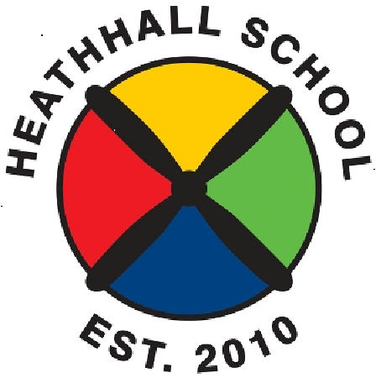
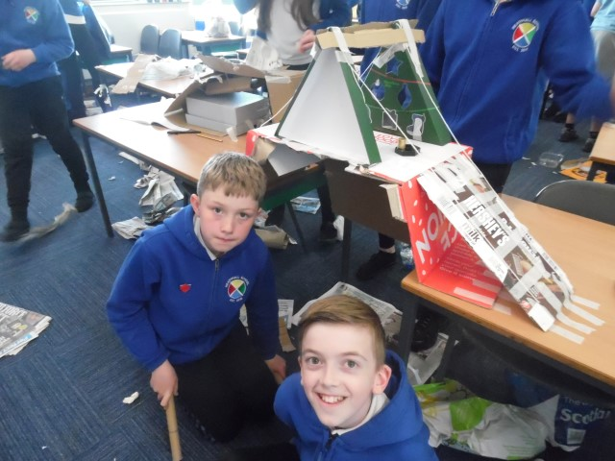

Heathhall School
Supporting Our Pupils
2020 -2021
At Heathhall we welcome and encourage the involvement of all partners in promoting effective learning for children to enable them to develop skills for Learning, Life and Work across all aspects of the curriculum.
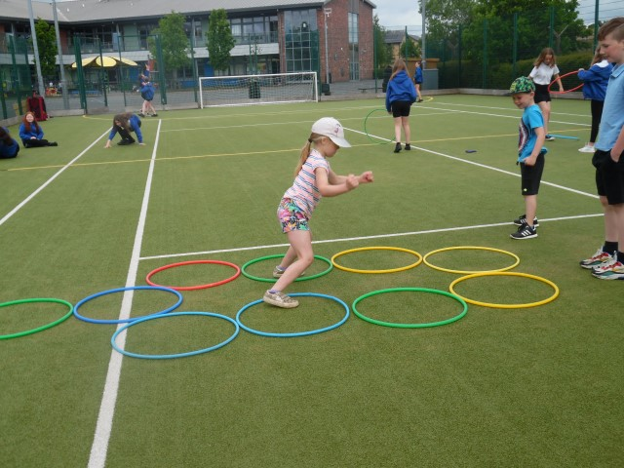

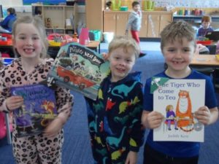

HEATHHALL SCHOOL – SUPPORTING OUR PUPILS
SESSION  2020-2021 |  | PUPILS INVOLVED |  | OTHER PARTNERS INVOLVED | DETAILS OF ACTIVITY / EVENT
Over the school year pupils at Heathhall have a number of opportunities where Curriculum for Excellence is delivered through partnership working. All staff at Heathhall work with partners to deliver learning and other experiences. This will vary from year to year but this list provides an idea of the variety of partners we have worked with during 2020-2021.
September
 | Nursery |  | Miss Downing |  | Snake, Leopard Gecko & Praying Mantis visit to nursery. Children interested in jungle animals. Miss Downing (nursery staff member) brought her pets into nursery to meet the children.
 | Whole School |  | DG Together  (Promoting Health & Wellbeing) |  | Walk to School Week – Encouraging pupils to walk, scoot or cycle your way to school to improve everyone’s health and help the environment. Classes at Heathhall can earn points towards winning the ‘Silver’ or ‘Gold’ Trainer.
October | Whole school |  | D & G Council |  | Autumn walk to school Week 5 Oct to 9 Oct 2020– Initiative is to encourage school pupils to walk or cycle to and from school. Class competition for the Silver & Gold Trainer Awards
 | P6 & P7 |  | Mr D Bass (D&G Instrumental Music Service) |  | Guitar tuition for individual pupils in P6 & P7
November
 | Whole school |  | NHS Nursing team |  | Flu vaccinations – Links to world of work and developing awareness of reasons for vaccination programmes
 | Whole school |  | Poppy Appeal Scotland |  | Raising awareness of Poppy Appeal and what it means
 | Whole School |  | Parents/Carers |  | Parent/Pupil/Teacher Talk Time – Opportunity for all to discuss pupil progress. (completed through telephone calls due to COVID 19 restrictions)
 | Whole school |  | Children in Need |  | Raising awareness of what this charity does – Pupils took opportunity to take part in “Wear what you want and something spotty” Children in need day and gave a donation
 | P6 & P7 |  | Mr D Bass (D&G Instrumental Music Service) |  | Guitar tuition for individual pupils in P6 & P7
 | P1 |  | Discover Dairy |  | Adopt a Cow – Pupils learning about how a cow is cared for and develop their literacy skills.
 | P2 |  | Parents/Carers |  | Pupils in class shared Remembrance day poem videos as part of their learning where they were developing an understanding of events which have taken place in the past.
December | Whole school |  | NHS Nursing team |  | Flu vaccinations – Links to world of work and developing awareness of reasons for vaccination programmes
 | Nursery |  | Nursery staff & children |  | Festive Celebration video home to parents – children singing and creating festive decorations. Staff video of reading ‘The night before Christmas’ for nursery children to be watched on Christmas Eve.
 | P1 |  | Parents/Carers |  | Christmas celebration video home to parents shared via Class Dojo
 | P1/2 |  | Parents/Carers |  | Christmas celebration video home to parents shared via Class Dojo
 | P3/4 |  | Parents/Carers |  | Sharing Christmas songs / message with parents via video link
 | P2 |  | Parents/Carers |  | Christmas Around the World celebration video shared through Class Dojo.
 | P3 |  | Parents/Carers |  | Christmas celebration - songs/music video home to parents shared via class dojo.
January - Feb | SCHOOL CLOSURE – COVID 19
 | Whole school – pupil choice |  | Team GB Olympic |  | Pupils and their families were encouraged to get active with a virtual “Travel to Tokyo” challenge
February | P3/4 |  | Parents/Carers |  | Sharing pupil choice of work (one per pupil) completed during ‘lockdown’ with parents via power point/ screen show video link on ClassDojo
 | P2 |  | Parents/Carers |  | World Book day event – Guess the book title from emojis quiz for parents via a video on ClassDojo.
 | P2 |  | Parent/Carers |  | World Book Day event – The Masked Reader –Stories were read by the Masked Reader – Can you guess who is reading the story?
March | Whole school |  | British Charity – Comic Relief |  | Comic Relief Red Nose Day- Raising awareness of what this charity does – Pupils took opportunity to take part in “Dress Down” day and gave a donation to the Comic Relief Charity.
 | Whole school |  | Ashleigh Building |  | Competition to design a Health and Safety Covid-19 poster to be displayed at the entrance to their building site.
 | P3/4 |  | John Allison - Active Schools |  | Hockey skills and games
 | Nursery |  | Morrisons Community Project |  | Joined with St Theresa’s, Locharbriggs and Cargenbridge to send children’s Spring pictures to create a Spring display in Morrsions Store, Dumfries. Children also created Spring cards to send to local residents of Turner Court and Alanbank.
 | P3 |  | Active Schools |  | Fun fitness - football, running and throwing.
April | P4, P4/5, P5/6, P6 and P7 |  | Active School |  | Physical games activities learning key skills of teamwork, cooperation etc.
May
 | Whole School |  | Parents/Carers |  | Parent/Pupil/Teacher Talk Time – Opportunity for all to discuss pupil progress. (Completed through telephone calls due to COVID 19 restrictions)
 | Nursery |  | NHS |  | Pre-school pupils eye screening - Links to world of work as children develop an awareness of different skills we need for occupations.
 | Individual representatives from various classes |  | Mrs Brown |  | Digital Leaders after school club.
 | P7 |  | Abertay University |  | BAGMDG Pupils took part in a STEM Webinar with Abertay University, Dundee where pupils applied their literacy and numeracy skills in a bridge building challenge.
 | Whole school |  | DG Together  (Promoting Health & Wellbeing) |  | Walk to School Week – Encouraging pupils to walk, scoot or cycle your way to school to improve everyone’s health and help the environment. Classes at Heathhall can earn points towards winning the ‘Silver’ or ‘Gold’ Trainer.
 | P2 |  | Parents/Carers |  | Developing their literacy skills pupils shared their videos of ‘fairyland writing’ via Class Dojo.
June | Nursery N5 pupils and all P6 pupils |  | Active Schools |  | Young Sports Leaders sessions with P6 pupils and transition to school for nursery pupils.
 | P2 |  | Parents/Carers |  | Money from Christmas enterprise activities was used to provide foods so that Primary 2 could participate in a ‘French Café’ tasting traditional French foods and practising French words they have learned.
 | P7 |  | Multi-agency Emergency Services/Health & Safety |  | Due to COVID restriction usual Operation Safety event was unable to take place in the usual way but was delivered instead via videos –Home fire safety, escape plans and electrical safety as well as information from Police Scotland and Scottish Ambulance Service.
 | P7 |  | Bubble Football Scotland  Active Schools  The Parlour  Dolce Vita  Funny Photobooth  Funktion Silent Disco  Farmfoods |  | P7 year group celebration fun day.  Day of fun activities to celebrate their time at Heathhall School – various businesses involved in delivering activities and food/refreshments over the day.
 | P7 |  | Alba printers |  | Working with P7 teachers to compile and produce Primary 7 yearbook.

