Child Protection Training for staff who work in Dumfries and Galloway Schools
This information outlines the child protection training expectations/agreements for staff who work in schools/ELCs. It is now in line with the National Framework for Child Protection Learning and Development 2024 - https://www.gov.scot/publications/national-framework-child-protection-learning-development-scotland-2024/documents/
There are now four distinct workforce levels. The core training provided will allow for a more focused approach towards who needs to know what in child protection.

The four levels are: 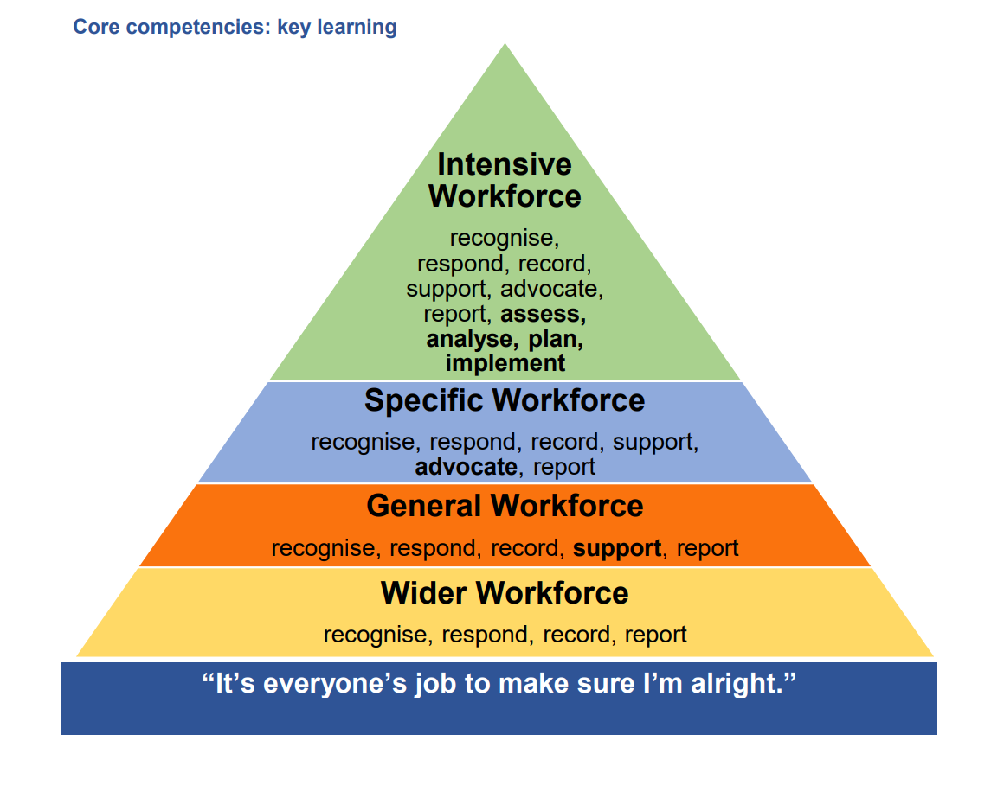
- Wider workforce
- General workforce
- Specific workforce
- Intensive workforce
There is flexibility between the groups depending on the roles of staff. Schools/ELCs can signpost staff to training if they think it fits into the role of the individual.
Distinguishing between the levels:
Wider workforce -
Everybody, regardless of role and remit must have at least a minimum, baseline awareness of core messages about child welfare, safety, and protection. The key message is that it is everyone’s job to make sure our kids are alright.

Key learning is to:
• Recognise (harm or risk of harm when they see it).
• Respond (by sharing concerns with others whose job it is to follow up on what has been reported).
• Record (keep records according to agency requirements).
• Report (sharing information and concerns with Child Protection Services (social work or police).
All staff who have contact with children and their families are expected to have at least this minimum level of child protection awareness.
General Workforce:
As part of their job/role/remit, people in this workforce group are likely to:
• Require a protecting vulnerable groups (PVG) check.
• Recognise potential signs of harm and abuse.
• Raise a protection concern through the appropriate route.
• Contribute relevant and appropriately recorded information to assessments/reports. Key learning is the same as the Wider Workforce, with additional expectations of:
- Support (offering comfort, reassurance, listening, seeking additional help from relevant family or services).
Specific Workforce:
All staff who, as part of their role, work directly with children or their family. People in this workforce group are likely to require a PVG and:
• Routinely work closely with children and their family, including supporting learning, health, practical or skill development in children, /parents, or supporting family time between children/parents
• Keep routine records, write reports and/or assessments for multi-agency child protection meetings, participate in child protection support plans
• Contribute to single agency recording and chronologies
• Contribute to generic or specific risk assessments
• Contribute to identifying and implementing appropriate support/ intervention plans
• Attend and contribute to formal protection or risk management meetings.
School/ELC staff within this workforce will usually be Child Protection Coordinators/those in a named person role/home or family link workers/nurture staff etc.

Intensive Workforce:
As part of their role, people in this workforce group will need a valid PVG and are likely to:
• Have a lead role in compiling and implementing a multi-agency Child’s Plan and/or in decision-making relevant to a child’s welfare
• Oversee the implementation of protection plans
• Have a specific, designated role in formal protection processes, including carrying out a child protection investigation
• Carry out specific, focused or specialist risk assessments
• Compile multi-agency or integrated chronologies
• Produce assessment/analytical reports on a child’s behalf for formal statutory decision-making
• Provide leadership, specialist advice, support, and reflective supervision to colleagues, including the creation of safe working practices and safer cultures that support a ‘whistleblowing’ policy.
Some of the tasks above will be carried out by Social Work or Health Colleagues but there may be tasks to be carried out by the Child Protection Coordinator within a school.

Existing Learning and Development for staff working in schools and ELC settings:
Workforce levels | Core Competencies/key learning | Core Training
All 4 levels:  - Wider workforce  - General workforce  - Specific workforce  - Intensive workforce | Wider workforce:  - Recognise  - Respond  - Record  - Report  General workforce:  As above but with the additional expectation of support (offering comfort, reassurance, listening, seeking additional help from relevant family or services) | - All staff to have complete the CP E-Learning module (only needs to be completed once)  - Attend refresh presentation in August (inset days)  - Three-year cluster training – delivered by the Education Safeguarding Manager.  - Complete the Prevent Duty Awareness course
Specific Workforce – e.g. named person/child protection coordinators/nurture staff etc. | - Recognise  - Respond  - Record  - Support  - Advocate  - Report | - Training needs should be identified and those in specific roles should access training provided via the learning and development calendar on GLOW and Multi-Agency training available from the Public Protection Partnership website.  - Staff should complete the TURAS Child Protection E-Learning modules levels 1 and 2
Intensive Training for Named Person/ Child Protection Coordinator/ Lead Professional. | - Recognise  - Respond  - Record  - Support  - Advocate  - Report  - Assess  - Analyse  - Plan  - Implement | - Training needs should be self-evaluated using the GIRFEC skills framework.  - Training can be accessed via the learning and development calendar on GLOW and Multi-Agency training available from the Public Protection Partnership website.  - Complete Prevent Duty training – Referrals  - Level 3 Child Protection Training – TBC
Every August the School Child Protection Coordinator/s in a school/ELC should deliver the safeguarding and child protection power point as provided by the authority. Please share the presentation with staff who missed it through absence and ensure they complete the CP E-Learning module.
School/ELC Child Protection Coordinators have a responsibility to know which staff have received training and they should keep a record of this
Staff who may come into the wider and general workforce:
Staff Group | Training method | Comments
Teachers / Classroom Assistants | - Three yearly cluster training or annual refresh  - CP E-Learning module.
Escorts/Taxi Drivers | E-Learning coordinated by transport dept.  All drivers have access to a CP sway - https://sway.cloud.microsoft/8ZBtA3MCzoci7G5F?ref=Link
Catering staff in all schools. | CP E learning module to be completed.
Facilities staff e.g. cleaners/janitors. | CP E learning module to be completed every three years.
Office staff | Three yearly cluster training or the annual refresh  Completion of CP E-Learning module.
Peripatetic staff | Three yearly cluster training or the annual refresh  Completion of the CP E-Learning module | Base school preferably but separate training can be arranged. Check they have done the CP E-Learning module
Supply teaching staff | Completion of CP E-Learning module and separate face -to face training is provided also.
Crossing Patrol Persons | Completion of CP E-Learning module/access to the SWAY - https://sway.cloud.microsoft/8ZBtA3MCzoci7G5F?ref=Link
Volunteers “non-regulated” | Review CP arrangements and procedures.  CP E-Learning module can be shared with them.
Volunteers undertaking “regulated work” | Review CP arrangements and procedures.  Completion of the CP E-Learning module

The Learning and Development Calendar will, where possible, have the four workforce levels so that staff know which courses are appropriate for their needs:
Learning \u0026 Development Calendar.pptx

Links to CP E- Learning module – can be accessed by all staff:
- Training content hyperlink - https://sway.office.com/epo1AlrLOSOXH2W2?ref=Link​
- Test (following training) hyperlink - https://forms.office.com/e/sN75zmHQgw​
Staff with a GLOW account can use the following account. Staff should forward their completion email to the school’s child coordinator to allow a record to be kept.
GLOW account users should use the following link: ​
https://sway.cloud.microsoft/8NeJEGiG2uWu6Gum?ref=Link ​

Links to TURAS E-Learning Modules:
An account will have to be made:
Child protection: practice level 1 [informed] | Turas | Learn (nhs. scot)
Child protection: practice level 2 [skilled] | Turas | Learn (nhs. scot)

Links to Prevent Duty Training - E-Learning modules:
Course 1 – Awareness –
Course 2- Referrals

