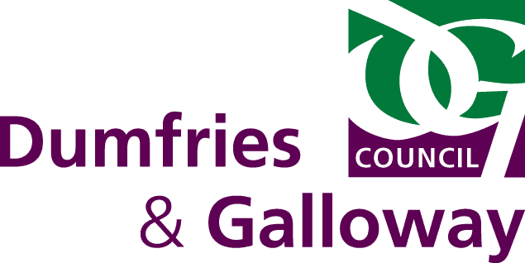

**Elmbank School**

**Handbook**





**Education Services**

**Contents**

|  |  |
| --- | --- |
| **Letter from Director, Education Services** | 4 |
| **Welcome from the Head Teacher** | 5 |
| **Authority Aims** | 6 |
| **School Aims** | 7 |
| **School Ethos** | 7 |
| **School Information** | 8 |
| **Contact Us** | 9 |
|  |  |
| **How the School Works** |  |
| * School Day | 9 |
| * School Uniform/Dress Policy | 9 |
| * School Meals | 10 |
| * School Transport | 10 |
| * Class organisation | 10 |
| * Positive Behaviour and Celebrating Success | 10 |
|  |  |
| **The Curriculum** |  |
| * Curriculum for Excellence | 11 |
|  |  |
| **The Wider Curriculum** |  |
| * Other opportunities | 12 |
|  |  |
| **Home/School Partnership** |  |
| * Parent Council | 12 |
| * Communicating with Home | 12 |
| * Attendance | 12 |
| * How is my child doing? | 13 |
| * Pupil Profiles | 13 |
| * Helping the School | 13 |
| * Helping your child | 13 |
| * Useful Information | 13 |
|  |  |
| **Support for All** |  |
| * Additional Support for Learning | 14 |
| * GIRFEC | 15 |
| * Child Protection | 15 |
| * Educational Psychology Service | 16 |
| * Home School Link Worker Service | 16 |
| * Educational Maintenance Allowance | 16 |
|  |  |
| **Leaving School** |  |
| * 16+ Learning Choices | 17 |
| * Support Available | 17 |

|  |  |
| --- | --- |
| **School Improvements** |  |
| * Improvement plan and priorities | 17 |
|  |  |
| **Health and Safety** |  |
| * Emergency Procedures | 18 |
| * Severe Weather and School Closure Arrangements | 18 |
| * Health Care | 18 |
| * Employment of Pupils | 18 |
| * Data Protection | 18 |
| * Images of Pupils | 19 |
| * Use of Internet | 19 |
|  |  |
| **Other Useful Information** |  |
| * Community and Commissioning Office | 19 |
| * Policies <http://www.dumgal.gov.uk/index.aspx?articleid=7432> | 19 |

* Whilst the term ‘parents’ is used throughout this handbook, it encompasses carers too.

**Letter from Director**



Dear Parents/Carers

Dumfries and Galloway Education Services is committed to delivering a high quality education for your children. As part of Dumfries and Galloway Council’s overall vision we aim to provide all children and young people with a good start in life and prepare them for adulthood and employment.

Education Services cannot deliver this alone for children and young people but work together with others and, as parents, you are one of our key partners. The research tells us that when parents are involved in their child’s education the child will do better. The school handbook is one of the ways in which we inform parents, not just about how the school works, but also about how you can help us help your children to succeed in school and life.

It gives me pleasure as Director, Education Services to commend this handbook to you as an invaluable source of information about your school and Education Services.

Yours sincerely

**Colin Grant**

Director

Education Services

**Welcome from Head Teacher**

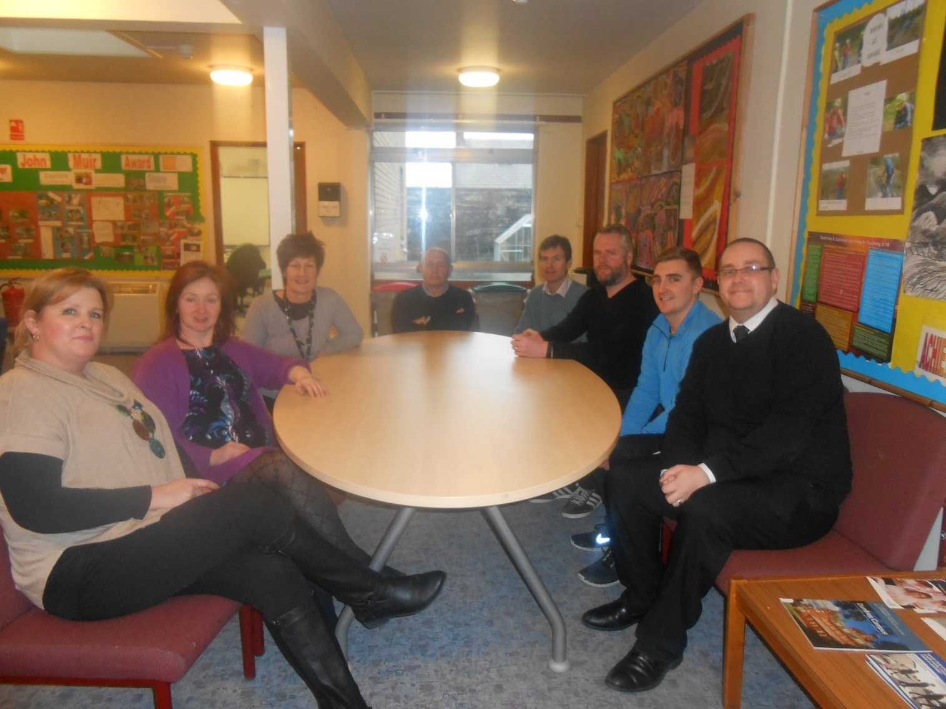

The staff of Elmbank School extends a warm welcome to all pupils, parents, agencies, friends and visitors to our school.

We want our school to be a happy, caring and stimulating place of learning for everyone and welcome your assistance and co-operation in achieving this.

Elmbank School helps vulnerable young people to obtain qualifications, achievements and experiences that will help them to secure a positive post-school destination.

As Headteacher, I welcome contact from parents and partner agencies to discuss the work we do. Please do not hesitate to contact me at the school to discuss any aspect of the work of the school.

Mr S. Jewell

Headteacher



**Education Services Aims**

Education Services deliver high quality services and facilities that promote a safe, healthy, nurturing, supportive and stimulating environment.

“Our Aim is to raise levels of attainment, achievement and participation in all children and young people”

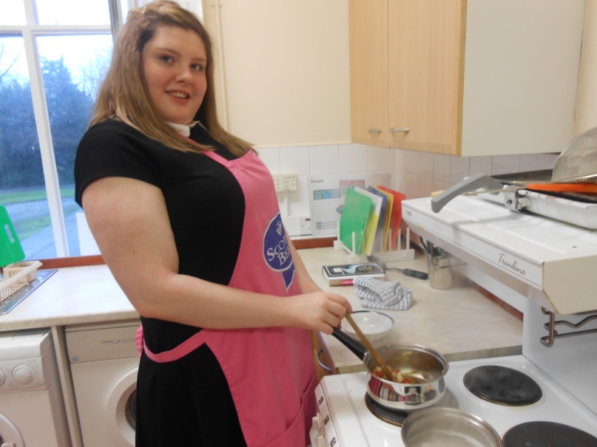

**Our Objectives**

1. **We will ensure that children and young people will be at the centre of our plans**This means planning by schools and support from the Education Service will be focussed on delivering to all of our children and young people the entitlements embedded in CfE and GIRFEC.
2. **We will improve our partnership working**  
   This means an emphasis on Cluster working, training on GIRFEC themes, parental involvement, multi-agency working, partnership with Community Learning and Development (CLD); Professional Learning Communities and collaboration with Education Scotland, the Care Inspectorate and Dumfries and Galloway College.
3. **We will encourage innovation, creativity, collaboration and a culture of sharing and learning in all our staff**This means a focus on transformational leadership, professional autonomy and local solutions and building capacity in all our staff.
4. **We will streamline our business processes**   
   This means empowering our schools and staff to find better ways of working, with an emphasis on professional autonomy, local solutions, developing leadership, capacity building, effective CPD and implementing GIRFEC processes.

**School Aims and Values**

* Focus on raising self-esteem and removing barriers to learning.
* 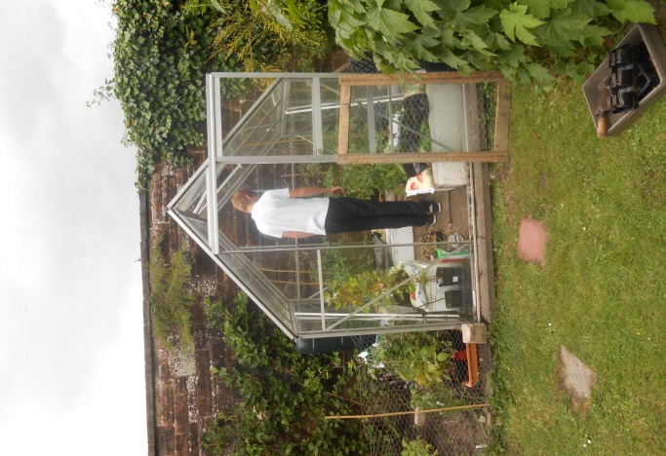Maximise the pupil’s potential and maintain an emphasis on learning.
* Develop social and life skills and prepare young people to play a productive part in society and in the community.
* Using the guidelines of Curriculum for Excellence to provide an education which meets each pupil’s individual needs.
* Assist and guide each pupil to access sporting and recreational opportunities open to the residents of Dumfries and Galloway.
* Get it right for every child.

Our core school values are currently under discussion with staff and pupils. It is anticipated that parents will be invited to contribute to this discussion, too.

**School Ethos**

Elmbank School provides education for pupils aged 11 to 18, from Dumfries and Galloway. Pupils attending Elmbank School have a variety of Social, Emotional and Behavioural Needs, and the high staff-pupil ratio means that we can offer significant individual support to these pupils.

The Curriculum for Excellence is delivered by specialists with a wealth of experience in conjunction with mainstream partners.

A flexible approach ensures appropriate inclusion based on individual requirements.

Links with work places and colleges provide pathways to post school provision.

**Educational Provision Working with Agencies**

We welcome the advice and input from many partner agencies: Aberlour, Education Officers, Educational Psychologist and Social Workers, to name but a few.

We all work together to assess, create and maintain pupils’ personal learning within the framework of Individual Education programmes.

Staff understand factors which affect the motivation of children and young people, and take action to improve and encourage an enthusiasm for learning and positive behaviour.

This team ensures pupils enjoy experiences in their community to allow them to develop within the 4 capacities of the Curriculum for Excellence:

**Successful Learners, Confident Individuals, Responsible Citizens, Effective Contributors**

**School Information**

Elmbank School 🕿 01387 254438

Lovers Walk 🖂 gw08officeelmbank@ea.dumgal.sch.uk

Dumfries

DG1 1LR

**Staff**

|  |  |
| --- | --- |
| Steven Jewell | Head Teacher |
| Geoffrey Smith | Principal Teacher |
| Samuel Thornely | Class Teacher |
| Susan Murdoch | Class Teacher |
|  |  |
| Jennifer Diab | Clerical Assistant |
|  |  |
| Frank Hayes | Support for Learning Assistant |
| Fiona Marchbank | Support for Learning Assistant |
| Lesley McColm | Support for Learning Assistant |
| Jamie Robson | Support for Learning Assistant |
|  |  |
| David McEwan | School Janitor |

**Terms and Holidays**

A list of term and holiday dates is available from the school or on the Council’s website

<http://www.dumgal.gov.uk/index.aspx?articleid=1466>

**Contact Us**

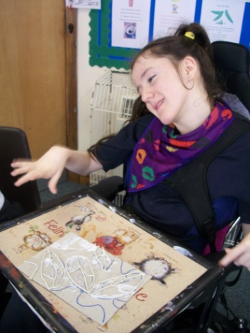Normally issues arising at a school level should be brought to the attention of the class teacher and senior school staff, such as Head or Depute Headteachers as appropriate. Complaints received directly by Education Services will, where possible, be dealt with at as local a level as possible, ie at individual school level.

Education Services operate within the complaints handling procedures for Dumfries and Galloway Council.  Information on this can be found at <http://www.dumgal.gov.uk/index.aspx?articleid=9246>.  Further support and advice can be provided to individual complainants through contacting either the complaints handler within Education Services or to the Councils Corporate Complaints Unit.

**How the School Works**

**School Day**

The school opens at 9.00 am to 3.30 pm



**School Uniform**

We have a smart basic uniform which consists of:

Black trousers, joggers or skirt  
White polo shirts or shirts  
Black sweatshirts/jumper

All Dumfries and Galloway schools must have a dress code which encourages pupils to dress in a way appropriate to attendance at school. This code must not lead to direct or indirect discrimination on the grounds of race, religion, gender, or disability. Prior to drawing up the dress code, parents, pupils and staff should be fully consulted and it is the expectation of Education Services that parents will be supportive of the dress code.

Clothing which is unacceptable in school under any circumstances would include items which:

• Could potentially encourage factions (eg football colours).

• Could cause offence (eg anti-religious or political slogans).

• Could cause health and safety difficulties such as loose fitting clothing,

dangling earrings.

• Are of flammable materials which may be a danger in certain classes.

• Could cause damage to floors.

• Carry advertising, in particular for alcohol or tobacco.

• Could be used to inflict damage on other pupils.

Parents in receipt of a grant for footwear and clothing from the authority will be encouraged to purchase items which are in accordance with the school dress code. Guidance is available on Clothing Grants from Pupil / Parent Support Unit on <http://www.dumgal.gov.uk/index.aspx?articleid=2235>

**School Meals**

For the past 8 years Dumfries and Galloway Council’s School Meal Service has taken steps to improve the nutritional quality of school meals.

This has been influenced by the introduction of both “Hungry for Success” and “The Schools (Health Promotion and Nutrition) (Scotland) Act 2007” which:

• Places health promotion at the heart of school activities

• Ensures that food and drink served in schools meets nutritional

requirements

• Ensures local authorities promote the uptake and benefits of school

meals and, in particular, free school meals

This has resulted in a service which provides and promotes healthy food choices with a restriction of certain foods high in fat, salt and sugar.

Dumfries and Galloway Councils current uptake of school meals is at a six year high, we would like to thank you for your continued support in encouraging your child to have a school lunch.

For more information call on 030 33 33 3000 and ask for DGFirst, Facilities Management (Catering)

Free school meals are available to support families who live and attend a school in Dumfries and Galloway and who are in receipt of qualifying benefits. Any questions about Free School Meals can be directed to the Pupil/Parent Support Unit (see page 19) or <http://www.dumgal.gov.uk/index.aspx?articleid=2233>

**School Transport**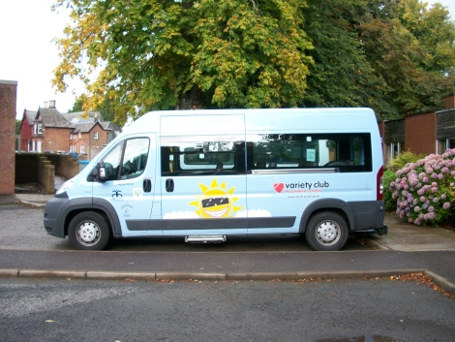

This is organised on a personal needs basis in line with the School Transport Policy <http://www.dumgal.gov.uk/index.aspx?articleid=7432>

**How do I find out if my child will receive school transport?**

This is discussed and organised at transitional review meetings.

**Class Organisation**

At Elmbank this is done in a year basis with all S2, S3 and S4 working together in small groups.

**Positive Behaviour and Celebrating Success**

Positive Behaviour and Celebrating Success are central to our work with all young people, using an individualised approach and support strategies.

Elmbank is a community that works on the ethos of mutual respect for all – this is an expectation of all pupils, staff and partners.

Elmbank School makes use of behaviour monitoring timetables which allow pupils to take responsibility by focusing on specific individual behaviour targets. Pupils are supported by staff to ensure these targets are met, and rewards are given to pupils who regularly exceed their targets.

School expectations will be encompassed in our school values, currently under discussion with pupils and staff. It is anticipated that parents will also be invited to participate in these discussions.

**The Curriculum**

**Curriculum for Excellence**

Curriculum for Excellence is bringing learning to life in the way education is delivered for all 3-18 year olds – in nursery, primary, secondary, at college, workplace or community learning. It takes a fresh approach to what, how and where young people learn. It aims to raise standards, improve knowledge and develop skills. Ultimately it aims to nurture young people as successful learners, confident individuals, effective contributors and responsible citizens.

**How will Curriculum for Excellence Work**?

In a climate which encourages pupils to work towards independence with appropriate support, at Elmbank:

* Learners will experience a broad, deep, general education to S3, with options in the senior phase to specialise, go on to further study and improve skills based on individual need.
* The ‘learner journey’ will be joined up from 3-18 to avoid gaps and overlaps in learning and to make the most of achievements outside school.
* Learners will work at a pace that suits, with enough challenge and support to stretch them.
* Lessons will be more engaging, inspiring and relevant to everyday life.
* Teachers will make connections between subjects, helping children make sense of the world.
* Children will learn *how* to learn and how to use their learning, not just memorise information to pass tests. This will help them adapt in an uncertain future with the ability to think for themselves, make sound judgements, challenge, enquire and find solutions.
* There’s more focus on knowledge *and* skills – including vital skills: literacy and numeracy, which underpin all learning and are critical in life.
* There are changes to assessment and how progress is reported to give learners, parents and employers better information on potential and achievement.
* New qualifications ensure there is more flexibility for young people in which qualifications they take, and in how young people take qualifications

***The above information is based upon National Guidance issued by Education Scotland***

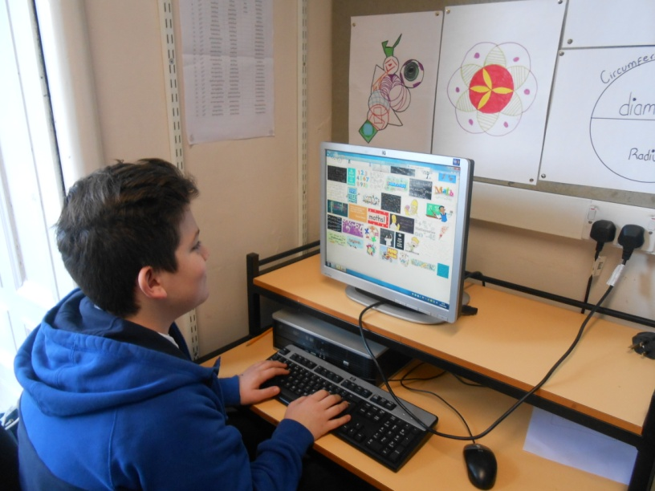

**The Wider Curriculum**

Pupils have opportunities to experience a wider curriculum based on individual choice and personalisation including the John Muir Award, ASDAN awards and the Shed Project. In addition, school staff work closely with local businesses and employers to help young people gain work experience.

**Home / School Partnership**

**Parent Council**

By law schools have a duty to promote parents’ involvement in children’s education. We are very keen that parents feel able to be involved in their child’s education and learning, that they are active participants in the life of the school and they feel able to express their views on school education generally. Any parent who would like to become more involved should contact the Headteacher Steven Jewell to discuss this.

**Communicating with Home**

We try to keep positive, open lines of communication with parents by phone calls, letters and meetings. Parents are also encouraged to contact school as required.

A school website is currently under development. This will contain school information, latest news, opportunities and useful links for pupils and parents. Further information will be sent to parents in due course. In the meantime, any particularly interested parents can contact the Headteacher, Steven Jewell for more details.

**Attendance** – (see Attendance at School Policy (2012))

It is your responsibility as parents to ensure that your child/children attends school regularly. For the safety of all children it is important for you to telephone the school office prior to/at the beginning of any absence. Absences are recorded and frequent or irregular absences not supported by a reasonable excuse, will be notified to parents and the matter may be referred to the Attendance Officer, part of the council’s Opportunities for All team. If possible please try to make dental/medical appointments out with school hours. However, if this is not possible, please inform us in writing or by telephone of the appointment and arrange to collect your child from class.

**Unexplained Absences / Lateness**

Parents are asked to ensure that:

1. The school is informed if the family is running late.
2. Any legitimate absence is notified to the school by telephone before 9am on the first day of the absence without fail, and that further calls, before 9am, are made on every subsequent day of the absence.
3. Contact telephone numbers, whether for home, for parents at work or for other emergency contacts, are kept up to date and are genuinely numbers where a response will be received. This is particularly important with mobile phone numbers.
4. The school is kept informed of the absence and the likely return date eg a note in the home/school diary.
5. Any planned absences are officially notified to the school, in writing, in advance.

Staff will ensure that absences are checked every day and follow up the whereabouts of any child for whom we have no explanation.

**Holidays**

The Government has highlighted the importance of school attendance to a child’s development and has required schools to set targets for improved attendance. Against this background, there is considerable concern at the increasing number of term-time holidays being taken by children at the request of their parents. The Head Teacher is not in a position to refuse permission to parents for such holidays but it is the view of Education Services that these holidays should be officially recognised as “unauthorised”.

Education Services recognises that some parents have difficulties in arranging their own holidays to suit school holiday periods and parents remain free, within reason, to remove their children for holidays during term time. They should, however, appreciate that prolonged absence from school at any stage is harmful to a child’s education and it is not possible – not fair to other children – to direct teaching time to assist a child who has been on holiday to catch up on what they have missed. This means that, whilst parents are at liberty to remove children from school for the purposes of family holidays, such absences will be recorded as ‘unauthorised’. Parents should continue to inform the school, in writing, of any such holiday plans.

The exception to this is when a family holiday is judged to be important to the well-being and cohesion of the family following serious or terminal illness, bereavement or other traumatic events.

**How is my child doing?**

Notes in the home/school diary provide feedback to parents on a daily basis. There is an annual school report produced each summer to summarise the child’s progress and learning throughout the year. These are supplemented by formal and informal meetings throughout the year. The school implements the Authority Guidelines ‘The Framework for Support 2006’.

**Pupil Profiles**

A profile is a snapshot of a child's or young person’s best achievements at a given point in time. Profiles are primarily aimed at learners and their parents and draw together a range of information about a child or young person’s learning. It is one of the ways in which a learner’s achievements can be recognised. Nationally it has been agreed that profiles will be produced at the P7 and S3 stage. The end of S3 represents an important milestone in every young person’s education. By the end of S3 all young people will have completed the Broad General Phase of Curriculum for Excellence. Young people should have produced their own profile, supported by staff, which gives a reliable and full account of their progress and achievements to date. It should include a focus on what they feel are their latest and best achievements.

More information is available from your school or on the Council website.

**Helping the School**

Volunteers and students are often involved in assisting at Elmbank. The school follows the Authority policy and ensures confidentiality is maintained.

**Helping your child**

You can help your child by keeping in touch with staff, attending meetings and encouraging co-operation and attendance in school.

**Useful Information**

For more information on parental involvement or to find out more about parents as partners in their child’s learning, please contact the school or visit the Education Scotland website – [www.educationscotland.gov.uk/parentzone](http://www.educationscotland.gov.uk/parentzone).

**Support for All**

Dumfries and Galloway Council is committed to the well-being and educational development of all learners. The process of inclusion requires all involved in the business of learning and teaching to demonstrate commitment, innovation and flexibility in order to ensure that all children and young people have access to quality learning opportunities and experiences.

The Authority aims to meet the needs of all children with additional support needs through a range of provision from mainstream classes (with or without support) to part-time or full-time provision in a school with a learning centre or base.

This commitment to meeting the needs of all children is based upon the requirements of the Education (Additional Support for Learning) (Scotland) Act 2004 amended in 2009 and is translated into procedure and practice by Dumfries and Galloway Education Services’ ‘The Framework for Support’. This Framework is currently under review.



**What is Additional Support for Learning (ASL)?**

If your child needs extra help or support in addition to that which is usually provided in school they can be said to have ‘Additional Support Needs’. Children may need additional support for short or long periods of time and for a variety of reasons. The reasons can include:

* Social or emotional difficulties
* Problems at home
* Being particularly able
* A physical disability
* Moving home frequently
* Behavioural difficulties
* Bullying
* A sensory impairment
* Communication problems
* Being a young carer
* Being a young parent
* Having English as a second language
* A learning disability
* Autism
* Attention Deficit Hyperactivity Disorder

If you have any concerns about your child you should speak to a member of staff in the school in the first instance. There are a number of ways in which concerns can be followed up. This may involve the input of other educational professionals such as Specialist teachers (Additional Support for Learning Teacher, Educational Visitor, Sensory Impairment Specialists) and Educational Psychologists. It may also involve your child being referred onto staff in external agencies such as health staff (Speech and Language therapist, Occupational Therapist, Physiotherapist etc). As a parent you will be closely involved in the whole process and your views sought throughout. If, after discussion with all concerned, it is felt appropriate, your child will have an educational plan agreed which will identify how they are to be supported.

Your child’s progress will be kept under review and any plans and support will be changed as necessary. As a parent you will be closely involved in any review process. There will be several opportunities for you to discuss your child’s progress. This may be through informal discussion with the teacher or at Parents’ Evenings or it may also be through more formal, focussed meetings with all agencies involved. You should discuss and agree with the school how you would like to be involved. Please contact the Head Teacher Steven Jewell for further details.

At the moment a small number of children will require a more detailed planning process which co-ordinates the input of education and other agencies to fully support the child. This plan is called a Co-ordinated Support Plan. The Co-ordinated Support Plan process is managed by Education Officers with responsibility for Additional Support for Learning.

Further information on all of the above is available from the school or on the Council website

<http://www.dumgal.gov.uk/index.aspx?articleid=10757> or from the following sources:

* **Enquire** – the Scottish advice and information service for additional support for learning, a charitable body registered in Scotland under registration number SC003527 <http://enquire.org.uk/>
* **Scottish Independence Advocacy Alliance** - a charitable body registered in Scotland under registration number SC033576 <http://www.google.co.uk/search?hl=en&source=hp&q=Scottish%20Independent%20Advocacy%20alliance>; or
* **Scottish Child Law Centre** - a charitable body registered in Scotland under registration number SC012741 <http://www.sclc.org.uk/>

Parents may also access further support through mediation services provided by Common Ground Mediation <http://www.commongroundmediation.co.uk/> or advocacy support through People’s Advocacy Support Service (P.A.S.S. Direct ) or Parents Inclusion Network (PIN) <http://www.parentsinclusionnetwork.org.uk/>.

**GIRFEC**

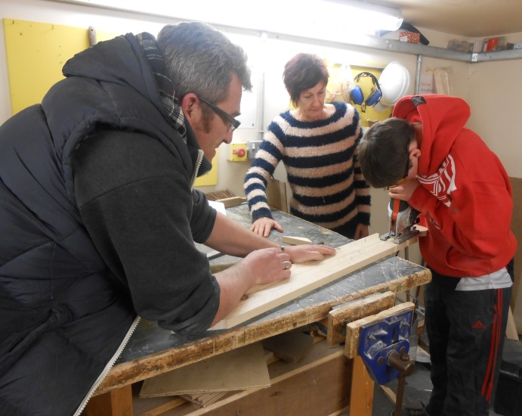Getting it right for every child (GIRFEC) is an approach from The Scottish Government that sets out how schools and other services should work with children and their families. GIRFEC is all about ensuring that children get the help they need when they need it – the right help at the right time. For you and your child, GIRFEC means that:

* You are the expert on your child and what you think matters. Getting it right for every child means that the School will always seek to involve you, to listen to your opinions and take them seriously.
* Your child will have a Named Person in the School. If you or your child need any advice or any support, the Named Person is your first point of contact and will make sure you get the help or advice that you need. Having a Named Person means that if there is anything that could affect your child’s wellbeing, he or she will receive support as quickly as possible so that problems do not develop.
* If your child has complex needs and needs help from several different services, GIRFEC means that all these services must work together for you and your child. You should never have to keep telling your story to lots of different staff in the School or the Education Department or the NHS. Your child will have a single plan that everyone works to and everyone is clear about what they are doing. When your child leaves secondary school there will be a Transition Plan in place for them in good time.
* The named person in Elmbank School is Steven Jewell, Head Teacher

For more information on ***Getting it Right for Every Child*** email [GIRFEC@dumgal.gov.uk](mailto:GIRFEC@dumgal.gov.uk).

**Child Protection**

All children have the right to be protected from harm, abuse and neglect. Every adult in Scotland has a role in ensuring all our children and young people live safely and have the opportunity to reach their full potential. The vision for all children and young people in Dumfries and Galloway is that they should be: **safe, nurtured, healthy, achieving, active, respected** and **responsible** and **included.** Schools and front-line education and child care services will play an important role in ensuring all children and young people are safe and well. Further information is contained within the Child Protection Policy for Schools, Pre-School and Child Care Services which is available from the school and the on the Council website.

**Educational Psychology Service**

Educational Psychologists aim to improve the life chances of all children and young people. Working in partnership with families and other services, we use applied psychology and knowledge of child development to address inequalities, support vulnerability and enhance inclusion. We seek to ensure that young people realise their potential to become successful learners, confident individuals, effective contributors and responsible citizens.

We do this by:

* Working with others in a consultative way to help them make sense of difficulties and make informed choices and decisions
* Sharing knowledge about ‘what works’ and promoting evidence informed approaches to develop the policy and practice of literacy, numeracy and health and wellbeing in our educational establishments and communities
* Raising awareness of the crucial role of communication, relationships and nurture in children’s lives
* Training and developing the skills of other professionals to improve children’s attainment and achievement
* Highlighting the interactive nature of assessment, teaching and learning
* Designing and implementing interventions in partnership with others which support individuals and communities to develop resilience and ensure that children are safe, healthy, active, nurtured, achieving, respected, responsible and included.
* Supporting effective transitions (early years into primary, primary to secondary and

secondary to post school) to improve the life chances of young people

The Psychological Service is based in offices in Newton Stewart, Dumfries and Annan, and each school has an identified Educational Psychologist. Further information about the service is available from the school.

**Home School Link Worker Service**

A Home Link Worker can meet with parents/carers, children or young people to offer advice or help with the sorts of things that can affect a child’s learning. These could be connected to a child or young person’s home or school life. The service aims to provide help and advice early and prevent something small from growing into a problem. A Head Teacher can ask for this support on a parent’s/carer’s behalf. As of January 2016, the Home School Link Worker Service is a part of the council’s Opportunities for All team.

**Educational Maintenance Allowance**

The Education Maintenance Allowance (EMA) is a means tested weekly allowance payable in two week instalments in arrears during term time only.  It is intended to encourage students to stay on at school in post-compulsory education.  Applications are available from all Secondary Schools, Community and Commissioning Section, Woodbank, 30 Edinburgh Road, Dumfries, DG1 1NW and your Local Area Customer Services Centre.

For further information on the EMA programme please contact, Mrs J Dalgleish, Community and Commissioning Section, Tel: 01387 260493.

**Leaving School**

Future provision for all our pupils is personalised through transition review meetings to create a plan.

**16+ Learning Choices**

16+ Learning Choices is a Scottish Government commitment to giving every young person an entitlement to learning at least until age 18.  It is part of the Curriculum for Excellence.  
The three key aspects are:

* the right **learning provision** must be in place - a range of options, including staying on at school, entering further or higher education, participating in the national training programmes, or taking part in personal and social development opportunities offered through community learning and development, must be available to each young person;
* the right **financial support** must be available to ensure that young people make choices based on the most appropriate learning for them, rather than on the amount of money offered;
* the right **information, advice and guidance** must be available to make sure that young people know what opportunities are on offer, how those fit with their own needs and ambitions, and how they will progress

Every young person leaving school at their earliest opportunity is entitled to further learning opportunities to help them develop skills for their future.

**Support Available**

**Activity Agreement Advisers** work with those young people who need extra support to keep learning. These include young people who have not been attending school or are dealing with personal issues and difficulties. What we do is work with each person to find a learning opportunity that is positive, enjoyable, based on their needs and that they can take responsibility for. We have two Activity Agreement Advisers who work directly with young people on a one-to-one basis to find out more about each person and their issues and interests in order to get the best learning programme in place. When the young person is happy with the learning programme that has been identified they will be asked to sign an Activity Agreement where they agree to follow the programme of learning and activities.

**School Improvements**

**Improvement plan and priorities**

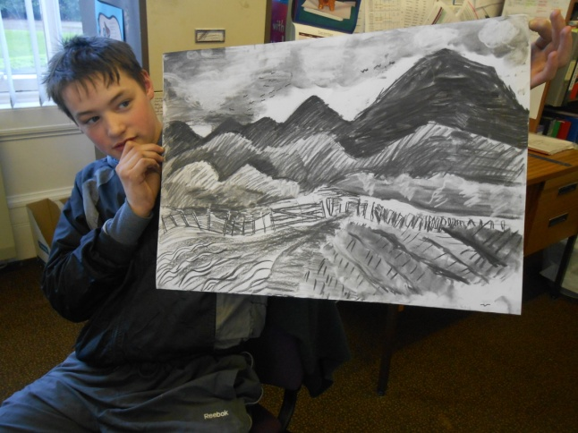In May each year, the school publishes a Standards & Quality Report providing all stakeholders with a comprehensive summary of the school’s work and learners’ achievements over the last year.  The first part of this report provides an overview of the school’s progress in addressing its key priorities, while the second part gives information about, for example, how well pupils are learning and achieving; how well the school is supporting children/young people to develop and learn.  In June, we publish a School Improvement Plan which outlines the key priorities for the school during the year ahead, following due consultation with staff, pupils and parents.  The plan indicates the expected impact of priorities on pupil learning, as well as providing brief information about the key tasks to be taken forward.  Both the report and the plan are published on the school’s website and are also available in hard copy, on request.

**Health and Safety**

**Emergency Procedures**

If your child feels ill during the school day and we feel that he/she would be better at home, we will telephone you or your emergency contact. Minor accidents, e.g. cuts, bruises, are dealt with by the school staff. Serious accidents are few, but should one occur your child will be immediately taken either to your doctor or to hospital, if necessary, and you or your emergency contact will be notified. We cannot stress enough the importance of supplying the school with the relevant information we require in such a situation, i.e. your own home and work number and a telephone number of an emergency contact.

We will request such information at the beginning of each new school year. Please update this as necessary.

**Severe Weather and School Closure Arrangements**

Head Teachers are authorised to make an emergency closure when the state of the weather or any other exceptional circumstance make it absolutely necessary in the best interests of the pupils. In these circumstances parents will be communicated with in a variety of ways including text messages, phone calls and emergency contact arrangements. All school closures will be notified on the Council Website:

www.dumgal.gov.uk

**Health Care**

Education Services is committed to ensuring that all children are able to fully participate in the life of the school. Many children will require their health care needs to be met at sometime within the nursery/school environment, for most children this will be for short periods of time only but for some children this may require more long term planning and support. If your child has any health care needs please contact the school to discuss arrangements. Full details of the support available and your role as a parent and the role of your child are contained within The Nursery and School Policy on Health Care Procedures Sept 2012 which is available from the school or on the Council website.

**Employment of Pupils**

If a school is notified by a pupil that they intend to take up part-time employment and that this employment falls within the terms as set out in “Part-time Employment: A Young Person’s Guidelines”; there are procedures for schools to follow. These procedures are detailed within Part-Time Employment of Pupils – Procedures for Secondary Schools which is available from the school or on the Council Website. <http://www.dumgal.gov.uk/CHttpHandler.ashx?id=3411&p=0>

**Data Protection**

Your child’s personal data will be held by the school. All personal data is held on our secure school management information system. We will ensure that the information we hold is accurate and up to date and each year you will be sent an Update Form detailing the information held by the school for you to check and update as required.

Access to the school management information system is by individual user and is password protected. Furthermore, access to confidential data is restricted to staff in school as appropriate.

Your school will also ask for your consent to take and use images of your child during the course of the school year. This permission will be obtained when your child starts school or at a new school, but you can amend your permission at any time by contacting the school office.

All schools in Dumfries and Galloway are expected to record any unusual incidents or concerns they may have about a child. Normally this information will be shared with parents or carers when issues of concern arise. This information may also be shared with other agencies, such as Social Work, if schools are asked for it. This allows all agencies who come into contact with children to make the best decisions for each individual child and to make sure they get the help they need when they need it.

If the school feels that any child may benefit from assessment or support from another agency and do not have child protection concerns they will always talk to parents or carers about this first.

**Images of Pupils**

The school does use photographs to provide a record of events and it is possible that photographs may appear in local papers or media. The authority has a policy on the use of images of pupils. You will be asked to read this when your child enrols and to clarify your consent with regard to the publication of images of your child.

**Use of the Internet**

As part of the whole learning process we allow our children supervised access to the Internet and e-mail. The authority runs its own filter system to ensure that young people are not at risk from exposure to inappropriate material. This filtering system is regularly being upgraded. We have a policy for use of the Internet and a contract for responsible use, which we ask parents and young people to sign up to.

**Other Useful Information**

**Community and Commissioning**

The Community and Commissioning Section is there to help parents and pupils and can be contacted on the numbers shown below regarding any aspect of Free School Meals/Clothing Grants, Education Maintenance Allowance, School Transport, Home Education, Parent Council administration, school transfers and enrolment, school catchment areas, performance licences, insurance matters and financial support for those pupils entering higher education.

(01387) 260437 (01387) 260498

(01387) 260433 (01387) 260493

**Policies**

There are a number of National, Education Services and school policies which will provide information on a range of issues. Further details of all of these are available from your school or on the Council website <http://www.dumgal.gov.uk/index.aspx?articleid=7432>. The following is a list of the most relevant policies although this is not an exhaustive list:-

* Acceptable Use of Dumfries and Galloway Council’s ICT Facilities In Schools (2009)
* Child Protection Policy for Schools, Pre-Schools and Childcare Services -
* Children Absent from School through Ill Health – Guidance (2011)
* Curriculum Swimming Policy ( 2012)
* Digital Images Policy (2012 )– Taking and Using Images of Pupils
* Dumfries and Galloway Equal Opportunities Policy and related Equality Schemes
* Part-Time Employment of Pupils – Procedures for Secondary Schools
* Enrolling in Schools – Placement Policy( 2012)
* Exclusion from Schools – Policy and Procedures (2010)
* Inappropriate Use of Social Networking Sites (2011)
* Parental Involvement Strategy (2006) – *this is under review*
* Primary School Class Organisation (2011)
* Protection of Vulnerable Groups (PVG) Scheme (2011)
* Providing Intimate Care for Children and Young People with Disabilities – National Guidelines for Schools
* Providing Intimate Care for Children – Procedures for Schools and Nurseries (2011)
* Nursery and Schools Policy on Health Care Procedures (2012)
* Respect for All – Anti-Bullying Procedures (2011)
* School Transport Policy
* Use of Mobile Phones and/or Internet Bullying – Procedures for Schools when drawing up policies ( 2007)
* Volunteer Policy and Procedures for Schools (2012)

Further information on all aspects of education is available on [www.educationscotland.gov.uk/parentzone](http://www.educationscotland.gov.uk/parentzone) .



**© January 2016**