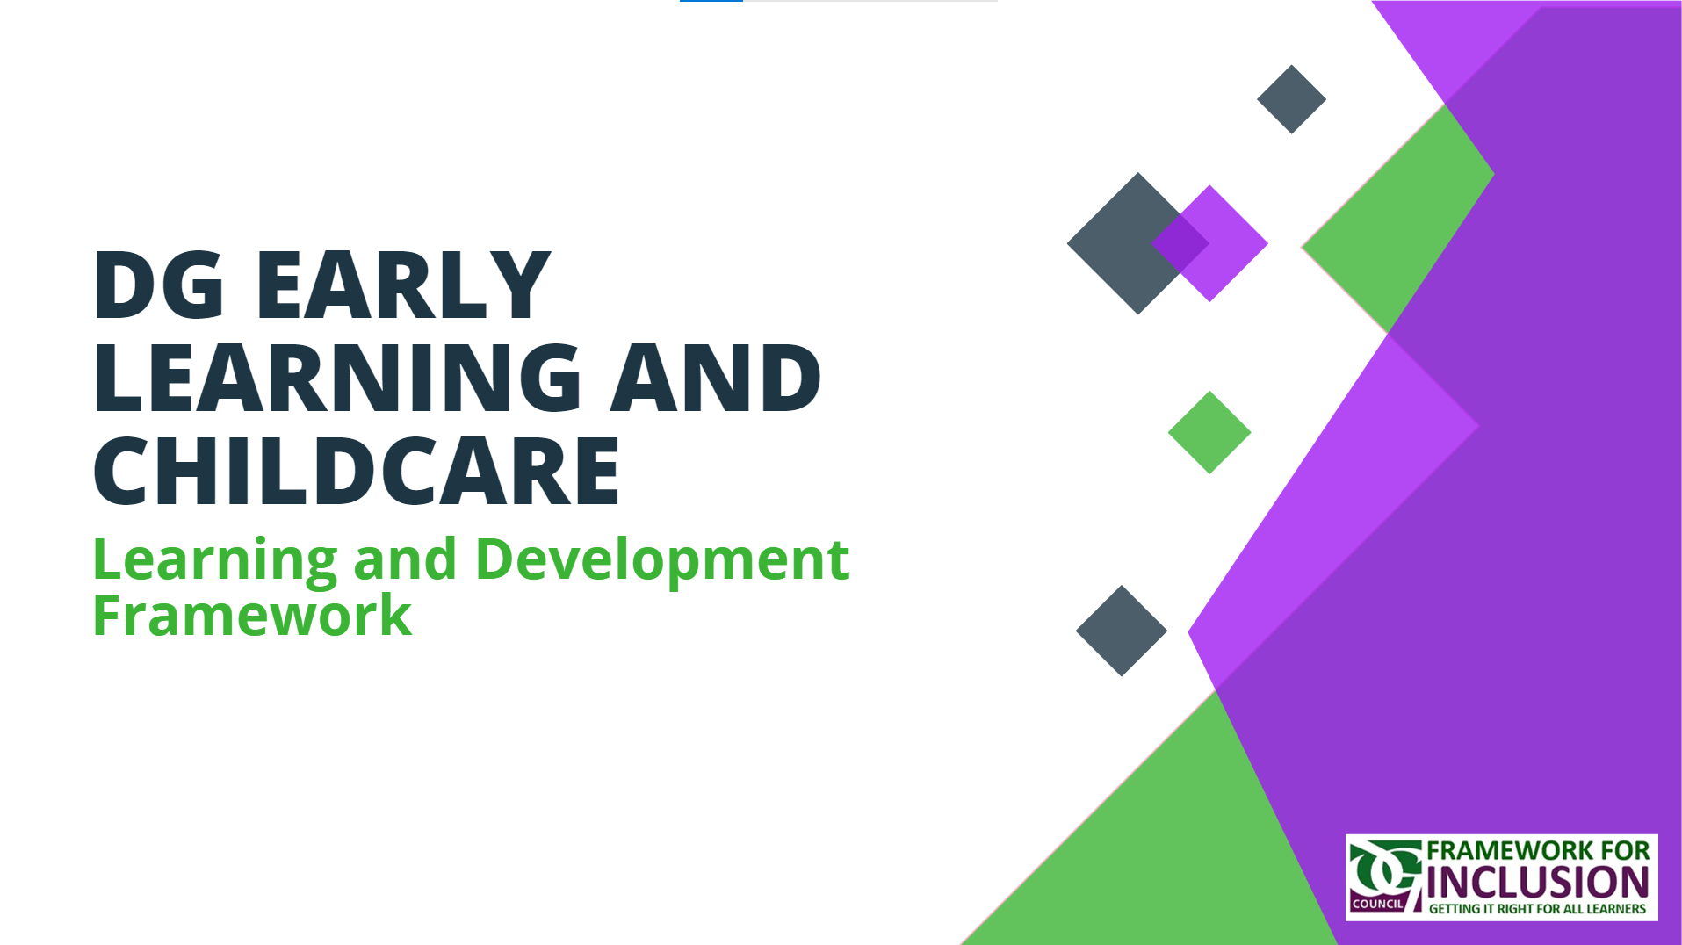
Name:





“Continuous professional learning (CPL) is an essential component of ELC quality and is linked to children’s development. We want a well-trained, professional and skilled workforce with access to high quality professional learning to help deliver the best ELC experience for our children.”
(Realising the Ambition, 2020).

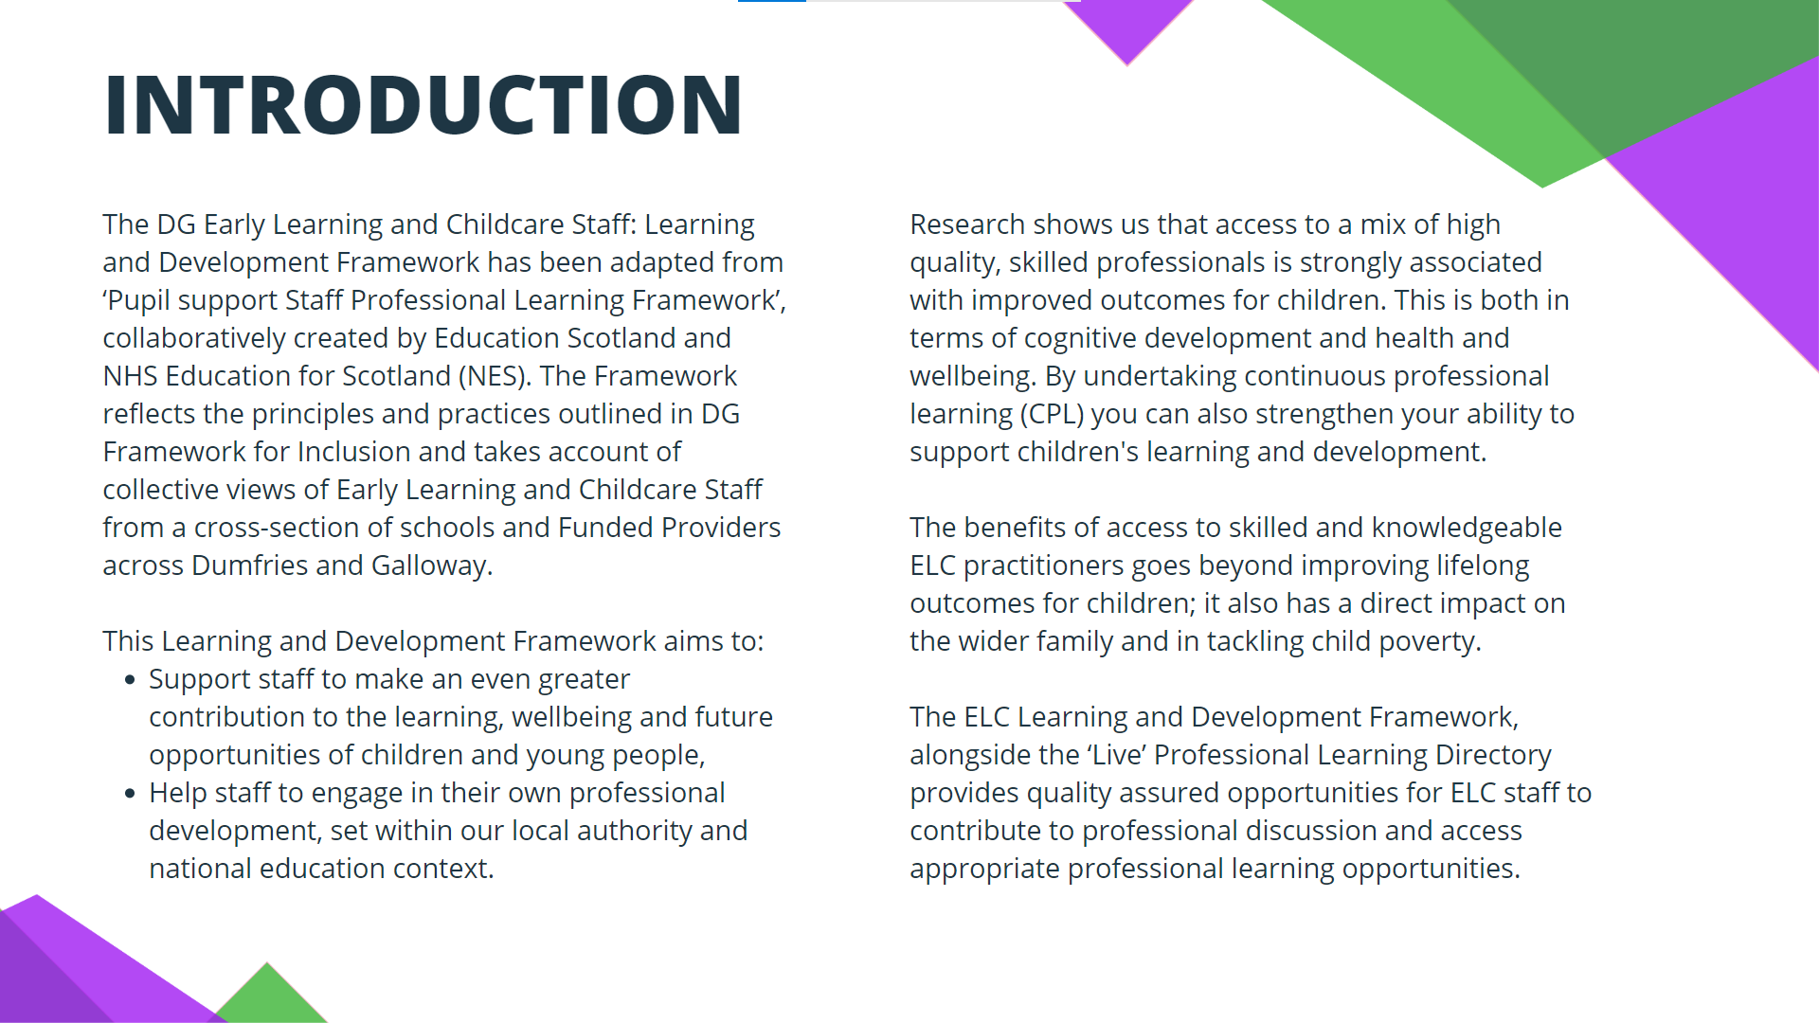
3

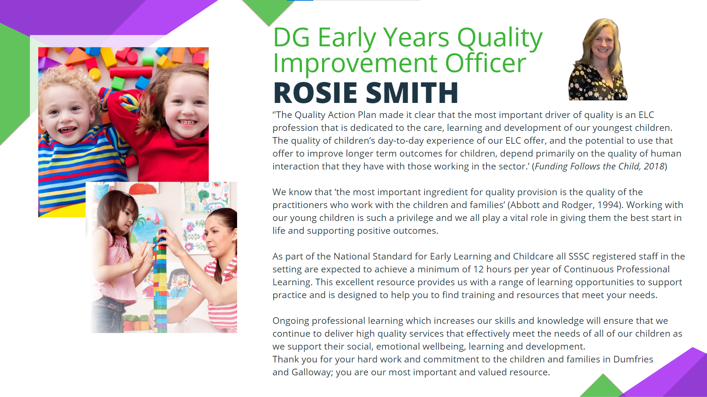
4
4

.

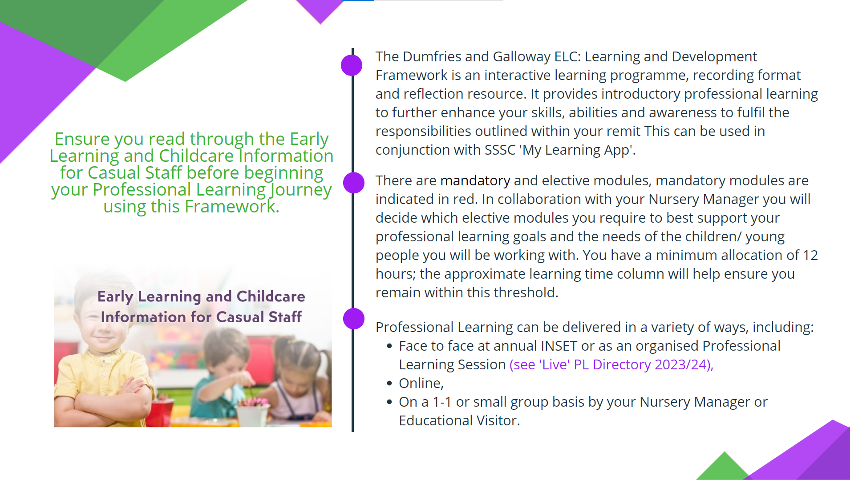
5
4
Early Learning and Childcare Information for Casual Staff (office.com)

Early Learning and Childcare Information for Casual Staff (office.com)


Section 1
Scottish Educational Context and Knowledge

Subsets | Approximate Learning Time | Professional Learning | Reflections and Next Steps | Have you completed this subset? Please click below to select an option
Scottish education context | 5 minutes  5 minutes | Curriculum for Excellence  Getting It Right for Every Child  Child Development in the Early Years |  | No
UNCRC and Rights and Participation | 5 minutes  10 minutes | United Nations Convention on the Rights of the Child (UNCRC): A Rights based approach in the Early Years  Learning Through Rights in the Early Years: Weaving the UNCRC through Policy, Provision and Everyday Practice |  | No
GDPR | 5 minutes | An Introduction to General Data Protection Regulation (GDPR) |  | No
Responsibility of All | 4 hours  15 minutes  20 minutes | respectme: Scotlands Anti-Bullying Service  Health and Safety at Work, Accident/Incident reporting & Fire Safety  Manual Handling of Young People and Equipment |  | No
Section 2

Communication and Collaboration: Developing Positive Relationships

Subsets | Approximate Learning Time | Professional Learning | Reflections and Next Steps | Have you completed this subset? Please click below to select an option
The skills to build positive, trusting relationships with children and young people (mentoring and interpersonal skills) | 2 minutes  15 minutes  10 minutes  8 minutes  15 minutes  1-2 hours  TBC | How to support a child who makes a disclosure.  Building positive relationships.  -What is a Relationship- Rich approach?  -Barnardo’s Scotland. All About Relationships  Introduction to Trauma Informed Practice.  Trauma awareness when supporting people who have a learning disability  Why does ‘shaming’ not positively impact behaviour?  Understanding the social factors which may impact on Children’s Outcomes in the Early Years |  | No
The ability to build positive relationships with parents and carers (language skills) | TBC  10 minutes | Supporting Parents to Further Engage in their Child's Development  Effective Communication: Having difficult conversations. |  | No
Section 3

Child Wellbeing and Development

Subsets | Approximate Learning Time | Professional Learning | Reflections and Next Steps | Have you completed this subset? Please click below to select an option
The ability to identify and respond to the emotional, wellbeing and development needs of children and young people | 5 minutes  5 minutes per section (5)  9 hours per week x 12 weeks.  5 minutes  20 minutes  Extended Course | What is Neurodiversity?  Introduction to Autism  Introduction to Neuroscience in the Early Years  (Accredited Course)  Introduction to Attunement and Attachment  Stages of Intervention- Training Package  Working with Individuals with Learning Disabilities |  | No
The ability to support positive relationships and behaviour, including reducing distressed behaviour | 10 minutes  20 minutes  15 minutes  15 minutes  Extended Course | Introduction to Nurture: The 6 Nurturing Principles  Introduction to distressed behaviour and how to help.  Self Regulation Strategies for Early Childhood and those with SEND  Solihull Approach:  Developmental and Emotional Milestones  Understanding behaviour that challenges |  | No
The skills, knowledge and ability to support children and young people | 1 hour  1 hour  15 minutes  15 minutes  Extended Course  TBC  TBC | Curricular Support  Numeracy  Early Numeracy  Literacy  Supporting the Development and Progression of Children's Early Language and Literacy  Health and Wellbeing  Mental Health and wellbeing  - We all have mental health.  Promoting Physical Development and Activity in the Early Years  Play Well- Supporting Wellbeing Through Play  STEM  National STEM CPL Module  ICT  Digilearn Scot- ICT in the early years. |  | No
The ability to support language and communication development in children and young people | 10 minutes per course. | Pre-TLQ can be found on the Live PL Directory.  How to support effective communication  (Certificated Modules)  Understanding Deaf and Hearing Loss  (Login must be created)  Understanding Cerebral Visual Impairment  (CVI) |  | No
Safeguarding and Child protection | 10 minutes | Child Protection and safeguarding  Child sexual exploitation in Dumfries and Galloway |  | No
Section 4

Personal and Professional Development

Subsets | Approximate Learning Time | Professional Learning | Reflections and Next Steps | Have you completed this subset? Please click below to select an option
The ability to drive your professional development, with the support of your school, employer and national agencies | Variable | My Learning App and SSSC Open Badges Recording your Professional Learning |  | No
Self-Evaluation in Early Learning and Childcare | 40 minutes | Self-Evaluation for Self-Improvement  Spotlighting effective practice in Belmont Nursery |  | No
Section 5

Wellbeing, Organisation and Creativity

Subsets | Approximate Learning Time | Professional Learning | Reflections and Next Steps | Have you completed this subset? Please click below to select an option
The ability to adapt and develop creative solutions in the ELC Setting | 2 minutes per video  10 minutes  55 minutes  5 minutes  30 minutes | Building confidence in identifying and responding to additional needs.  Play in Early Childhood: The Role of Play in any Setting  The Brain Architects: Building Resilience Through Play  Brain- Building Through Play: Activities for Infants, Toddlers and Children  Understanding Gendered Play |  | No
The ability to positively manage your personal wellbeing with the support of your employer and establishment team | 5 minutes | Dumfries and Galloway Council- Self Referral Services  Your Wellbeing Action Plan |  | No
The ability to plan, with your line manager, for maximum, positive impact of pupil contact time | Variable | Performance and Development Review- DG Paperwork  All ELC Staff will move towards the ‘Check-In’ process via iTrent by April 2025. |  | No


‘Live’ Professional Learning Record
Click here to access: ELC and Learning Assistant: Live Professional Learning Directory
Course/ Session Title | Date | Hours to claim back?  (See: ELC Hub) | Reflections and Next Steps | Time sheet complete?  Please click below to select an option
e.g.  Meeting Learners Needs | Wednesday 15th November | 3.30pm-4.25pm  (55mins) | Autism- Top Tips: We often have the closest relationship with the young people, so have confidence to share your insight/ knowledge/ recommendations with the class teacher. Small changes can make a big difference- too much perfume? Subtle noises?  Ed Psyc: PACE- Dan Huges. Think about using a Playful, Accepting, Curious and Empathetic approach. Use ‘I wonder’ instead of ‘You are being….’  Relationship Rich Schools: Nurture principles, children’s brains can be in ‘Saber Tooth Tiger Land’ be empathetic to this, Unconditional positive regard, teaching children how to behave is part of their learning- manage our expectations. | Yes  Date:  15.11.2023
No
Date:
No
Date:
No
Date:
No
Date:
No
Date:




