Copied from https://www.facebook.com/photo/?fbid=435083318173905&set=a.176288207386752
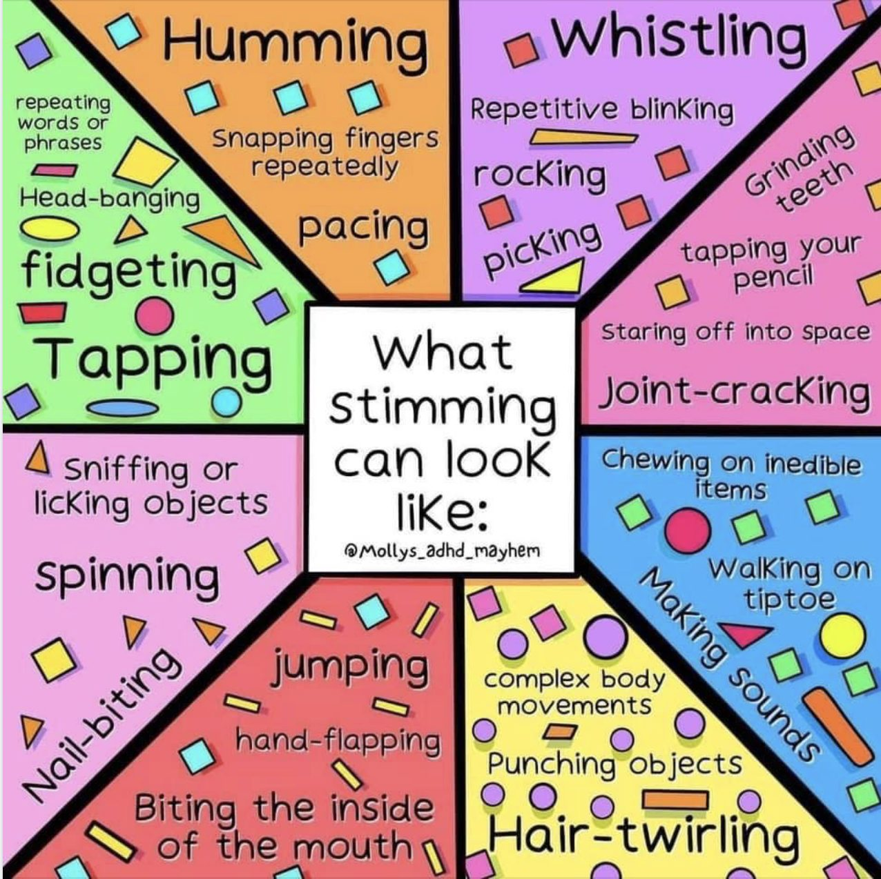

Stimming - a guide for all audiences (autism.org.uk)

11 People With Autism Explain What Stimming Feels Like (themighty.com)

Copied from https://www.facebook.com/theicannetwork/posts/stimming-what-it-feels-like-from-the-inside-in-the-beautiful-images-that-follow-/1814912845360584/

