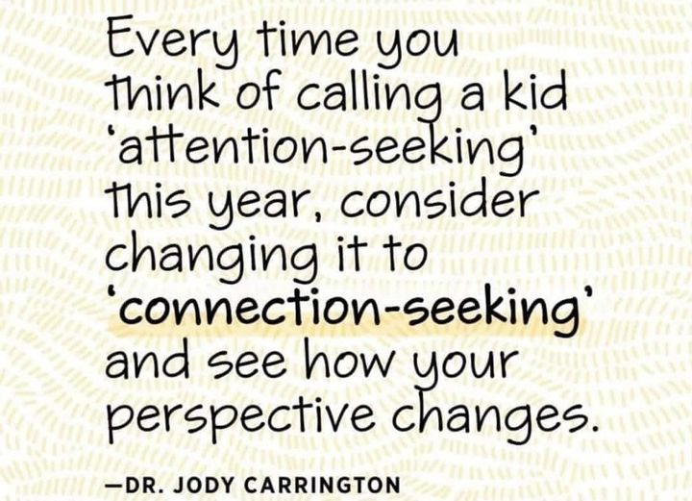

(copied from https://www.facebook.com/MontessoriMusings 16.02.2024)

