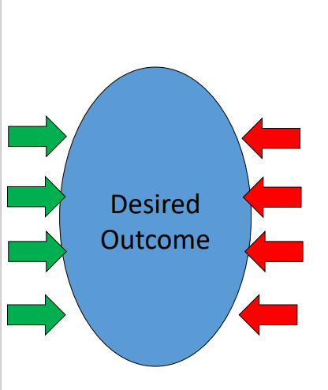
Force Field Analysis

- A tool to help you and your team to analyse the forces for and against a change or an area of improvement.
- Two main purposes:
1. To help you decide whether to go ahead with the change.
2. To strengthen the forces for a change and to minimise the forces against a change.
- It can also build confidence and support for the change amongst the team, help you to understand the forces at play within your system, support with action planning and help mitigate against obstacles.

Facilitating the Activity

- With your team consider your desired outcome or change
- Using a format such as that outlined below, ask the team to write down all of the driving forces for the change and then all of the opposing forces against the change.
- Rate the forces and give them a score.
- Look at the opposing forces - is there anything you can add on the driving side to weaken the opposing forces or to mitigate the barrier? Is there anything you can do to strengthen the driving forces even further? Does this change their score?
- Assuming the change is still going to go ahead, the information can then be used to inform an action plan and next steps that you need to put in place to ensure a successful change.

Desired change / area of improvement:

Driving Forces  1 (weak) to 5 (strong) |  |  |  |  |  | Restraining Forces (Barriers)  1 (weak) to 5 (strong)
5 | 4 | 3 | 2 | 1 | Status Quo | 1 | 2 | 3 | 4 | 5

Actions:

