Earthquake Relief Fundraiser – Dalry School - Weds 8th March 2.00 – 3.30pm
Dalry School is holding a fundraiser for Mary’s Meals Syria Earthquake Appeal. Their partner in Syria has been able to respond quickly in the provision of food aid, and fundraising like ours will allow them to continue to provide this as the communities try to recover, and to respond to the needs of families in and around Aleppo.
Event to include –
- Café & entertainment
- Basketball tournament
- Clothes swap (children’s)
- Games & activities
- Stalls – bake sale; toys/games; bric-a-brac; members of community
- Easter raffle
- ‘Dress up’ day for school pupils
- ‘Get rid of your small change’
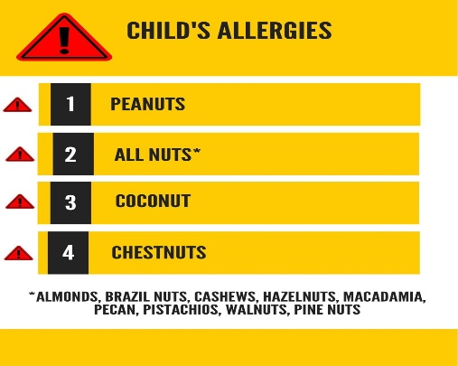
We need your help!
- Drop in for refreshments and a chat; enjoy the activities taking place in the school.
- Give us goods to sell – toys; bric-a-brac; children’s games – anything accepted within reason!
- Baking to sell…. and to consume! But because of allergies within the school community, these items need to be nut free – see image on right.
- Do you have items to sell? Have a sales table in return for a donation.
- Raffle prizes
Financial donations accepted in return for participation and purchases!

Contact gw08officedalry@ea.dumgal.sch.uk/01644 430259 to book a stall. Keep an eye out for community social media & posters for further information, or get in touch with the school.

With many thanks for your support,
Pupils and Staff of Dalry School

