WHAT IS THE PERIMETER:

The perimeter is the distance all the way around the outside of a 2D shape.
To work out the perimeter, add up the lengths of all the sides.
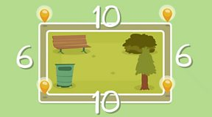
The area of the shape is L x B:
= 10 x 6 = 60
The Perimeter of the shape is:
10 + 10 + 6 + 6 = 32
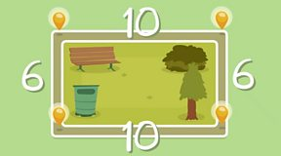Area:
AREA:

Watch the video below:

https://www.bbc.co.uk/bitesize/topics/zjbg87h/articles/zwqt6fr

