Home Learning: Tuesday 26th/Wednesday 27th/Thursday 28th September 2023
 | TUESDAY | WEDNESDAY | THURSDAY
MATHS | - SUMDOG contest  - Worksheet – Multiply by 10/100/1000 – try the x10 and x100 questions.  - Challenge – try x1000.  - Create a tessellating pattern: see below. | - SUMDOG contest  - Mental Maths sheets  - Parabolic curve sheet – use a piece of squared paper to draw a parabolic curve following the instructions on the sheet. | - SUMDOG contest  - Subtraction sheet  - Calculating area sheet  - See sheet for explanation.  Area = L x B
LITERACY | Spelling:  - Complete a spelling task off the grid.  Reading:  - Reading Book (20 minutes)  Writing:  - Use the grid with 25 different writing tasks – choose one and to complete. | Spelling:  - Write 6 sentences using your spelling words – remember to add in connectives.  Reading:  - Reading Book (20minutes)  Writing:  - Use the grid with 25 different writing tasks – choose one and complete. | Spelling:  - Test yourself on your spelling words.  Reading:  - Reading book (20 minutes)  Writing:  - Go onto Newsround and write a recount of a story that you find interesting.  - https://www.bbc.co.uk/newsround
HWB | Take a walk in the garden/park or wood, how many different natural objects can you collect? Can you arrange them all in a symmetrical pattern? | Complete some exercises at home:  Send me a photo!  Example:  6-star jumps 6 jumping jacks  6 bunny hops 6 sit ups  6 shuttle runs 6 squats | Listen to your favourite piece of music – what is it, why do you like it and how does it make you feel.
Outdoor Maths/STEM activity | See below for some outdoor Maths activities
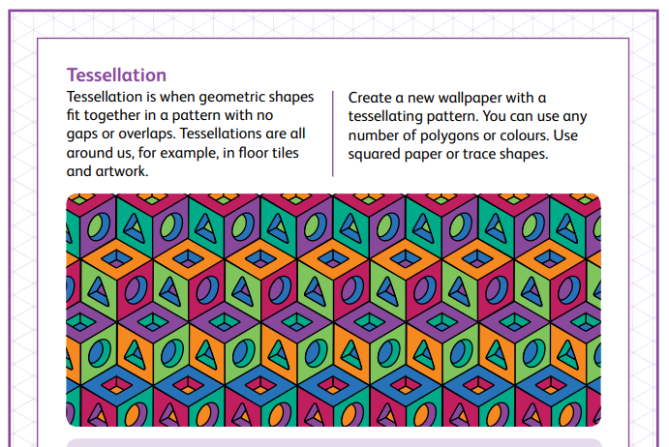

OUTDOOR MATHS:
