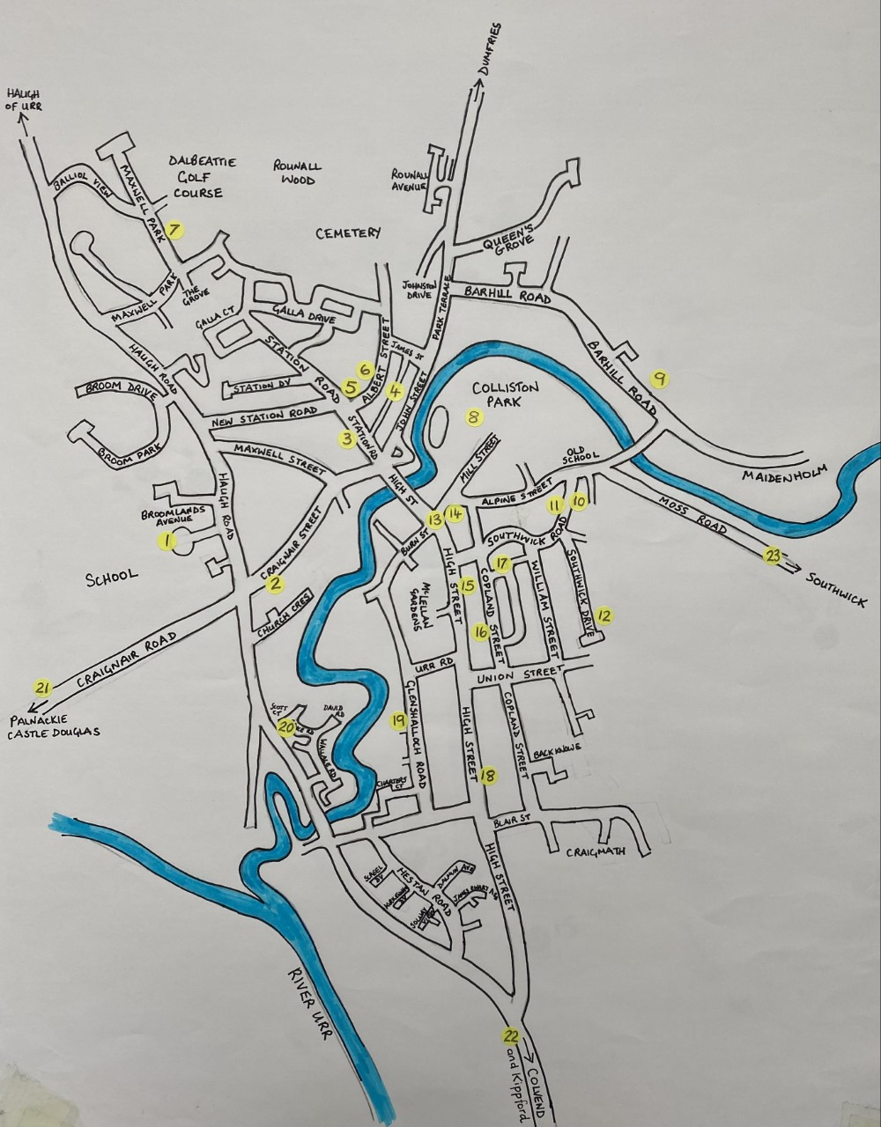
Extra location. Number 24. No anagram letter to collect but it can be visited to see the decorations.
24
Name ________________________ Address_____________________________________________________
Email:______________________________________ Contact number:_________________________________
Please return completed forms to Dalbeattie Primary School via a school child or by post to Dalbeattie Primary School, Craignair Road, Dalbeattie DG5 4LU by Friday 19th May. Alternatively you can post them through the door of Dalbeattie Community Initiative Office by the same date. Returned forms will be entered into a prize draw for three prizes of 1st £30, second £20 and 3rd £10. The first, second and third placed entries in the vote for the decoration competition will receive £50 (Spar Voucher), £25 cash and £15 cash. We are grateful to the Dalbeattie Coronation Committee for making this £100 prize fund possible. Thank you all for supporting this event. Every little good deed helps our local community. THANK YOU!

