Illustrate  The author has asked you to design a new front cover for the book.  Remember you need a title, author, illustrator (you) and an image.  It needs to be  - Eye catching  - Colourful  - Bold writing  - Neatly presented. | Neeps and Tatties  By Carey Morning | Word Hunt  Can you find 10 Scottish Words in the story.  - Create a table using the headings  Scottish word English word Meaning of the word  Can you create some sentences using the Scottish words you have found?
Rhyming words  This story is told using rhyming words.  - List 10 pairs of rhyming words from the story.  e.g sang – alang  neep - sleep | Reading Comprehension Tasks | Summarise  What is this story about?  Write a short summary to tell people the main idea of the story.
What’s not there?  Why do you think the neeps and tatties fell out?  I think the neeps and tatties fell out because… | 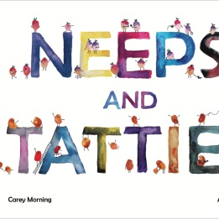 | Read and Understand  What happened when the Haggis sat on the wall playing his song?  When the Haggis sat on the wall…

