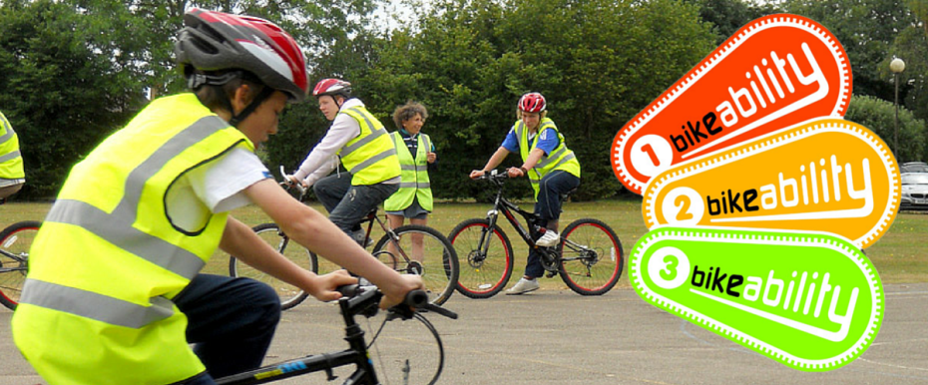
REMINDER OF UPCOMING BIKEABILITY SCOTLAND TRAINING COURSES BELOW – PLACES FILLING UP FAST

Dear Schools of Dumfries and Galloway

Firstly, a huge thank you for your response to our survey. We were delighted with how many of you took the time to get back to us – it was a very useful exercise and has given us the information we need to know how best to support you with Bikeability Scotland in the region. We are currently finalising a new guidance document for Bikeability Scotland specific to D&G which we will circulate to you all as soon as it is finished.
In the short-term, two key factors which were identified as lacking for many schools was a lack of trained staff in the school and access to mentoring support from more experienced trainers.
Therefore we are delighted to offer the following training dates for Cycle Training Assistants (CTA) across the region. The courses are free of charge.

CTA Training - www.cyclinghub.scot/course/cycle-training-assistant-scqf-level-5
Course length - 9am-5pm
Dates and Venues
- Dumfries - Thursday 5th March – Greystone Rovers Classroom
- Dumfries - Saturday 14th March - Greystone Rovers Classroom
- Newton Stewart – Sunday 15th March – Merrick Leisure Centre
- Annan – Sunday 22nd March - Annan Swimming Pool
- Stranraer – Saturday 25th April – Reuse Shop Stranraer

If you would like staff or volunteers at your school to attend this training, please let me know which date and how many staff members. I will then be able to send you signing up instructions. Our courses are on a first come first served basis but we can schedule more in any location as demand dictates.

Alongside this we are training Cycle Trainers in the region to offer support and mentoring to your sessions alongside the identification of suitable training areas and access to bikes regionwide should you need them.

Thank you for your patience as we have pulled this together. Please don’t hesitate to contact me should you have any questions.

All the best

Josh

Josh Wood
Bikeability Coordinator (Dumfries and Galloway)
Cycling Scotland
24 Blythswood Square
Glasgow
G2 4BG

Telephone: 07563555054

www.cycling.scot

