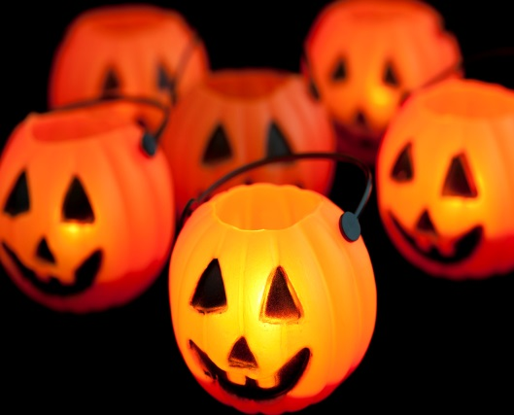

Collin Primary
Halloween Party
Friday 29th October
1.30-3PM
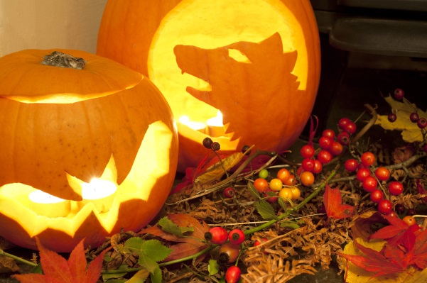
Dress to impress-
Come to school in
your creepiest
costume!!!

