Collin Nursery
Learning Together
Week Beginning 8th February 2021
Sir Captain Tom Moore  It was with great sadness that we heard the news about Captain Tom this week. He was such a huge inspiration to us all throughout the first lockdown - families enjoyed making and sending him cards and thoughts for his 100th birthday – a very special man who touched the hearts of  everyone.  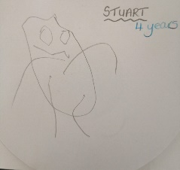  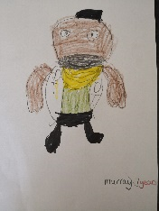  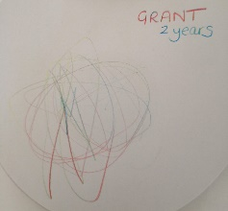  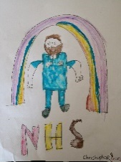 |  | Anjay  Anjay has now had her last day with us in Nursery. She was deeply touched by all your thoughts, photographs, drawings and paintings which we made into a leaving ‘book’ for her to treasure. She has asked to pass on her thanks and to say that she will miss everyone – but will come back to visit us when she can – we will miss her and wish her all the very best for the future
Daffodils  To help you to make the daffodils for Dryfemount waterproof – we can laminate them in nursery if this would be helpful?  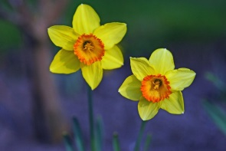 |  | Photographs  This week is our last before the mid term holiday and we would like to share a special photograph on the blog (on Friday 12th February) of the children throughout lockdown. We think this would be a lovely way to connect them together before (hopefully) coming back on the 22nd. Please choose your favourite photo and forward it before Friday (let us know if it’s one you’ve already forwarded and we’ll add it in)  Thank you
This Weeks Project
Your Family Time Capsule

We all hope and pray that we are finally seeing a way out of the difficult times we have all experienced over the last year. This week our project is important in that we want everyone to reflect over that time and to create a Family Time Capsule together.
This Time Capsule will reflect your journey over the last year and will contain things that are important to you as a family and be something that captures life for you in 2020 / 2021. All the activities within this week’s plan are just ideas, as you will have your own thoughts together as a family.
We would like all members of your family to take part.

Literacy  Write – write it all down. How has it been, how is it still?  Talk and Listen – talk to each other – remember events that have happened, things that have happened very differently and chat about them together.  Read – look back over messages, letters and texts – take time to reflect on everything you have achieved over the last year.  Capture the children’s thoughts (you write things down for them)  Add to the time capsule | Numeracy  Think about the length of time that things have been different for us all.  Make a record (decide between the family which way would be best eg. chart, drawing, tally) of the following:  How long have things been different for us?  How many months?  How many days?  How many seasons?  How old were you all?  How much did certain things cost?  Add in anything else you can thing of – use your mathematical imagination to suit your family to extend this activity. | Health and Wellbeing  Even though things have been very difficult, there have also been times to spend more quality time with family.  Capture all the things which you have done as a family. Remember them and record the things which you really enjoyed and would like to keep doing more of. eg – did you have more chances to go for family walks? Work together in the garden last summer? | Social Studies  Probably the most important decision – what are you going to make your time capsule out of?  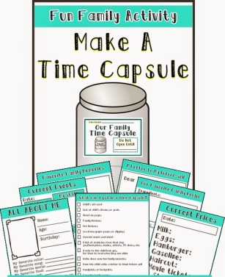
Expressive Arts  In Nursery, the easiest way to express ourselves creatively is by drawing, painting and making. Think about all the discussions you are having with your families.  Draw – paint – make little models – make collages - what will you add to your time capsule to capture you and your family? | Religious and Moral Education  Think about others and yourselves – what effect has the lockdown had on everyone? How do we think it has been for our relatives who have not been able to get out and about or see you. How do they / you feel? How do you help? What do you have to use to communicate? eg technology  How does everyone feel not being able to have a hug? (gently talk about how important the children’s role has been in keeping others safe and well). Write down all your family thoughts and add to the time capsule.  A difficult element of the time capsule for everyone xx | Technologies  Photographs are a great way to capture the last year. Choose some which you look back on and which evoke special memories for you. You will all look back and be touched by how you felt at certain times.  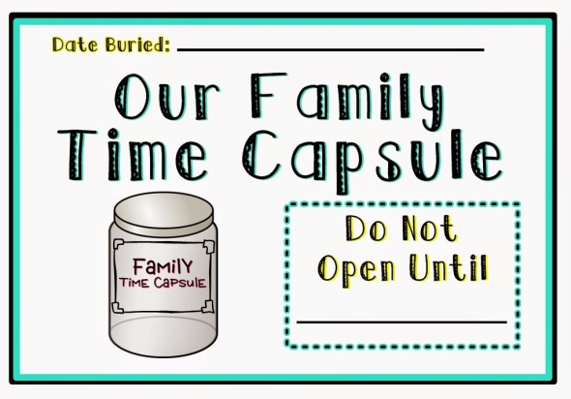 | Science  Lots of thought has to go into ‘where’ you are going to keep your time capsule. Think about the scientific components of different materials and have a discussion about what you make your time capsule out of and where it can be stored. eg – if you want to bury it in the garden, what material will you have to make it out of? (cardboard will not last etc)
Curriculum for Excellence – I can make a personal link to the past by exploring items or images connected with important individuals or special events in my life
I share experiences and feelings and ideas and information in a way that communicates my message.

