Collin Nursery
Learning Together
Week Beginning 1st February 2021

We are all going through tough times together and everyone is feeling and experiencing personal challenges at the moment. CAMHS - NHS Highland have produced some great child friendly posters offering advice and support to children and families during lockdown. They can be found on their Facebook page @ (CAMHS, NHS Highland). We are also here at any time, please just pick up the phone or send a message if you would like to chat

Literacy  (Linking to Religious and Moral Education)  When you create your daffodils, can you write a little note to send to the residents of Dryfemount? Think of something to tell them about yourselves (your grown up will write it down for you) and then you can ‘write’ your name at the end so that they know who has sent it.  Curriculum for Excellence  Within real and imaginary situations, I share experiences and feelings, ideas and information in a way that communicates my message. | Numeracy  The challenge of this week is to go out for a long walk around your neighbourhood. We want you to count how many vehicles you see passing you on the road. Use tally marks to help you to keep count.  What sort of vehicles did you see and how many of each?  Start off with cars, tractors, lorries, buses and add any more that you see.  Curriculum for Excellence  I can match objects, and sort using my own and others’ criteria, sharing my ideas with others | Health and Wellbeing  We all appreciate how good the outdoors is for us and getting out regularly gives us a good opportunity to feel the fresh air on our faces and to burn off extra energy.  This week, when you go for your walks or spend time in the garden, use your grown up’s phone to record how many steps you do each day. Can you increase your number of steps every day?  Curriculum for Excellence  I am developing my understanding of the human body and can use this knowledge to maintain and improve my wellbeing and health. | Social Studies  When we were out this week, we saw the first Snowdrops peeping their heads out! When you are out for your walks, have a look and see if you can see any bulbs popping through the ground. Do you have any in your own gardens? Could you take a photo?  Curriculum for Excellence  I explore and appreciate the wonder of nature within different environments and have played a part in caring for the environment.
Expressive Arts  (Linking to Religious and Moral Education)  Will you paint, draw, colour or make your daffodils? Have a look at some photographs or pictures to help you decide what colours you will need.  Now – you might think a daffodil is just yellow or green, however – are they really all yellow? Are some maybe pale yellow, lemon or cream? Do some have orange in amongst them? What colour are the stems? Dark green, light green, lime green, emerald green? Have a good look before you decide what your daffodil will look like. We will be so pleased with all the children’s work.  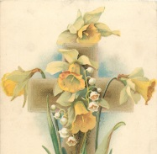  Curriculum for Excellence  I have had the freedom to discover and choose ways to create images and objects using a variety of materials. | Religious and Moral Education  We have a very big job to undertake and we would love it if you could all participate . Our links with Dryfemount Residential Home in Lockerbie continue and this week, they are asking the children to create homemade Daffodils for an outdoor garden display for all their wonderful mums. They can be any size and made out of any material (but need to be waterproof as they are staying outside). Please drop your daffodils in to school at anytime (please ring the nursery bell) and we will safely deliver them to Dryfemount.  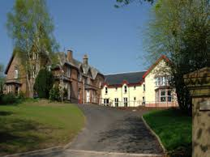  Curriculum for Excellence  As I play and learn, I am developing my understanding of what is fair and unfair, and why caring and sharing are important. | Technologies  Last week, you created different types of shops of your choice and had great fun choosing items to sell and thinking of prices and signage. This week, focus your thinking on the contents of your food cupboard - get out all the tins and packets, explore the different shapes and materials the items are packaged in – are they in tins, cardboard or plastic containers? Talk about this with your families as you’re investigating.  Now – what can you build with all these items? We can’t wait to see your creations  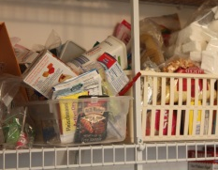  Curriculum for Excellence  I explore ways to design and construct models | Science  We hope you were able to take part in the Big Garden Bird watch, I’m sure you encouraged lots of birds to your gardens with your fantastic birdfeeders. Well done!  This week we have a suggestion from Andrew with a link to some amazing ice experiments.  Please follow the following link for some great ideas:  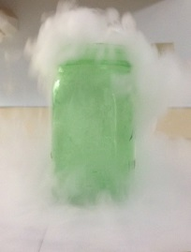  https://pin.it/tQZ20mY  Please forward your photographs when you’ve had a go  Curriculum for Excellence  By investigating how water can change from one form to another, I can relate my findings to everyday experiences.
Thank you very much to Payson’s mummy who highlighted a fantastic source of funding for outdoor clothing for us – we will definitely be investigating this – fingers crossed, thank you Melissa

