Collin Nursery
Learning Together
Week Beginning 25th January 2021

Literacy  (Linking to technologies this week)  Once you have made your shop, you need to think up a name for it?  Write down the following:  The shop’s name  Open/ Closed  Prices  Help the children to mark down their ideas (all their marks are important and a great achievement). This will give them the idea that their print has an important purpose.  Curriculum for Excellence  I explore sounds letters and words, discovering how they work together and can use what I learn to help me as I read or write. | Numeracy  Last week you were all busy learning your shapes. Can you go outside and get the person helping you to draw some shapes (that you have picked). You can colour them in with your favourite coloured chalk. If you haven’t got chalk, what else could you use? Have a look around your garden, could you fill the shapes with stones, woodchips, leaves twigs?  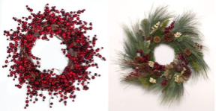  Curriculum for Excellence  I enjoy investigating objects and shaped and can sort, describe and be creative with them. | Health and Wellbeing  This week is a time to get outside, play and have loads of fun with your family – yes, all of them! What will you choose to do?  It might be a game of football, throwing and catching, running, racing or something else – take photos of each other, smile, laugh and have a great time together  Curriculum for Excellence  I am developing my movement through practice and energetic play. | Social Studies  As the mornings and nights get a tiny bit lighter the sun was shining in Nursery today. Can you carry on with your weather chart this week? Think about what season we are in and what season is coming next. Which season do you like the best? Can you tell us why?  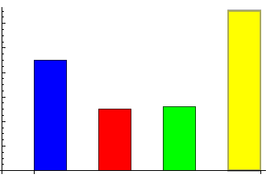  Curriculum for Excellence  While learning outdoors in differing weathers, I have described and recorded the weather, its effects and how it makes me feel and can relate my recordings to the seasons
Expressive Arts  Simple Play dough  This is the recipe we use at Nursery and the children all know how to make it  8 spoonfuls of plain four  2 spoonfuls of salt  Baby oil (or if you haven’t got any it works ok without)  Food colouring and water to mix  Mix everything together and enjoy!  Try adding something to give it a nice smell or texture – let us know what you have used and we’ll share your ideas next week.  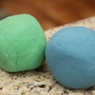  Curriculum for Excellence  I have the freedom to discover images and objects using a variety of materials. | Religious and Moral Education  You did some lovely things for your neighbours last week and I’m sure your kindness made them very happy. This week can you phone someone close to you and have a chat with them? Tell the person everything you have been doing and ask them if they are feeling ok. It could be your Nana / Granny, Papa / Grandad, your sister / brother, or one of your friends.  Curriculum for Excellence  I am developing an understanding of why caring and sharing is important | Technologies  Last week you made and created your own dens. To carry on from that activity, this week – can you create a shop? What sort will it be? A bakers, Tesco, a shoe shop?  Think about all the things you can put in your shop, do you have everything you need? Do you have to make some of the things? Use your imagination and creativity maybe you could use some of your online relatives or friends to be your customers too!  Curriculum for Excellence  I explore and discover different ways of representing ideas in imaginative ways. | Science  I wonder if your bird feeders have attracted any birds yet? Give them time, it sometimes takes them a while to realise they are there! This will help you to count the different types on birds you see in the garden. Can you get the person helping you to write down the names of the birds you find and you can draw a picture? You might even be lucky enough to be able to take a photograph – remember to be nice and quiet  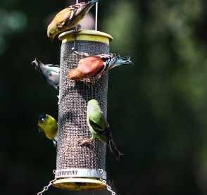  Curriculum for Excellence  I have observed living things in the environment over time and am becoming aware of how they depend on each other.
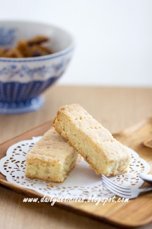
A shared recipe idea- thanks Julia
Shortbread Biscuits
125g butter or pure vegetable margarine, softened
125g caster sugar
1 tsp vanilla essence
200g self raising flour
1 tsp baking powder
1 tbsp water
Optional: 2 tbsp cocoa powder
Optional: milk chocolate chips
Method: mix margarine, sugar, water and essence together, add dry ingredients, bake at 180 degrees for 20 minutes

