Collin Nursery
Learning Together
Week Beginning 18th January 2021

First of all this week, we would like to wish Darragh a very Happy 4th Birthday – we all hope you have a fantastic day!

Literacy  Do you have a favourite story book? Have a look at the following things.  Who wrote the story?  Who drew the pictures?  Enjoy some quiet time and listen carefully to the story.  Can you write a story? and can you draw a picture about your story?  Make your story into a book.  That means you are now an ‘Author’ and an ‘Illustrator’.  Curriculum for Excellence  I enjoy exploring and choosing stories and other texts to watch, read or listen an can share my likes and dislikes | Numeracy  Some of you have been learning about shapes this week. Can you find the following in your home?:  A square A circle  A rectangle A triangle,  An oval A semi circle?  How many different words can you think of to describe the shapes you have found? Here’s a couple to start you off – round and straight.  An extension of the activity:  Can you draw a house by using the different shapes you have described?  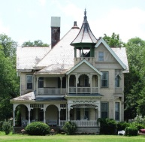  Curriculum for Excellence  I enjoy investigating objects and shaped and can sort, describe and be creative with them. | Health and Wellbeing  Can you create a hopscotch outdoors? You can use chalk or sticks to make the boxes and numbers and use a stone to throw (be careful!).  Try to be as imaginative as possible  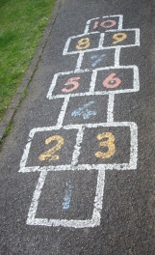  Curriculum for Excellence  I am developing my movement through practice and energetic play. | Social Studies  Last week it was so frosty, we thought you would be able to make ice bubbles. This week, it has been raining, snowing and at times icy too!  Activity: Create a weather chart where you record the following:  - What day is it?  - What date is it?  - What is the weather like today?  Can you draw a picture of the weather today?  An extension of the activity:  - How many days did it rain?  - How many days was it sunny etc?  Can you make a chart to record your findings?  Curriculum for Excellence  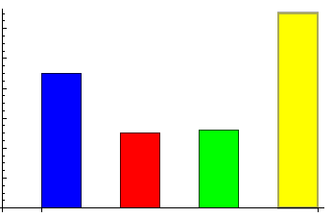  While learning outdoors in differing weathers, I have described and recorded the weather, its effects and how it makes me feel and can relate my recordings to the seasons
Expressive Arts  Let’s learn a new song (to the tune of 5 little ducks went swimming one day)  5 little lambs went leaping one day,  Over the hills and far away  Mummy sheep said don’t go far  But only 4 little lambs went Baa!  Can you think of some other animals and their babies you could sing about? Can you make up some funny words?  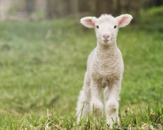  Curriculum for Excellence  I enjoy singing and playing along to music of different styles and culture | Religious and Moral Education  We are all missing each other – can we send a message to each other?  Here are some to start us off:  Payson says she can’t wait to play outside with her friends  Cole says “I hope you’re feeling good and hope to see you soon”  Tayla says “Hi everyone, I am missing you all, Hope to see you soon”  Ethan says he misses his friends  Darragh says “Hello to all my friends at nursery. Missing all the fun and games. Looking forward to playing with you all soon.”  Lewis says “Hi!”  Emily says “I miss you all and can’t wait to get back to nursery”  Fabian says “Hello everyone, I miss you”  Christina says she’ll see you soon  Bryce says “hello – when are we going to play?”  Curriculum for Excellence  I am developing an understanding of why caring and sharing is important | Technologies  Inside or outside, we’re going to make a den this week.  Carefully think about the materials you are going to use (please remember you have to tidy up afterwards!) Measure the space you are going to need, get a piece of paper and a pen and draw a plan – is your den going to be big enough for 2 people – or maybe more? What are you going to make the roof out of and what are you going to put inside? Use your imagination and send us a picture when its finished if you can  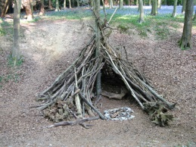  Curriculum for Excellence  I explore and discover different ways of representing ideas in imaginative ways. | Science  Our focus this week is looking after the birds in our environment. We are going to make bird feeders out of lard and bird seed.  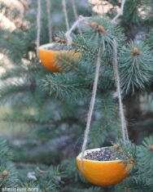  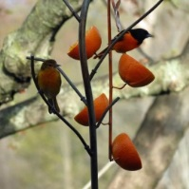  Step 1: find something to put your bird feed into - orange skins, coconut shells, toilet roll holders etc.  Step 2: attach a string so that you can hang it up  Step 3: melt the lard – see a solid form melt into liquid (or a soft texture)  Step 4: add bird seed and mix well  Step 5: spoon the mixture into your feeders.  Step 6: cool the mixture and let it set before you put it outside.  Curriculum for Excellence  By investigating how water (a solid substance) can change from one form to another, I can relate my findings to everyday experiences.
And a fantastic suggestion from Cole’s mum – should we participate in the RSPB Big Garden Birdwatch? What a great idea – you can sign up at RSPB.ORG.UK/BIRDWATCH and all you need to do is to watch your garden for an hour, record what birds you have seen and forward to the RSPB!
