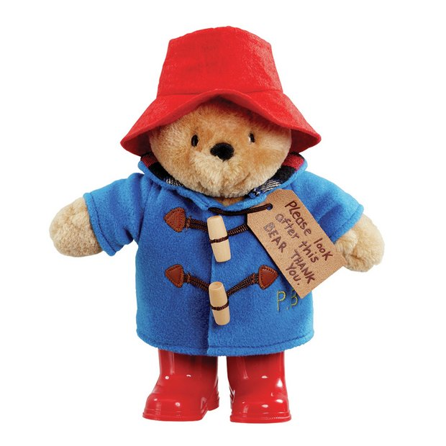

Paddington Bear
Paddington is a toy bear. His boots are shiny and red like an apple. He has a soft red had and a cosy blue duffle coat. Paddington’s body is soft to touch and his boots are hard. He had one label on his jacket and two wooden toggles on his jacket. Paddington is standing tall with his arms open. I like Paddington because he is a funny character, and he made a great present for my friend.

- Full stops, capital letters and commas used correctly.
- Adjectives included – ‘shiny’ ‘cosy’ ‘blue’.
- Connectives included – ‘and’ ‘because'.
- Simile included – ‘shiny and red like an apple’.

Spelling
Try to sound out any words that you are unsure of. What sounds can you hear at the beginning, middle and end? Some of the words that you need will be difficult to sound out – just try your best!
Try to remember the spelling and ‘tricky words’ you have learned.
Have a go and don’t worry if some of the words are difficult to spell.

