Committed Christians

: _________ 

My name is:



I inspire people because :



My name is:



I inspire people because :







My name is:



I inspire people because :





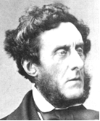

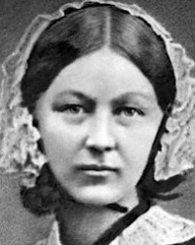

My name is:



I inspire people because :





My name is:



I inspire people because :





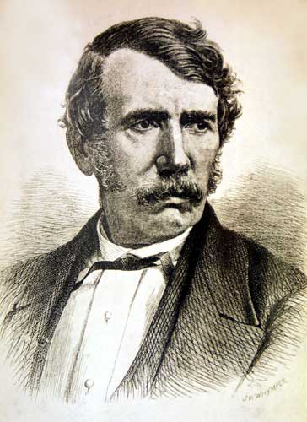

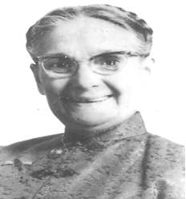

My name is:



I inspire people because :



