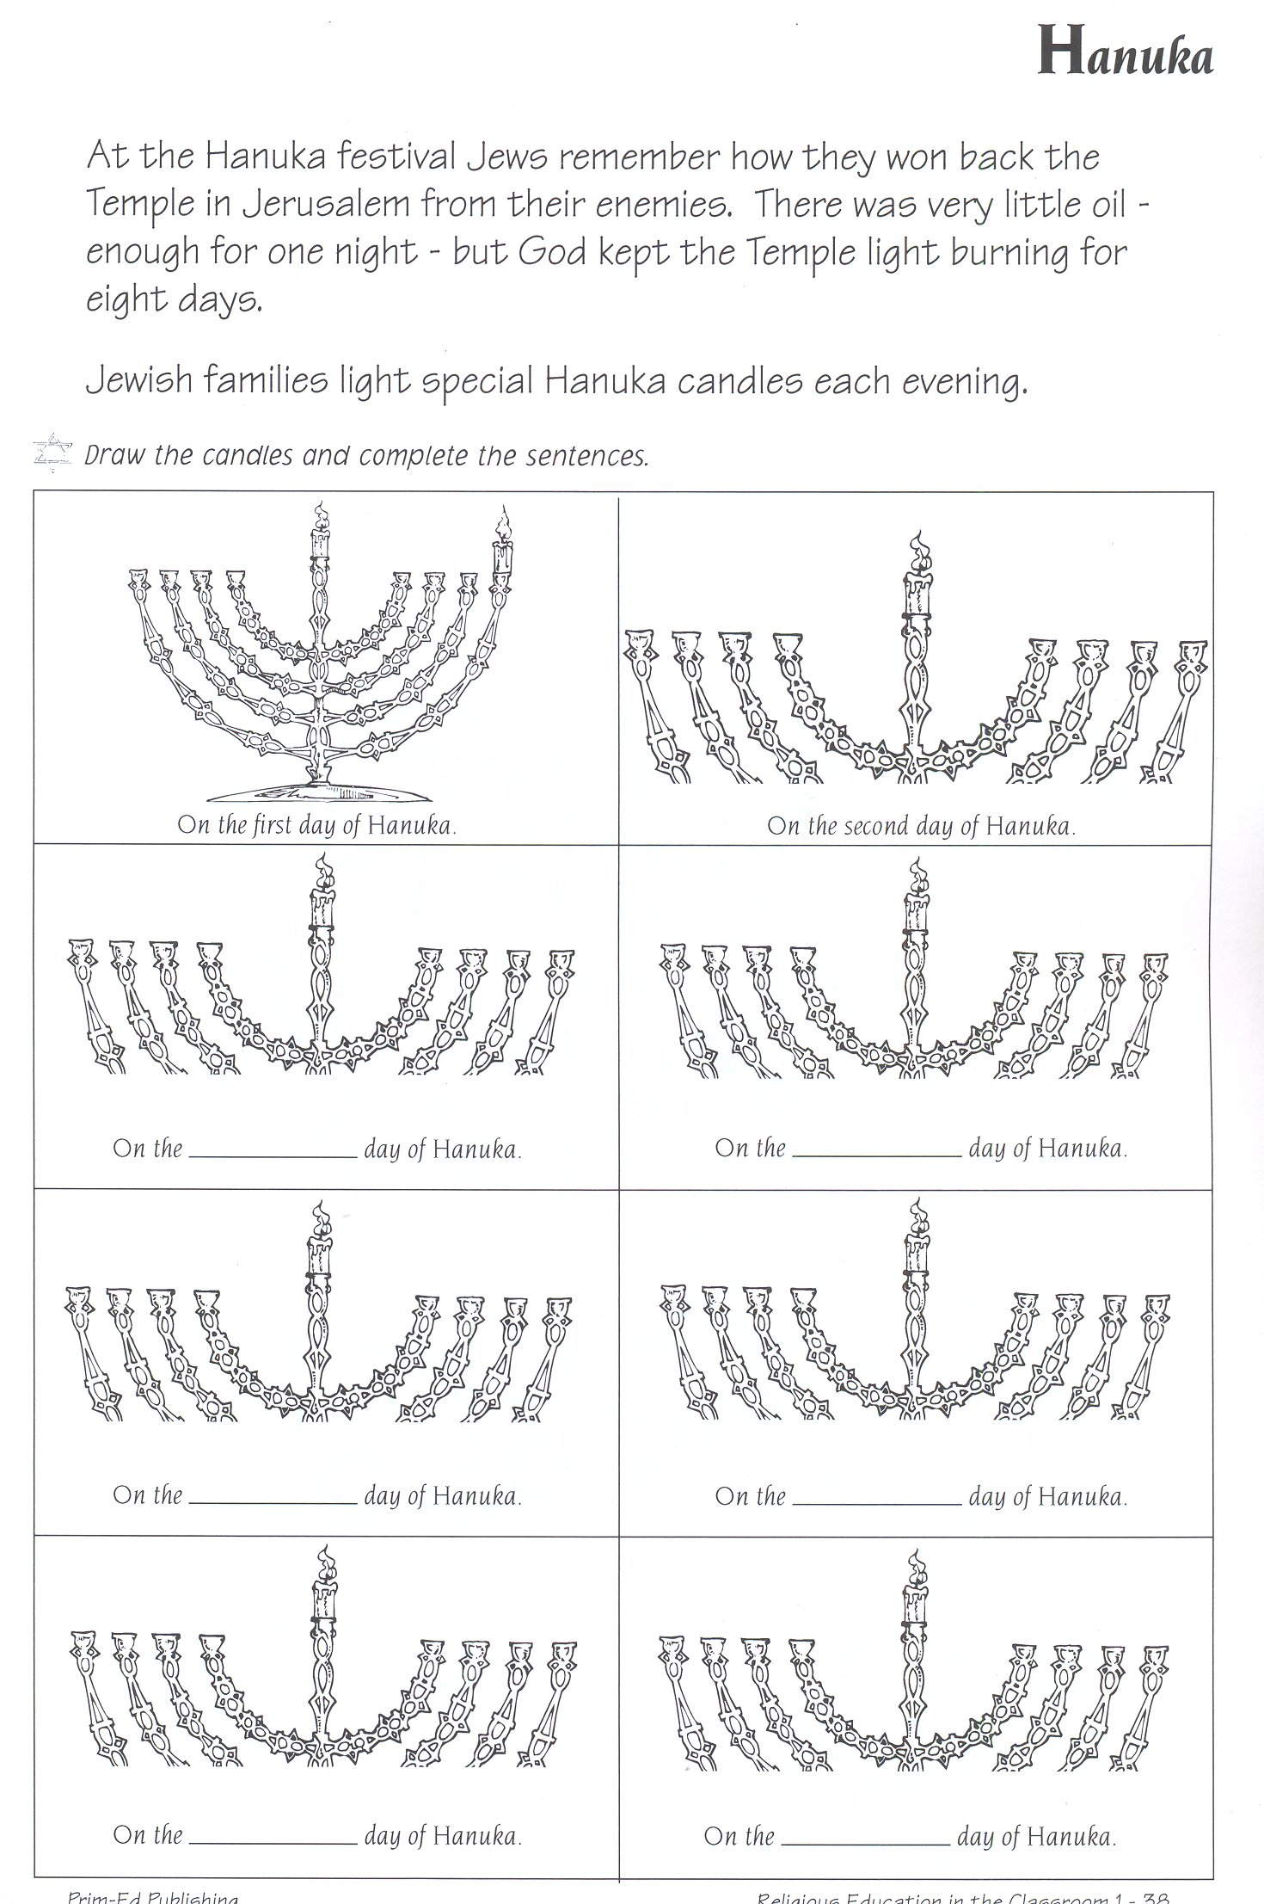
fourth sixth eighth third seventh fifth

