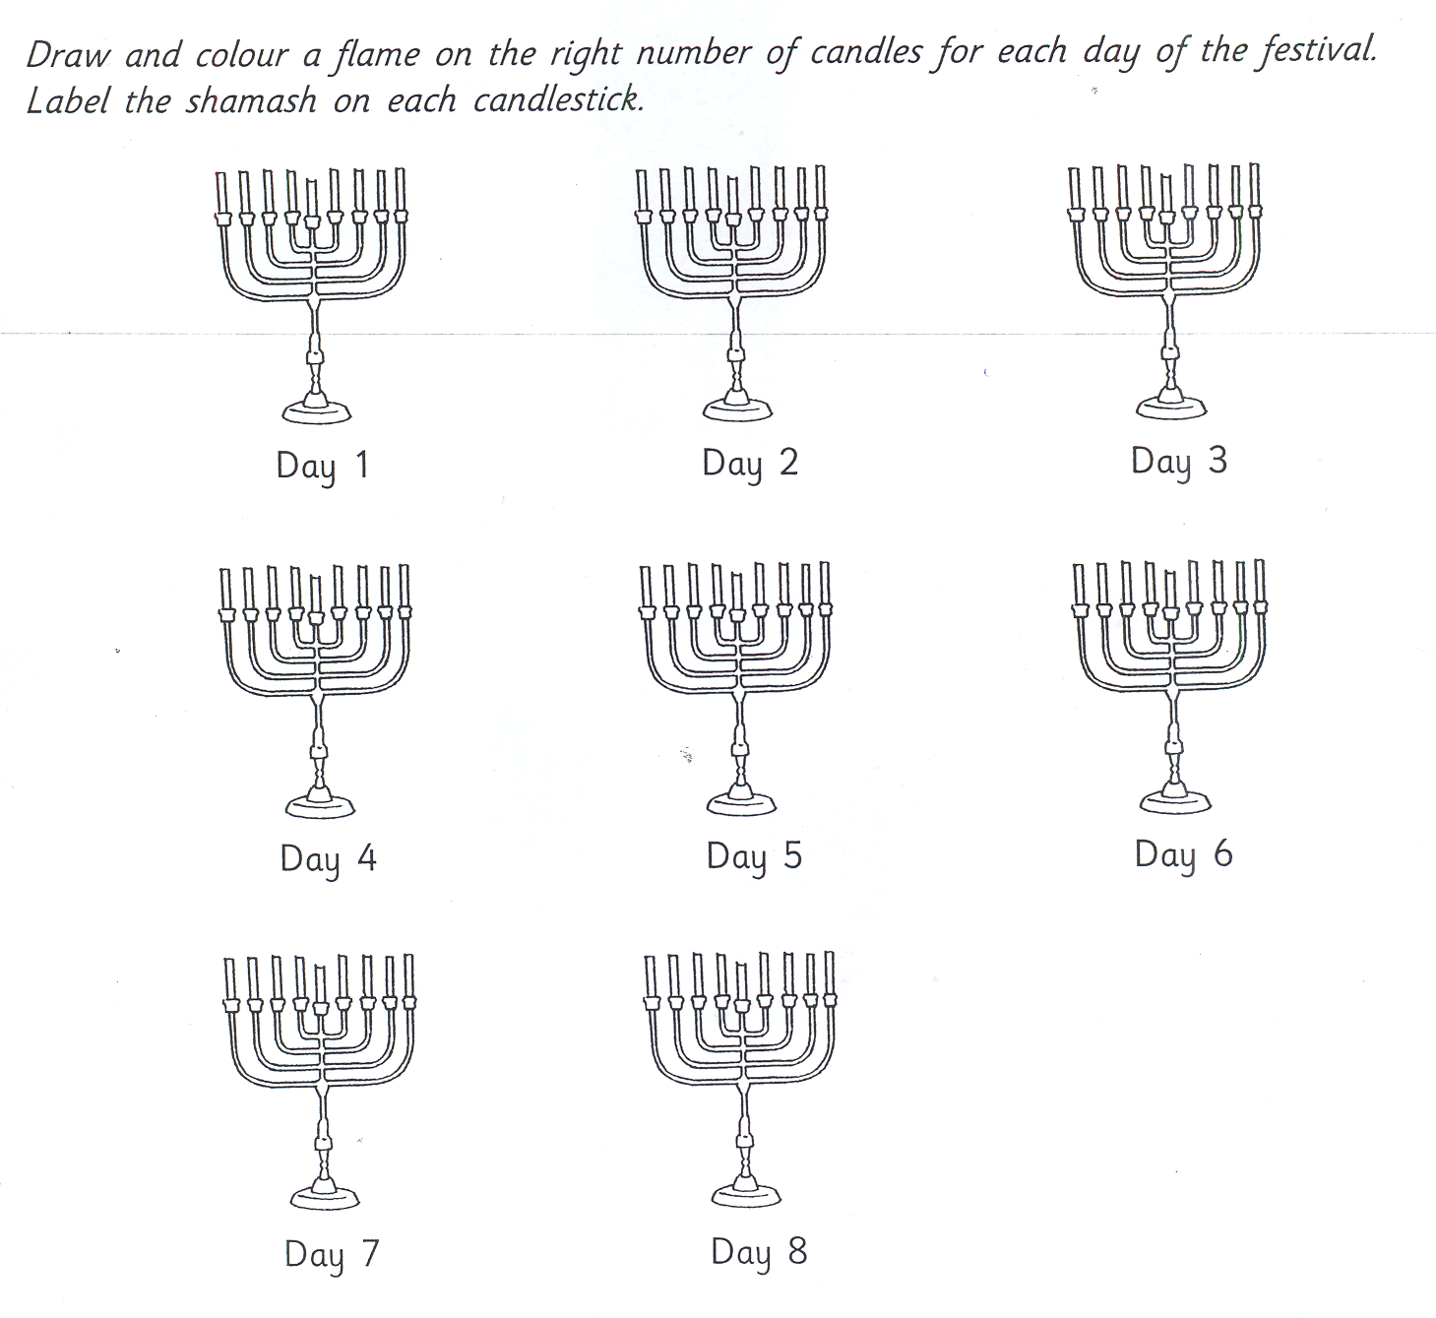

- Hanukkah is called the F _ _ _ _ _ _ _ of L _ _ _ _ _ .

- It takes place in N _ _ _ _ _ _ _ or D _ _ _ _ _ _ _ .

- The festival lasts for e _ _ _ _ days.

- It celebrates when the T _ _ _ _ _ in J _ _ _ _ _ _ _ _ was made holy again in 164BCE.

- Jewish homes light a special nine-branched H _ _ _ _ _ _ _ _ _ _.

- The small ninth candle in the middle is called the sh _ _ _ _ _ .

- This servant candle is used to l _ _ _ _ the others from the right to the left.

- A candle is lit for each night of the festival until all e _ _ _ _ candles are alight.

