Week 9 Online Learning P2/3 Miss Gainford
Welcome to another week of online learning. I hope that you have all had a good week.
This week we are continuing with the second join in handwriting. I have included a lined sheet to help you with this. Remember to use a sharp pencil, to sit up straight, to use the lines and to make your letters the correct height and for them to sit on the base line.
The dotted line is the height of the small letters and for the top of the round parts for b, d, g, h, k, p, q and y.
In Maths we are looking at capacity. If you do not have a measuring jug, look at the side of your milk container as there are 2 and 3 litre measures on the larger container and on the smaller one there is a mark for 1 l and 2 l. To get 1 litre, fill the milk container to the 3 l mark and pour this into a different container, a jug if you have one. Pour this liquid back into the milk container but only up to the 2 l mark. What is left in the jug is 1 l.
Use this litre to complete your maths tasks.
Use your litre container to find items in your house that hold more than, less than and 1 l . See how close your estimation skills are.
Remember that there are 1000ml ( millilitres) in a litre.

In questions 1 to 6 remember to divide 1000 by the bottom
number and multiply by the top to find your answers.
Look carefully at the scales.
If it is more than 1000 ml it is a whole litre ( 1 l ) plus the fraction.

Convert all the containers into mLs first. The small milk container has pints marked on it too. People used to measure in pints instead of litres.
Which liquids do we still use the old imperial measurements for instead of metric measures?

Complete the problems either on the printed sheet or in your jotter.

In RME last week we looked at what showed commitment in Judaism and, in your opinion, what the balance of this commitment was, which you showed by colouring the pie chart. This week I want you to use the same pie chart to show your own commitment. Have a think and list things that you are committed to and again colour the sections to show the balance of your own commitment to this selection. These could include family, friends, pets, clubs, hobbies and school you decide what you want to include and then colour the outside sections to show the balance of your commitment.

In art we are continuing to look at energy and this week I would like you to draw deep sea creatures which produce their own light this is called bioluminescence .
Watch these explanations.
https://www.youtube.com/watch?v=fYsAK24le6U
https://www.youtube.com/watch?v=oKjFVBVGad0
Now have a look at some real life examples
https://www.youtube.com/watch?v=XD7thJVRKmQ
As you can see many of these creatures are like nothing you might have seen before so use your imagination to create the strangest bioluminescent sea creature yet to be discovered and give it a name.
The Swiss artist Paul Klee who was born in 1879 painted The Golden Fish in 1925 using watercolours and oil paints. It glows strangely in the dark, making it look magical and mysterious just like your deep -sea creature. You can get the same effect by using watercolour and oil pastels or wax crayons.
- Draw your fish on white paper. You might want to add sharp teeth like the angler fish or create a completely new shaped creature. You can choose either to lay the paper landscape or portrait fashion depending on the shape and size of your creature.

- Colour in the creature using bright coloured crayons or pastels.

- Mix the water colour in shades of very dark blue to black.

- Paint the whole sheet and over the creature. The wax will resist the paint and look as if it is glowing in the dark.

- If you don’t have these art materials just draw your creature to show what it looks like.

- This is Paul Klee’s painting of The Golden Fish. See how the Golden Fish looks as if it is glowing by contrasting the light and the dark colours. It is black around the fish.

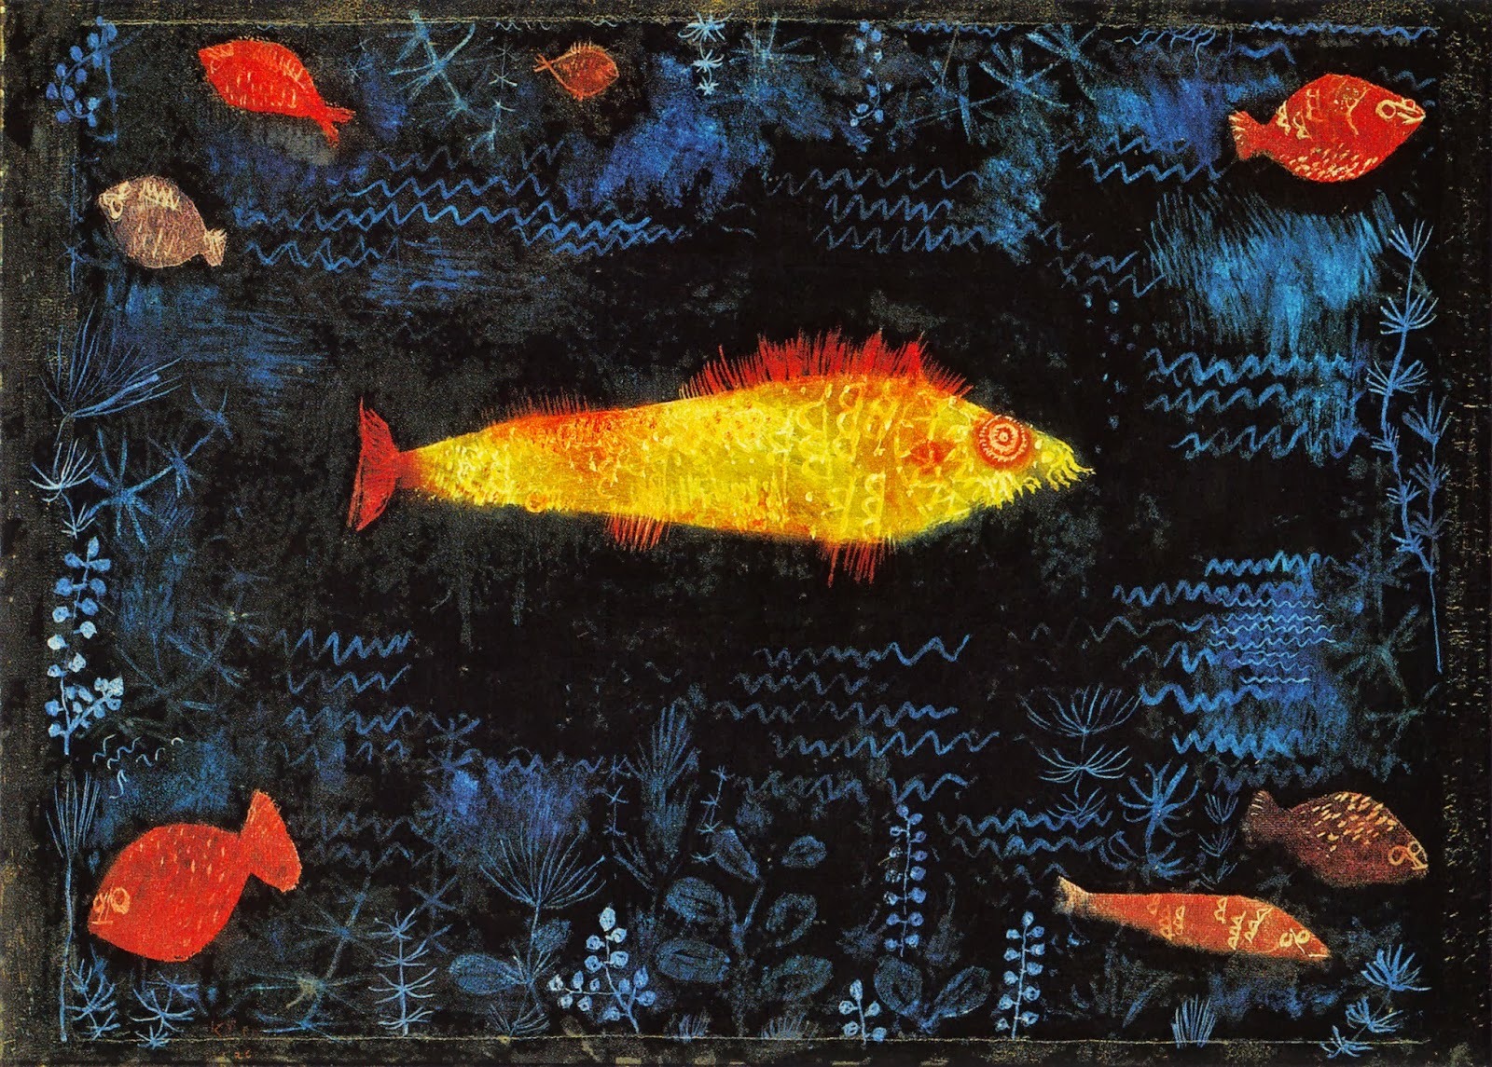

Have fun, do what you can.
Talk to you again next week.
Miss Gainford

