[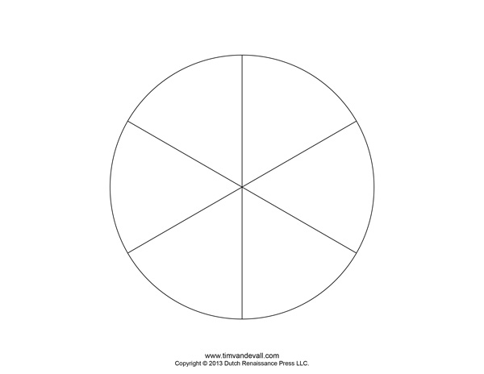](http://www.timvandevall.com/wp-content/uploads/make-your-own-pie-chart.png)

1. Choose the six things or people that you are most committed to in your life.
2. Draw how you show this commitment to them.
3. Colour each section to show their importance to you.

I show the most commitment to ………………………………………………………………………………………………

………………………………………………………………………….. by ……………………………………………………………………….

………………………………………………………………………………………………………………………………..this is because

……………………………………………………………………………………………………………………………………………………………

…………………………………………………………………………………………………………………………………………………………..

My Commitment Wheel