The Bravery of Judah

- Who refused to allow the Jewish people to practise their religion?

- What happened to anyone who was found reading the Torah?

- What did the King do to the Jewish peoples’ holiest building and what was it called?

- Who is Sketch A a picture of and what was he the leader of?

- What did Judah and his soldiers fight to win the Temple back?

- What is the Ner Tamid is supposed to do?

- How much oil was left?

8. How long did it take to get more oil?

9. What was the miracle?

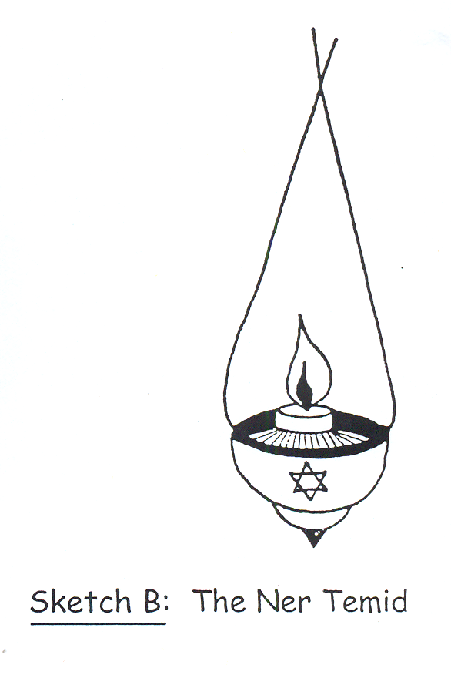
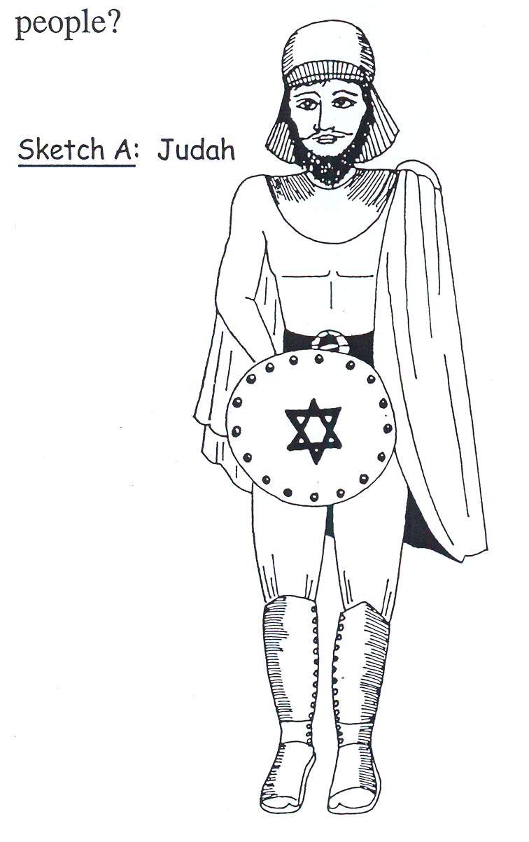
1O. What did the miracle prove?

