Week 9 Online Learning P1 Miss Gainford

Welcome to another week of online learning. I hope that you have all had a good week.
This week in RME we are looking at a new mini topic about a Jewish Festival called Hannukah which takes place in December every year. It celebrates good triumphing over evil and being able to follow their beliefs. We will be looking at this story today.

Watch the following clip and then answer the questions. You do not need to print them out unless you want to, just answer the questions and draw a picture of Judah the Maccabee, the temple and the lamp.
https://www.youtube.com/watch?v=zsXQfCeMHs8
Can you retell the story of Hannukah ?
Banned means not allowed.
Did you see the Star of David, the Jewish symbol, in the story?
It was important for the Jewish people to be allowed to practise their religion.
A miracle is something amazing that cannot be explained and is often linked to a religion.

This week I was watching the news and heard that people who cannot hear ( who are deaf ) are having problems understanding what people are saying because they are wearing a mask and this prevents them from being able to read their lips.
This is when they watch the movement of your lips to work out what you are saying. It is not easy, give it a go with someone else. Did you understand what they said and did they understand you?

Another way for deaf people to communicate is using sign language. This is when you use your hands, face and body to show words.
In our school we use Makaton. Here are a few signs that you can learn.
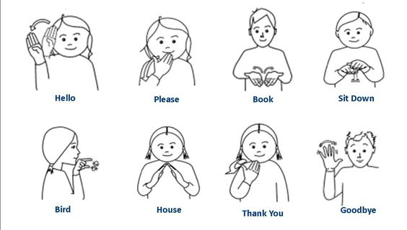
Watch this video to learn more about being deaf.

https://www.youtube.com/watch?v=I_EmsguJMic
I thought that this was also an interesting video by people who are deaf who are letting us know more about how it feels to be deaf and what they would like us to do.
https://www.youtube.com/watch?v=JY4uof7vvZk
Can you say hello in sign language?

We all use our hands to talk to others, complete the Hand Sign sheet to discover some signs that we all understand.
Use a different colour border for each box and colour the people’s jumpers the same colour to match. Draw pictures for the ones at the bottom and if you can think of any others, put them on the back.
As a challenge, see how long you can stop talking and only use sign language to communicate.
Have fun.
Talk to you again next week.
Miss Gainford

