Week 8 Online Learning P5 Miss Gainford
Welcome to another week of online learning. I hope that you have all had a good week.
This week in language we are looking at the use of speech marks. When I was taught it at school you had to use a 66 at the start of the speech and a 99 at the end but often now people just use two lines for both just as my laptop does. Both are correct. Speech marks wrap around the actual words that are spoken with other punctuation inside such as a full stop, comma, question mark or exclamation mark.
Follow the instructions on your sheets.
Red group you can colour match the rectangles by drawing matching coloured borders using a different colour for each pair or cut and arrange the rectangles in pairs.
In maths we are looking at weight this week. Again follow the instructions on your sheet. If you have scales, see if you can estimate an object in kg and g and then test to see how close you were. The more that you estimate the better you will become at judging weights which will come in handy at the next guess the weight competition. Having the correct weight is important for baking, science experiments and not getting charged for excess baggage when you go on holiday.
In RME we are completing our section on Judaism with a commitment wheel. This is a pie chart which can show visually how important you think that each section is to Jews to show their commitment to God. This is your own opinion.
Choose which areas you want to include from the following topics that we have covered this year.
Synagogue, Bar/ Bat Mitzvah, Tu Bishvat, Passover/ Pesach, Moses and the Ten Sayings, Abraham and the Covenant, Kosher/ Trefeh food, Shabbat, Mitzvah Day and the Torah.
In art because you have been looking at renewable energy I thought that we would paint or draw a windfarm. This can either be on land or at sea where you could include reflections using the vanishing point for these too. We will be looking at how to use perspective and the vanishing point in our art work to make the turbine wind farm more realistic. Watch the You Tube video for instructions on how to do this.
https://www.youtube.com/watch?v=sMPFe2U5_gg

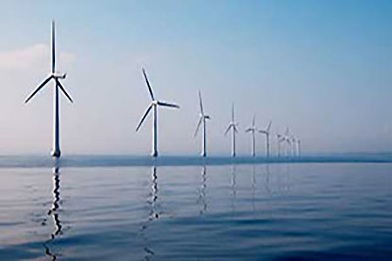
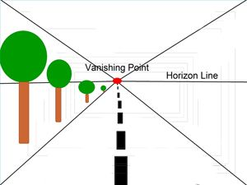

Remember that the further away something is, the smaller it becomes.
Have fun. Talk again next week.
Miss Gainford.

