Week Seven primary 5 online learning Miss Gainford
Hello everyone and welcome to yet another week of online learning. I loved looking at your NHS video. It was great to see everybody looking so happy and healthy and I'm sure you enjoyed seeing each other as well. I'm only sorry that I couldn't send in a video but that is one of the drawbacks of living on your own, it is impossible to throw a ball to yourself whilst recording it.

For handwriting this week I would like you all to Practise the second join. Have a look at sheet 16, read the instructions carefully and follow the arrows after you have gone to the top of each tall letter. Make sure that you write in between the wider lines. The bottom line is for lazy letters and remember that t is a teenager it's not a tall or a small letter.
Draw extra lines on the back to practise each pair of letters.
If you do not have a printer use your workbook and leave a line in between each pair of letters.
In maths this week we are continuing with measure.

- Write these lengths in order. If you convert them all to cm first it is easier to do.
- Start with the shortest first.
123cm 1m 28cm 1.2m 1 ¼ m
- Start with the longest first.
3 ¾ m 3.8m 372cm 3 ½ m

- Write down which item you would use to measure the following.

30cm ruler metre stick 150cm tape measure metre trundle wheel
- Your height.
- The length of a screw.
- The length of a pencil.
- Your sitting room
- The distance around a basketball
- The width of a football pitch.
- The distance around a tree trunk.
List four things you would measure in
- centimetres b) metres

Questions 3,4 and 5 are on the length in Kilometres scanned sheet.

Remember that a kilometre is 1000 metres.

This week you will be working out distance problems in metres.
Remember that the question
“ What is the length? ” is asking you to add.
“How much longer? “ is asking you to subtract.
“ Which is longer? ” is asking you to add and then compare.

In question 4 you will have to use estimation and then check it. You will also have to use subtraction and remember that the boat can only visit two places.

Use the Problem solving and enquiry in metres sheet.

You will also be using estimation, this time in centimetres, before
measuring accurately with a ruler between the ends of the light grey lines. Make sure that you start at 0 on your ruler.
The more you estimate the closer you will get to the right answer at your first attempt.

Estimate then Measure in cm sheet.

In RME we are finding out about the Jewish festival called TuB’shevat which is known as the birthday of the trees as this was when the growing year started on the 15th of Shevat and it was used to calculate the tax that people had to pay for the fruit they grew.

Let’s have a look at why trees are important to the planet first.

https://www.youtube.com/watch?v=5I7u5FMQxHA

Now let’s find out why Jewish people have a festival to celebrate them.
https://www.youtube.com/watch?v=znsAzz26XeY

Obviously we can’t travel to Israel but we can think about the wood and paper that we use and why we should look after trees and if we can, plant them to help the planet.

The fruit that is eaten during this festival all comes from Israel. Just in case you don’t know what they look like, here are some pictures.

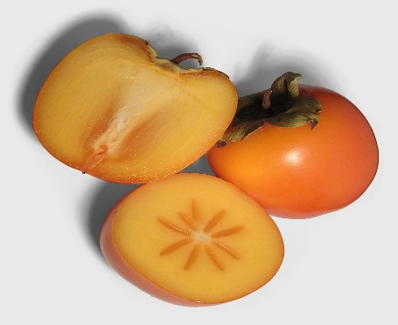 Sharon fruit
This Photo by Unknown Author is licensed under CC BY-SA

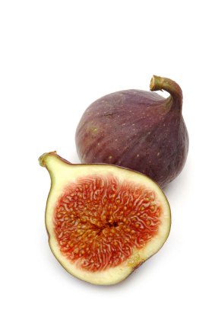 figs

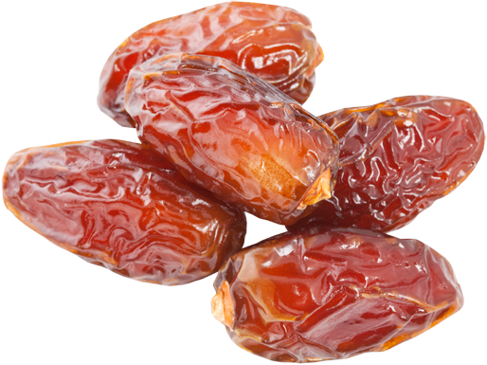 dates
This Photo by Unknown Author is licensed under CC BY-NC

Read Information sheet 17and then answer the questions on the first sheet and draw a poster to advertise it on the second or one to encourage people to save trees.

In art I would like you to draw or paint a self portrait but with static hair as I know that you have been learning about this in your topic. If you are not sure how to do this take a look at the photographs below. As your hair is now longer, due to Lockdown it will be quite wide and high and just for fun you can make it any colour or colours that you want.

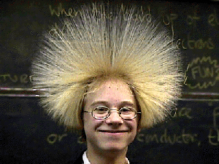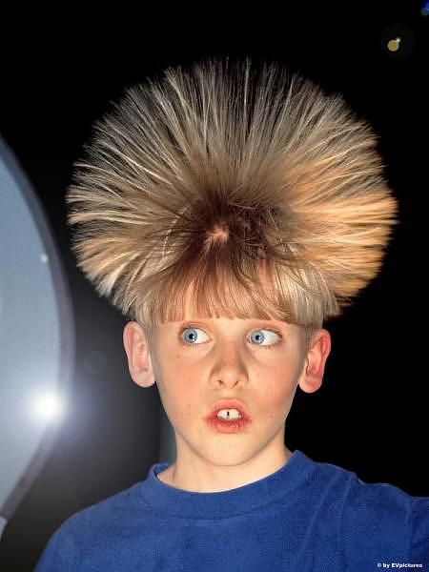

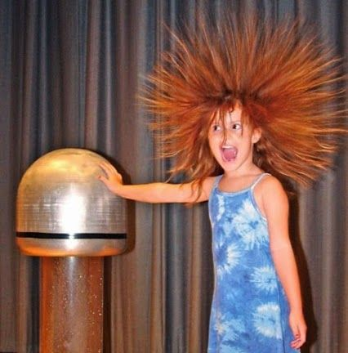
This is a Van de Graff generator. You can include it in your picture. Decide which expression you want and study it carefully in a mirror before drawing it especially the mouth, eyes ( think which direction they will be looking in) and eyebrows. Don’t forget to add your ears if you can see them.

Have fun.
I will talk to you again next week.
Miss Gainford

