[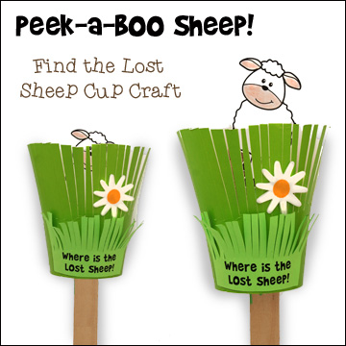](http://www.google.co.uk/url?sa=i&rct=j&q=&esrc=s&source=images&cd=&cad=rja&uact=8&ved=0ahUKEwjpzre6pdfMAhUGChoKHcotDNUQjRwIBw&url=http://www.daniellesplace.com/html/Bible-themes-Parable-Lost-Sheep.html&psig=AFQjCNG-CZovMiqno6mL8Y7zlUU2Xt9Cnw&ust=1463237148630923)