Week 6 Learning activities P2/3 Miss Gainford 11/5/20

Hello everyone and welcome to another week of online learning.

Last week we looked at a special place called Lourdes in France and a special person called Saint Bernadette. This place and person are important to Christians.

This week we are going to look at a special person for Buddhists he is The Buddha who started life as Prince Siddhartha. He was born in Nepal in May and became The Buddha in May and Buddhists celebrate this during the Wesak festival also known as Buddha day which this year is on May the 7th.

Prince Siddhartha lived in a palace and had everything he wanted but he knew that there was more to life so he gave it all up and became a holy man. He spent the rest of his life trying to understand why people suffered and he said that the way to stop it was to stop selfishness ( thinking only of yourself and what you want ), Greed ( wanting everything for yourself ) and hatred ( when you really dislike someone or something). Buddha means “ the one who has found the answers” which he then went on to teach to other followers or disciples known as monks who then taught other people how to reach peace or Nirvana by following the middle path, not being rich or poor. After he died people continued to follow his teachings and to live their life in a way that does not cause suffering to anyone or anything.

Watch the following clip to find out more.
https://www.youtube.com/watch?v=1wUh3E9PSbI

Print off the correct sheet for you or copy the answers and pictures onto a sheet of paper if you do not have a printer.

Buddha meditated or sat peacefully thinking until the answer to suffering came to him. Follow this meditation link to see if it helps you to think more clearly. Buddhist statues show him sitting in the lotus position, have a go and see if you can sit like that. If it is too difficult try the second version.

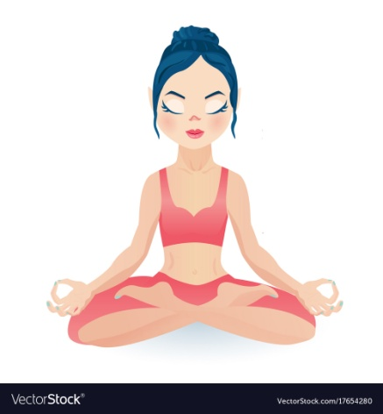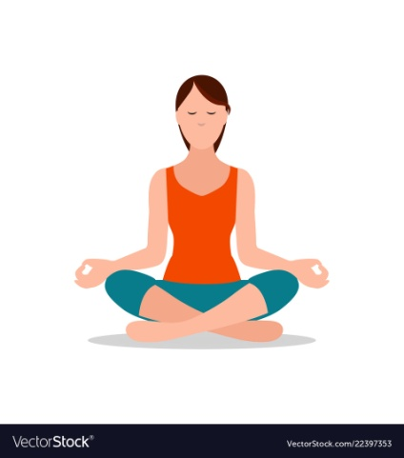

Now try this Buddhist meditation it will help you to become calm and peaceful and to deal with any worries that you might have ( but remember to also tell someone if you do). You do not have to use the people that they suggest to think about you can choose another friend or relative if you want to .

https://www.youtube.com/watch?v=98ficcEu-ns

You can use this any time that you are worried or need to be calm and focused. When I tried it and was saying and thinking cat, Paddy ( my cat ) came downstairs to sit beside me.

Last week we looked at the balancing of each food groups. In health this week we are looking at Healthy eating and checking to see if we have a healthy diet because this is what our body needs to work properly and to help to keep us fit and healthy. The Buddha realised that not eating was the wrong path and that we need to eat properly.

Watch this power point Double click on it and then move to the next slide using your down arrow key. To end show, right click on your mouse or pad and choose End show.

2 More Images
Everyday this week I would like you to record what you eat including snacks and drinks, this can be pictures or words or both. At the end of each day have a look at it and circle

Blue for protein ( meat, fish, eggs, nuts and pulses or vegetarian or vegan substitutes )
Green for fruit or vegetables this can be one fresh fruit juice a day.
Yellow for dairy ( milk, cheese, yoghurt or milk substitute if you have an allergy to Lactose).
Brown for grains ( bread, rice, potatoes and cereals )
Red for sugar and fats ( sweets, cakes, biscuits, ice cream, oil, butter or alternative)

When you have coloured it in see if you have each group covered everyday.

Remember that sugar can be found in fruit ( fructose) and in milk ( lactose ) and in bread, crackers, bagels and pizza (maltose). Some food will have more than one coloured circle.

If you have all five colours at the end of the day draw a smiley face. If you don’t have five have a think about what was missing and what you could have added. Maybe you could plan next weeks menu?

Eat well, stay fit
Miss Gainford

