Week 6 Learning activities P2 Miss Gainford 11/5/20

Hello everyone and welcome to another week of online learning.

Last week we looked at Synagogues, the Jewish holy building. Within this building is an Ark which is a cupboard that holds the 6 Torah scrolls and is always on the wall closest to Jerusalem the holy city for Judaism and also Christianity and Islam. The Ark is the most important part of the Synagogue because it contains the word of God in the five books of Moses which are the same as the first five books of the Old Testament in the Christian Bible.

Watch the following video clip to find out more about it.

https://www.bbc.co.uk/programmes/p0115gry

Did you notice how many things are used to protect the Torah Scrolls and how much care and respect people show when handling them?

You are not to touch them with your hands so a Yad ( which means hand in Hebrew, the Jewish language) is used to help you to keep your place and it looks like a little silver hand.

The mantle is the cloth covering which is often decorated with embroidery such as the Star of David and has
fringes sewn onto the top and bottom edges.

The breast plate is the metal badge that is hung around it. Can you see the two stone tablets on it that were
given to Moses by God when he was told the rules that people were to live their lives by? Jewish
people call them the Ten Sayings.

Often there are bells on the scrolls so that everyone can hear where the Torah is.

The Ner Temid is the everlasting light that is to show that God is always with them.

When the ark is not in use the curtains are drawn.

The Torah is made out of animal skin called parchment and written on with a feather by a man called a Scribe. It takes a very long time, a year, to write one and over time they have to be sent away to be repaired. When the Torah can’t be repaired any more it is buried and a new one made.

If you can, print out the correct worksheet for you and answer the questions and colour the picture.

If you do not have a printer, answer the questions and draw a picture of the Torah scroll in an Ark.

Why not have a go at making your own Torah scroll and write things that are important to you on it and then roll it up. You will need a strip of paper and two things to roll it around. You might even make a mantle to protect it.

Or if you noticed Hebrew is written from the right to the left, try and write your name backwards starting on the right for example nhoJ.

Or make your own quill out of 3 plastic straws. You will need a grown up to help you with this.

Step 1: Supplies: 3 plastic straws, scissors, paper and ink or paint.

Step 2: Start Cutting
If your straws are like mine, they have a bendy thing at the end. Cut them off and make them the same length.
Two of your straws need to be cut lengthwise too.

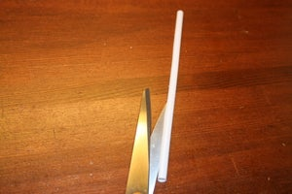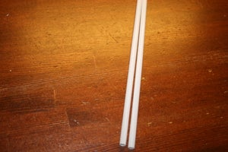

Step 3: Making the Body
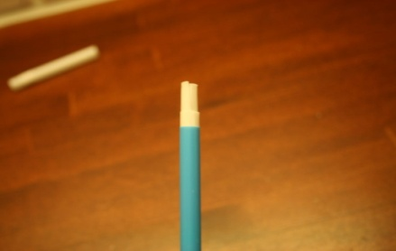
when you have cut the straws, it should be easy to put them in to each other, but remember to put the lines on the same side.

Step 4:
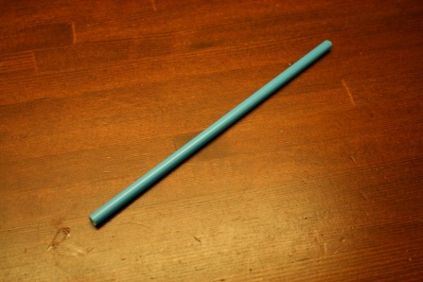
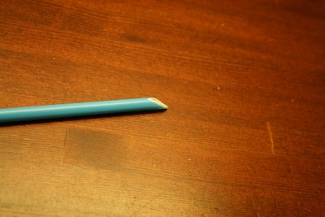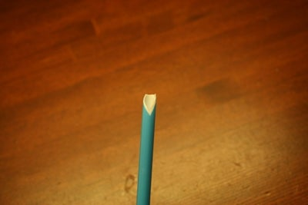

2 More Images
Cut off the end of the three straws on an angle. Remove the tip, then cut a line down the middle. Sharpen the tip again.

Step 5:

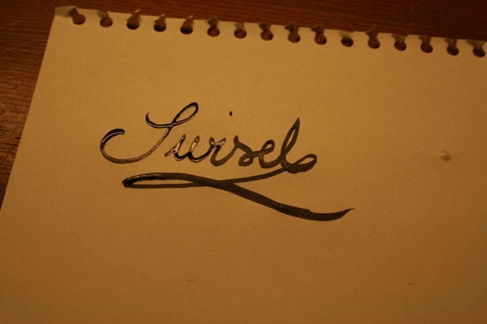
The possibilities are endless, the pen draws and writes beautifully. Have a go.
If you are done and want to clean the pen, you can just take apart all the straws, wash them and then put them back together again.
In Health this week we are continuing to look at food and this week we will be taking a closer look at sugar and remember the difference between a meal and a treat.
Meals give you the nutrients that your body needs to stay healthy and a treat is something that you can have now and again these are often high in sugar or fat. If you eat too much of this food group you will become overweight and unfit and you will have to visit the dentist more often.
Watch this video clip to discover more.
Remember Soda is a fizzy drink.
https://www.youtube.com/watch?v=Io5mi5OwlEk
If you can, print out the food for your meals sheet and complete it and draw pictures on the back of five more items full of sugar.
If you can’t print it fold a page in two and write the words Meals and Treats at the top of each side and draw meals on one half and treats on the other.
Try to make healthy choices this week.
Goodbye for now Miss Gainford.

