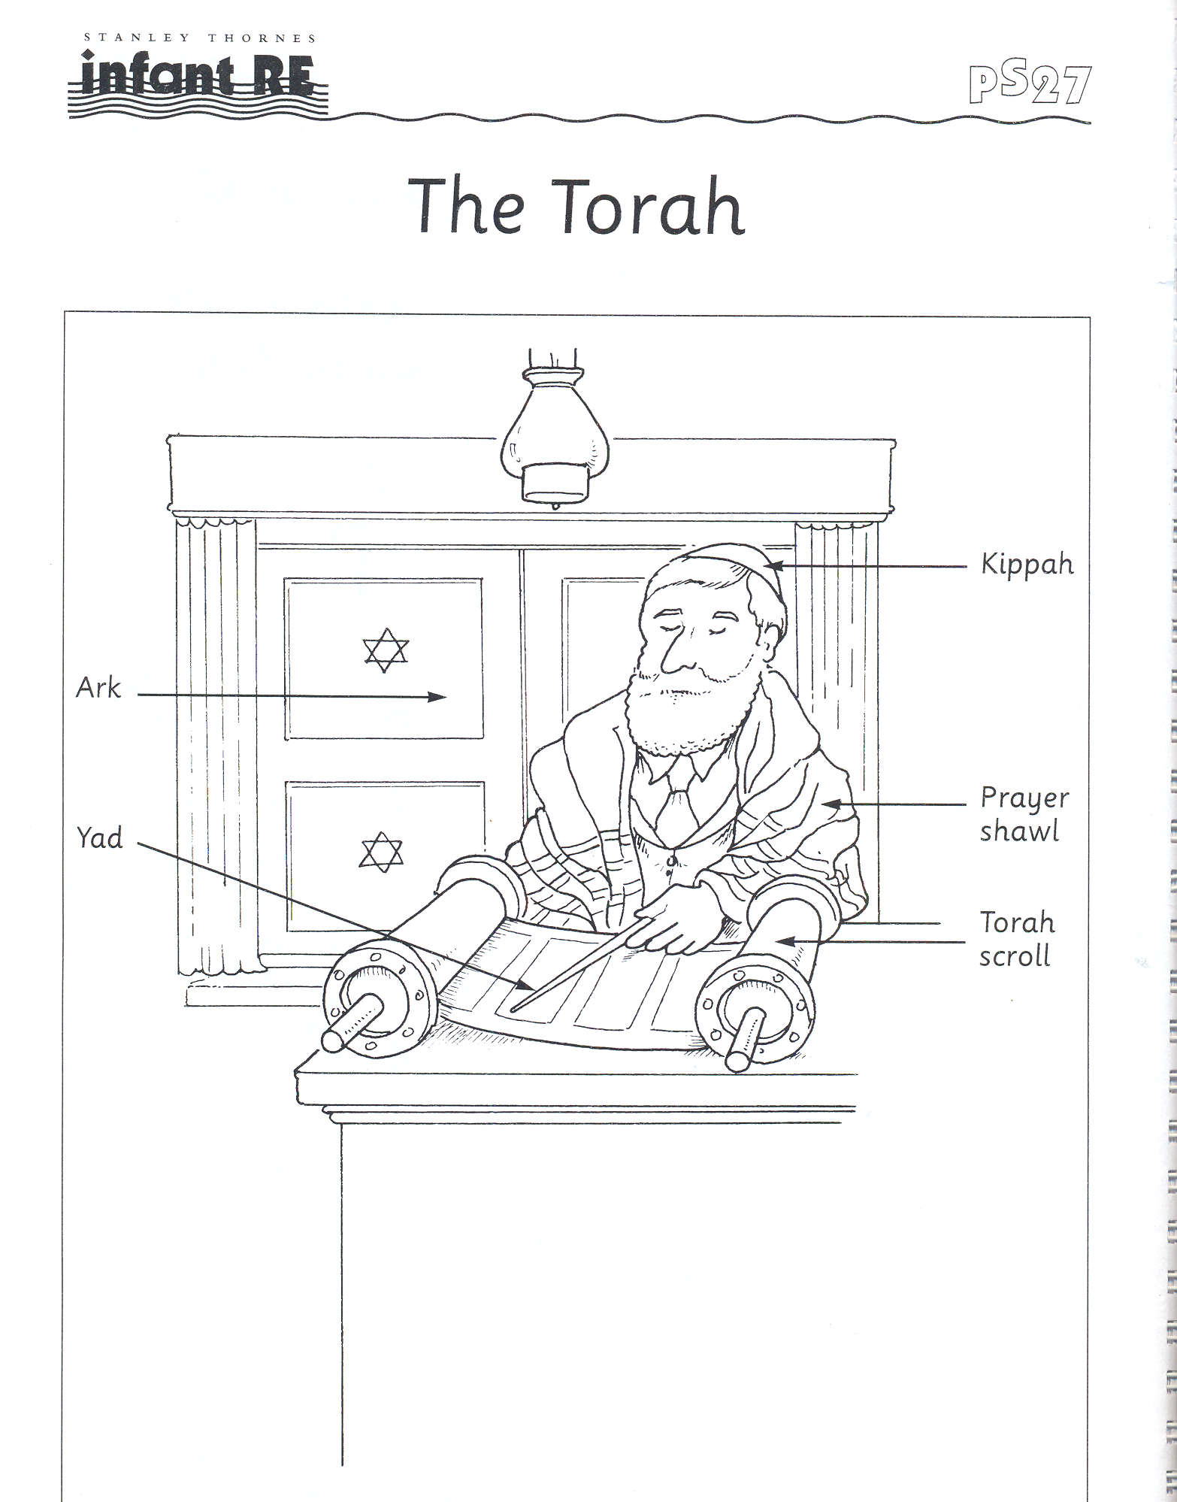

Torah scroll Prayer shawl

Yad Kippah

Star of David Ark Ner Temid

