The torah
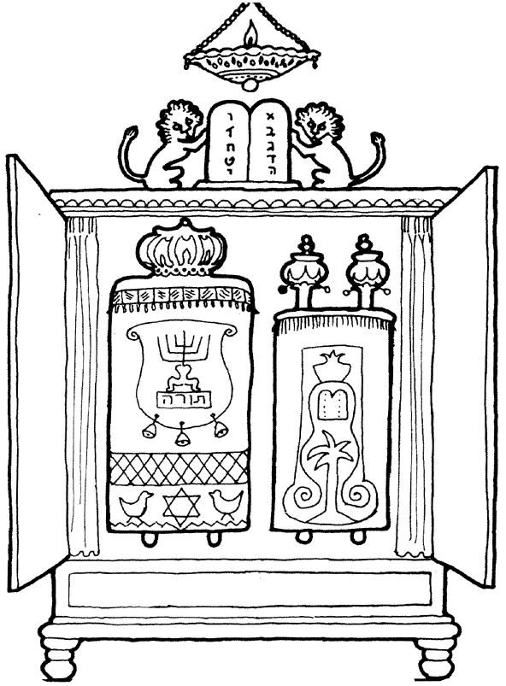
The Torah scrolls contain the special Holy writings for the
Jewish people. They are kept in the Ark in the Synagogue.

Ner Temid

Ten sayings

mantle

Ark

curtains

Match the items to the descriptions.

- The A _ _ is the box that the scrolls are kept in.

- The N _ _ T _ _ _ _ is the everlasting light above the Ark.

- The m _ _ _ _ _ is the material covering the scrolls.

- The two stone tablets with the T _ _ S _ _ _ _ _ _ are above the Ark.

- The c _ _ _ _ _ _ _ in the ark are closed when the scrolls are not used.

