**The crocodile and the Priest**

[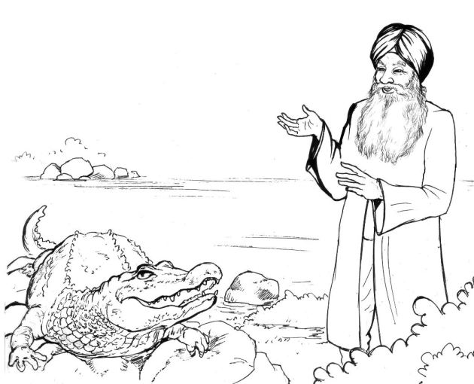](https://infotechfusion.files.wordpress.com/2013/02/12.jpg) [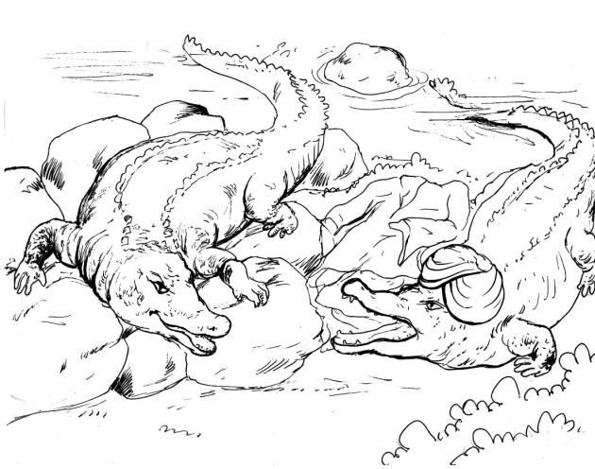](https://infotechfusion.files.wordpress.com/2013/02/13.jpg)

We are all one